

Air Quality Bureau
2021 Annual Network Review

Table of Contents

Introduction, Public Review and Comment 3

Section 1.0 Overview 3
Site Designation Coding 3
Air Monitoring Network 4
Air Quality Data 4
Overview of Monitored Parameters 4
Monitoring Methodology 5

Section 2.0 - Network Review by Pollutant and Respective Air Quality Control Regions 6
2.1 Nitrogen Dioxide (NO₂) 8
NO₂ - Air Quality Control Region 1 9
NO₂ - Air Quality Control Region 5 9
NO₂ - Air Quality Control Region 6 10
2.2 Ozone (O₃) 11
O₃ - Air Quality Control Region 1 12
O₃ - Air Quality Control Region 2 13
O₃ - Air Quality Control Region 3 14
O₃ - Air Quality Control Region 5 15
O₃ - Air Quality Control Region 6 16
2.3 Sulfur Dioxide (SO₂) 18
SO₂ - Air Quality Control Region 1 18
2.4 Particulate Matter PM_{2.5} Non-Continuous - Federal Reference Method (FRM) 18
PM_{2.5} - Air Quality Control Region 6 19
2.5 Particulate Matter PM_{2.5} Continuous (BAM) 19
PM_{2.5} - Air Quality Control Region 3 20
PM_{2.5} - Air Quality Control Region 5 21
PM_{2.5} - Air Quality Control Region 6 21
2.6 Particulate Matter PM₁₀ Non-Continuous – Federal Reference Method (FRM) 21
PM₁₀ - Air Quality Control Region 6 21
2.7 Particulate Matter PM₁₀ Continuous (BAM) 22
PM₁₀ - Air Quality Control Region 1 22
PM₁₀ - Air Quality Control Region 6 23
PM₁₀ - Air Quality Control Region 7 24

Section 3.0 - Other Projects 24

Section 4.0 - Summary 25
4.1 Network Modifications During FY2021 25
4.2 Pending/Completed Network Modifications During FY2021 25

Section 5.0 - Addressing New Monitoring Requirements in Monitoring Network 25
5.1 Lead 25
5.2 Nitrogen Dioxide 26
5.3 Sulfur Dioxide 26
5.4 Ozone 27

Section 6.0 - Other Issues 28

List of Figures

Figure 1 – New Mexico Air Quality Control Regions 6
Figure 2 – Monitoring Network Locations 7
Figure 3 – Air Quality Control Region 1 NO₂ Monitoring Locations 9
Figure 4 – Air Quality Control Region 5 NO₂ Monitoring Locations 10
Figure 5 – Air Quality Control Region 6 NO₂ Monitoring Locations 11
Figure 6 – Northern New Mexico Ozone Monitoring Locations 12
Figure 7 – Southern New Mexico Ozone Monitoring Locations 12
Figure 8 – Air Quality Control Region 1 Ozone Monitoring Locations 13
Figure 9 – Air Quality Control Region 2 Ozone Monitoring Locations 14
Figure 10 – Air Quality Control Region 3 Ozone Monitoring Locations 15
Figure 11 – Air Quality Control Region 5 Ozone Monitoring Locations 16
Figure 12 – Air Quality Control Region 6 Ozone Monitoring Locations 17
Figure 13 – Air Quality Control Region 1 SO₂ Monitoring Locations 18
Figure 14 – Air Quality Control Region 6 PM_{2.5} FRM Monitoring Locations 19
Figure 15 – Air Quality Control Region 3 PM_{2.5} Continuous (BAM) Monitoring Locations 20
Figure 16 – Air Quality Control Region 5 & 6 PM_{2.5} Continuous (BAM) Monitoring Locations 20
Figure 17 – Air Quality Control Region 6 PM₁₀ FRM Monitoring Location 22
Figure 18 – Air Quality Control Region 1 PM₁₀ Continuous (BAM) Monitoring Location 23
Figure 19 – Air Quality Control Region 6 & 7 PM₁₀ Continuous (BAM) Monitoring Locations 24

List of Tables

Table 1 – New Mexico Monitoring Network 2021 29

2021 Network Review
Air Quality Bureau
New Mexico Environment Department
July 1, 2021

Prepared by
Roman Szkoda, Ambient Air Monitoring Program Manager

The purpose of this document is to provide information concerning the operation of the ambient air monitoring network by the New Mexico Environment Department (NMED) Air Quality Bureau (AQB) in Fiscal Year 2021 which covers the period from July 1, 2020 through June 30, 2021.

Introduction

In October 2006, US EPA issued final regulations concerning state and local agency ambient air monitoring networks. Under 40 CFR, Part 58, Subpart B, States are required to submit an annual monitoring network review to the Environmental Protection Agency (EPA) regional office in Dallas, Texas. These regulations require states to submit an annual monitoring network review to US EPA. This network plan is required to provide the framework for establishment and maintenance of an air quality surveillance system and to list any changes that are proposed to take place to the current network during the 2021 Fiscal Year. The annual monitoring network review must be made available for public inspection for at least 30 days prior to submission to EPA.

1.0 Overview

At the end of the state fiscal year June 30, 2021, the Bureau continued operating the 20 criteria air pollutant monitoring sites located in 11 of the State’s 33 counties. Each air monitoring location is sited to meet the three basic monitoring objectives and at least one of the six federal criteria of: NO₂, O₃, CO, Lead, particulate matter (PM₁₀ and PM_{2.5}), and SO₂ for ambient air monitoring networks.

In 2021 the Ambient Air Monitoring Section currently has a full-time staff of eight during FY 2021.

Table 1 (Network Element Worksheet) contains the listing of all New Mexico Environment Department, Air Quality Bureau ambient air monitoring sites operating at the end of the state fiscal year 2021.

Site Designation Coding
The NMED-Air Quality Bureau’s 20 air monitoring stations each have their own state region designation identified with a numeric-alpha code and site name (i.e.1ZB Bloomfield). The number and name represent the state’s Air Quality Control Region and the letter(s) identifies the site followed by the name of the site. In addition, each site has a numeric AQS (Air Quality System) identifier code which is based on EPA’s state, county and site ID (i.e. 35-045-1005) designation. The first two numbers identify the state (New Mexico is 35), the second set of three numbers refers to the county where the monitoring site is located. The third set of four numbers is the monitoring site ID number. Figure 1 on page 6 shows the state and EPA air regions. The table below is a complete listing of all 20 air monitoring sites designation code, both state and EPA throughout the network.

NMED Site Designation EPA - AQS Number Designation
1H - Sub Station 35-045-1005
1ZB - Bloomfield 35-045-0009
1NL - Navajo Lake 35-045-0018
2LL - Los Lunas 35-061-0008
2ZJ - Bernalillo 35-043-1001
3CRD - Coyote Ranger District 35-039-0026
3SFA - Santa Fe Airport 35-049-0021
3ZD - Taos 35-055-0005
5ZR - Carlsbad 35-015-1005
5ZS - Hobbs Jefferson 35-025-0008
6CM - Anthony 35-013-0016
6O - La Union 35-013-0008
6Q - Las Cruces Office 35-013-0025
6WM - West Mesa 35-013-0024
6ZL - Holman Road 35-013-0019
6ZK - Chaparral 35-013-0020
6ZM - Desert View 35-013-0021
6ZN - Santa Teresa 35-013-0022
6ZQ - Solano 35-013-0023
7E - Deming Airport 35-029-0003

Air Monitoring Network
NMED-AQB regulates air quality to protect public health and the environment in the State of New Mexico, excluding Bernalillo County. Air monitoring data are required by regulation and are used to determine compliance with U.S. EPA’s NAAQS. Other important uses of the air monitoring data include the production of a daily Air Quality Index (AQI), daily air quality forecast report, support of short and long-term health risk assessments, identification of localized health concerns, and tracking long-term trends in air quality. New Mexico monitors four of the six NAAQS criteria pollutants: NO₂, O₃, particulate matter (PM₁₀ and PM_{2.5}), and SO₂. NMED-AQB does not monitor for CO or Lead as New Mexico currently does not meet the criteria for monitoring these pollutants.

Air Quality Data

Overview of Monitored Parameters – Criteria Pollutants

Nitrogen Dioxide (NO₂)
NO₂ is a highly toxic, reddish brown gas that is created primarily from fuel combustion in industrial sources and vehicles. It creates an odorous haze that causes eye and sinus irritation, blocks natural sunlight and reduces visibility.

Ozone (O₃)
Ground- level O₃, also known as photochemical smog, is not emitted into the atmosphere as ozone, but rather is formed by the reactions of other pollutants. The primary pollutants entering this reaction, VOC’s and oxides of nitrogen, create ozone in the presence of sunlight. Ozone is a strong irritant of the upper respiratory system and causes damage to crops.

Sulfur Dioxide (SO₂)
SO₂ is a gaseous pollutant that is emitted primarily by industrial furnaces or power plants burning coal or oil containing sulfur. At high concentrations, breathing can be impaired. Damage to vegetation can also result.

Fine Particulate Matter (PM_{2.5})
Fine particulate matter with a diameter of 2.5 microns or less is created primarily from industrial processes and fuel combustion. These particles are breathed deep into the lungs. Exposure to particle pollution is linked to a variety of significant health problems ranging from aggravated asthma to premature death in people with heart and lung disease.

Particulate Matter (PM₁₀)
Particulate matter with a mean diameter of 10 microns or less is emitted from transportation and industrial sources. Exposure to particle pollution is linked to a variety of significant health problems ranging from aggravated asthma to premature death in people with heart and lung disease.

Meteorological Monitoring
NMED-AQB includes meteorological monitoring of the local area because the outcome of air pollutants is influenced by the movement and characteristics of the air mass into which they are emitted. If the air is calm and pollutants cannot disperse, then the concentration of these pollutants will build up. Conversely, if a strong and turbulent wind is blowing, the pollutant will rapidly disperse into the atmosphere and will result in lower concentrations near the pollution source. The measurements of wind speed and direction, temperature, humidity, rainfall, barometric pressure, ultraviolet radiation and solar radiation are important parameters used in the study of air quality monitoring results and to further understand the chemical reactions that occur in the atmosphere.

Monitoring Methodology
NMED-AQB air monitoring network uses Thermo Environmental Instruments i-Series for all gaseous monitoring. The Model 42i Chemiluminescence monitor collects NO/NOx/NO₂ data, the Model 43i Pulsed Florescence monitor collects SO₂ data and the Model 49i UV Photometric monitor collects Ozone data. The current Thermo i-series monitors are in the process of being replaced with Thermo iQ-series instruments which is anticipated to be completed by the end of the 2022 State’s fiscal year. For particulate matter sampling, NMED-AQB uses the Thermo Environmental Instruments 2025i Series Partisol FRM samplers. Three of the four 2025i samplers are PM_{2.5} designated and the fourth is designated as PM_{10.} NMED-AQB is also operating the BAM-1020 continuous particulate matter sampler, both PM₁₀ and PM_{2.5} after replacing the aging TEOM samplers. The BAM samplers allow for real time data as it provides particulate concentrations continuously. This also has the added benefit of letting the public know of high particulate events (via the Bureau’s web page) allowing citizens that may have respiratory health conditions to take necessary precautions.

2.0 Network Review by Pollutant and Respective Air Quality Control Regions

NMED-AQB has reviewed its current ambient air quality network and proposed changes to the network implemented during Fiscal Year 2021. Current NAAQS, data trends, siting concerns, site access concerns, and other monitoring issues all contribute to any proposed network revisions.
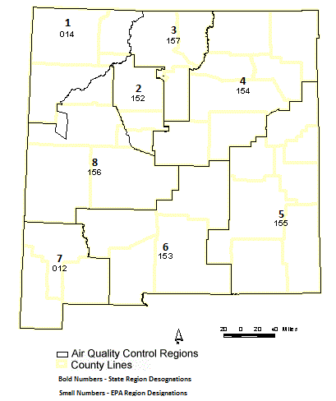

Figure 1

The Bureau’s air monitoring network for 2021 consists of the sites and monitors listed in Network Elements Spreadsheet. All site changes (if any) which have occurred or planned to take place in 2021 are included along with any network modifications for 2020. Figure - 1 above is an overview of the state’s and EPA’s designation of Air Quality Control Regions (AQCR’s). Figure - 2 on the next page depicts AQB’s current monitoring network and shows the locations of monitoring sites as of 2021. The number of monitoring locations operated by the State remained unchanged throughout the 20 sites.
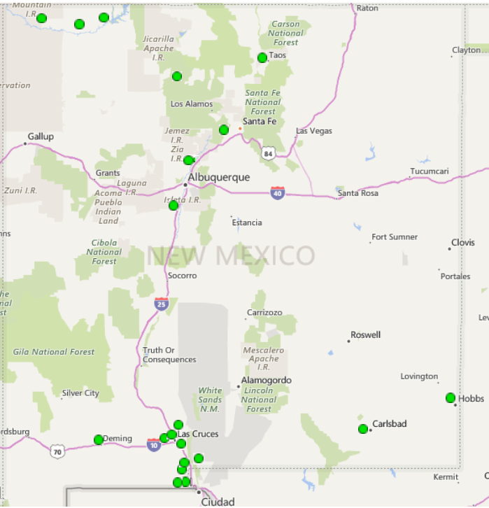
Monitoring Network Locations
Figure 2

Population of Metropolitan Statistical Areas (MSA’s)

Albuquerque MSA | Population
Albuquerque Metro  El Paso-Las Cruces MSA  Las Cruces Metro | 918,018  Population  218,195
Farmington MSA  Farmington Metro | Population  123,958
Santa Fe MSA | Population
Santa Fe Metro | 150,358
Carlsbad-Artesia & Hobbs µSA  Carlsbad-Artesia  Hobbs | Population  58,460  71,070
Taos µSA  Taos Micro Area  *NMED has no air monitoring stations in Bernalillo county due to the City of Albuquerque having its own monitoring group which covers the county.  Above population statistics based on US Census Bureau 2019 data. | Population  32,723

Based on the most current population NMED’s Air Quality Bureau meets the air monitoring network requirements set forth in 40 CFR Part 58 Appendices A through E.

2.1 Nitrogen Dioxide (NO₂)
The Bureau operates seven air monitoring sites in the network for Nitrogen Dioxide. Three in AQCR-1 which are in San Juan County, two in AQCR-5, one being in Eddy County and the second in Lea County and two in AQCR-6 both of which operate in Doña Ana County.

Nitrogen Dioxide (NO₂) Air Quality Control Region 1 (EPA Region 014)
The Bureau operates three air monitoring sites in AQCR-1 for Nitrogen Dioxide which are in San Juan County consisting of the Substation, Bloomfield, and Navajo Lake sites. Figure 3 indicates the location of the monitoring sites.
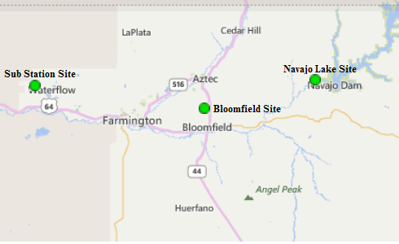

Figure 3

Substation Site AQS #: 35-045-1005:
Substation NO₂ Parameter 42602, Method 074, POC 2
The Bureau continues to operate the NO₂ monitor at the Substation air monitoring site. There were no changes implemented in 2021.

Bloomfield Site AQS #:35-045-0009:
Bloomfield NO₂ Parameter 42602, Method 074, POC 1
The Bureau continues to operate the NO₂ monitor at the Bloomfield air monitoring site. There were no changes implemented in 2021.

Navajo Lake Site AQS# 35-045-0018:
Navajo Lake NO₂ Parameter 42602, Method 074, POC 1
The Bureau continues to operate the NO₂ monitor at the Navajo Lake air monitoring site. There were no changes implemented in 2021.

Nitrogen Dioxide (NO₂) Air Quality Control Region 5 (EPA Region 155)
The Bureau operates two air monitoring sites in AQCR-5, located in Eddy County, and Lea County consisting of the Carlsbad and Hobbs sites. Figure 4 indicates the location of the monitoring sites.
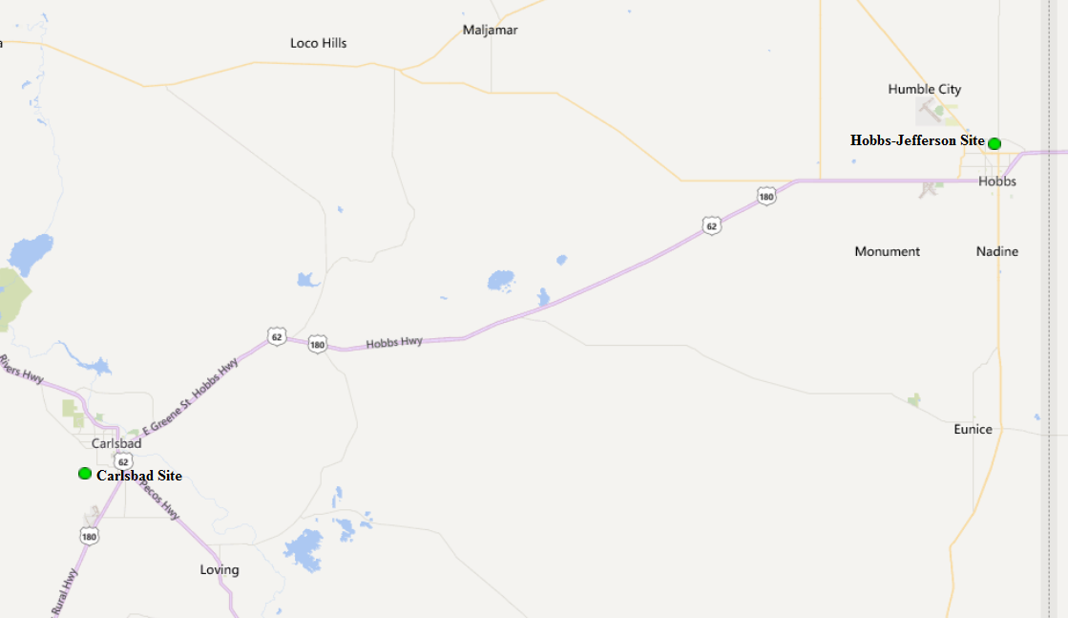

Figure 4

Carlsbad AQS #: 35-015-1005:
Carlsbad NO₂ Parameter 42602, Method 074, POC 1
The Bureau continues to operate the NO₂ monitor at the Carlsbad air monitoring site. There were no changes implemented in 2021.

Hobbs Jefferson AQS #: 35-025-0008:
Hobbs NO₂ Parameter 42602, Method 074, POC 1
The Bureau continues to operate the NO₂ monitor at the Hobbs air monitoring site. There were no changes implemented in 2021.

Nitrogen Dioxide (NO₂) Air Quality Control Region 6 (EPA Region 153)
The Bureau operates nine air monitoring sites in AQCR-6, located in Doña Ana County. Two of the nine monitoring sites, Desert View and Santa Teresa monitor for NO₂. Figure 5 indicates the location of the monitoring sites.

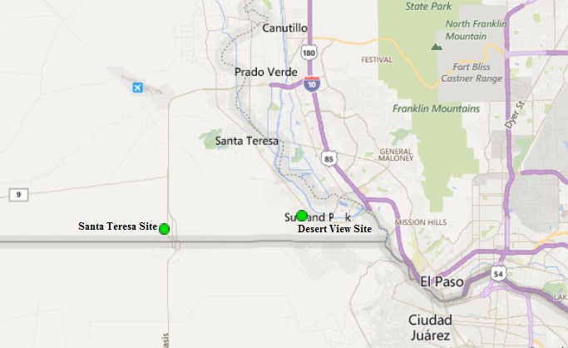

Figure 5

Desert View AQS #: 35-013-0021:
Desert View NO₂ Parameter 42602, Method 074, POC 1
The Bureau continues to operate the NO₂ monitor at the Desert View air monitoring site. There were no changes implemented in 2021.

Santa Teresa AQS #: 35-013-0022:
Santa Teresa NO₂ Parameter 42602, Method 074, POC 1
The Bureau continues to operate the NO₂ monitor at the Santa Teresa air monitoring site. There were no changes implemented in 2021.

2.2 Ozone (O₃)

The Bureau is continuing the operation of fourteen air monitoring sites in the network for Ozone, seven in northern New Mexico and seven in southern New Mexico. In the northern half of the state there are three sites in AQCR-1 which are in San Juan County, two sites in AQCR-2, one being in Sandoval County and the second in Valencia County, and two sites in AQCR-3, one in Santa Fe County and the second in Rio Arriba County. In the southern half of the state, there are two sites in AQCR-5, one in Lea County and the second in Eddy County and five sites in AQCR-6 which are in Doña Ana County. Figure 6 indicates the location of the northern monitoring sites and Figure 7 indicates the location of the southern monitoring sites.

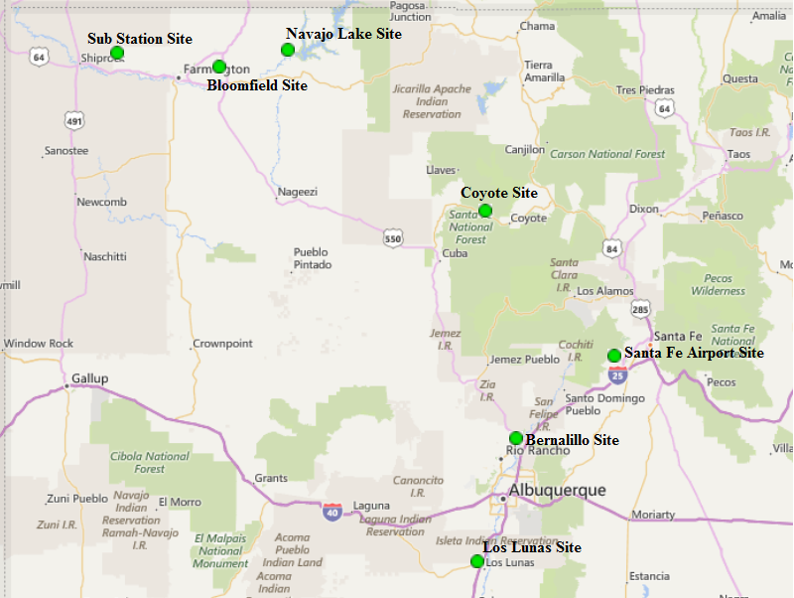

Figure 6

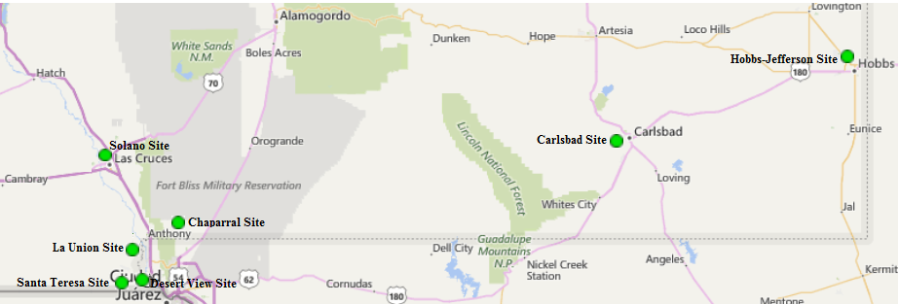

Figure 7

Ozone (O₃) Air Quality Control Region 1 (EPA Region 014)
The Bureau operates three air monitoring sites in AQCR-1 for Ozone which are in San Juan County consisting of the Substation, Bloomfield, and Navajo Lake sites. Figure 8 indicates the location of the monitoring sites.

Figure 8

Substation Site AQS #: 35-045-1005:
Substation O₃ Parameter 44201, Method 047, POC 1
The Bureau continues to operate the O₃ monitor at the Substation air monitoring site. There were no changes implemented in 2021.

Bloomfield Site AQS #:35-045-0009:
Bloomfield O₃ Parameter 44201, Method 047, POC 1
The Bureau continues to operate the O₃ monitor at the Bloomfield air monitoring site. There were no changes implemented in 2021.

Navajo Lake Site AQS# 35-045-0018:
Navajo Lake O₃ Parameter 44201, Method 047, POC 1
The Bureau continues to operate the O₃ monitor at the Navajo Lake air monitoring site. There were no changes implemented in 2021.

Ozone (O₃) Air Quality Control Region 2 (EPA Region 152)
The Bureau operates two ozone air monitoring sites in AQCR-2, one located in Sandoval County, and the second in Valencia County consisting of the Bernalillo and Los Lunas sites respectively. Figure 9 indicates the location of the Bernalillo and Los Lunas sites.

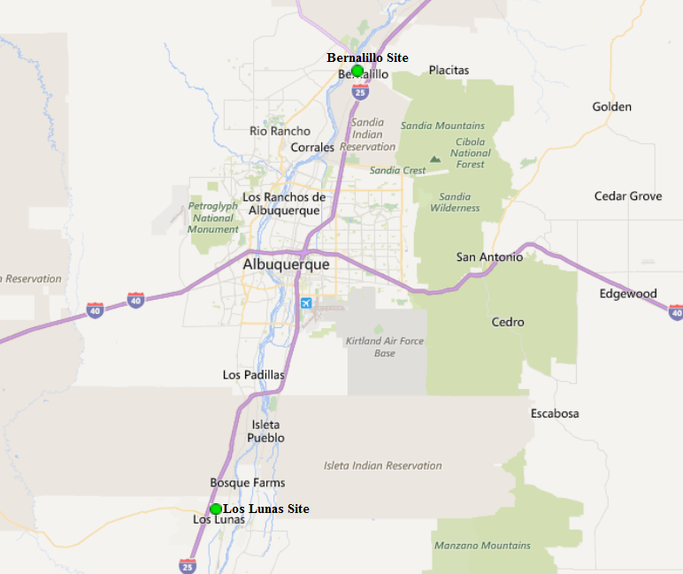

Figure 9

Bernalillo (DOT Yard) Site AQS#: 35-043-1001:
Bernalillo O₃ Parameter 44201, Method 047, POC 1
The Bureau continues to operate the Ozone monitor at the Bernalillo air monitoring site. EPA Region-VI has noted that this site is not required due to the City of Albuquerque (COA) currently operating more than the required Ozone sites for the Albuquerque MSA. However, NMED had requested to continue operating the O₃ monitor at Bernalillo and provided an explanation for continuing ozone monitoring in the 2015 Five-Year Network Assessment. NMED will continue collaborating with EPA Region-VI on appropriateness of continuing operating the Bernalillo site. No changes occurred in 2021.

Los Lunas AQS #: 35-061-0008:
Los Lunas O₃ Parameter 44201, Method 047, POC 1
The Bureau continues to operate the Ozone monitor at the Los Lunas air monitoring site. There were no changes implemented in 2021.

Ozone (O₃) Air Quality Control Region 3 (EPA Region 157)
The Bureau operates two ozone air monitoring sites in AQCR-3 located in Santa Fe County and Rio Arriba County consisting of the Santa Fe Airport and Coyote Ranger District sites. Figure 10 indicates the location of the two sites.

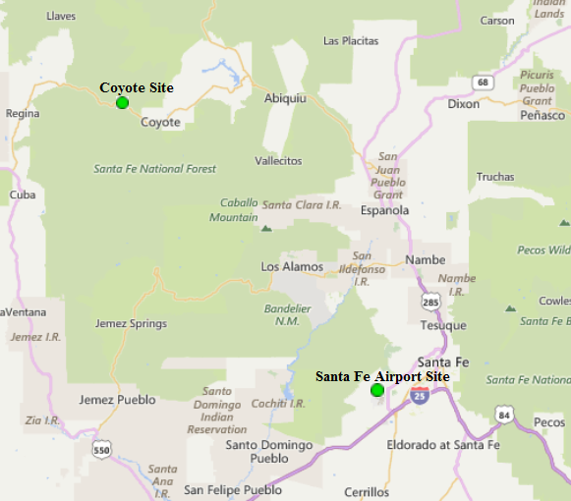

Figure 10

Santa Fe Airport AQS #: 35-049-0021:
Santa Fe Airport O₃ Parameter 44201, Method 047, POC 1
The Bureau continues to operate the Ozone monitor at the Santa Fe Airport air monitoring site. There were no changes implemented in 2021.

Coyote Ranger District AQS #: 35-039-0026:
Coyote Ranger District O₃ Parameter 44201, Method 047, POC 1
The Bureau continues to operate the Ozone monitor at the Coyote Ranger District air monitoring site. There were no changes implemented in 2021.

Ozone (O₃) Air Quality Control Region 5 (EPA Region 155)
The Bureau operates two ozone air monitoring sites in AQCR-5, located in Eddy County, and Lea County consisting of the Carlsbad and Hobbs sites. Figure 11 indicates the location of the two sites.

Figure 11

Carlsbad AQS #: 35-015-1005:
Carlsbad O₃ Parameter 44201, Method 047, POC 1
The Bureau continues to operate the Ozone monitor at the Carlsbad air monitoring site. There were no changes implemented in 2021.

Hobbs Jefferson AQS #: 35-025-0008:
Hobbs Jefferson O₃ Parameter 44201, Method 047, POC 1
The Bureau continues to operate the Ozone monitor at the Hobbs air monitoring site. There were no changes implemented in 2021.

Ozone (O₃) Air Quality Control Region 6 (EPA Region 153)
The Bureau operates a total of eight air monitoring sites in AQCR-6. Five of those sites monitor for ozone consisting of the Chaparral, Desert View, La Union, Santa Teresa, and Solano sites. Figure 12 indicates the location of the ozone monitoring sites.

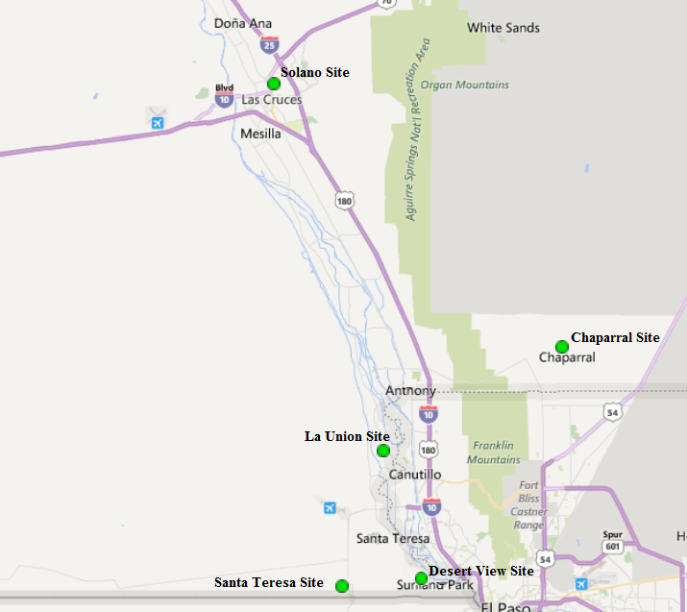

Figure 12

Chaparral AQS #: 35-013-0020:
Chaparral O₃ Parameter 44201, Method 047, POC 1
The Bureau continues to operate the Ozone monitor at the Chaparral air monitoring site. There were no changes implemented in 2021.

Desert View AQS #: 35-013-0021:
Desert View O₃ Parameter 44201, Method 047, POC 1
The Bureau continues to operate the Ozone monitor at the Desert View air monitoring site. There were no changes implemented in 2021.

La Union AQS #: 35-013-0008:
La Union O₃ Parameter 44201, Method 047, POC 2
The Bureau continues operating the Ozone monitor at La Union, there were no changes implemented in 2021.

Santa Teresa AQS #: 35-013-0022:
Santa Teresa O₃ Parameter 44201, Method 047, POC 1
The Bureau continues to operate the Ozone monitor at Santa Teresa, there were no changes implemented in 2021.

Solano Road AQS #: 35-013-0023:
Solano Road O₃ Parameter 44201, Method 047, POC 1
The Bureau continues operating the Ozone monitor at Solano Road, there were no changes implemented in 2021.

2.3 Sulfur Dioxide (SO₂)
The Bureau operates two air monitoring sites in the network for Sulfur Dioxide. Both sites are in the northern half of the state in AQCR-1 which is in San Juan County consisting of the Sub Station and Bloomfield air monitoring sites. Figure 13 below indicates the location of the SO₂ monitoring sites.
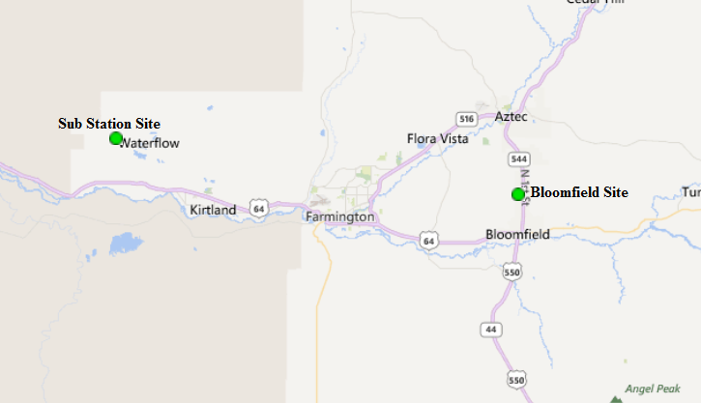

Figure 13

Sulfur Dioxide (SO₂) Air Quality Control Region 1 (EPA Region 014)

Substation SO₂ AQS #:35-045-1005
Substation SO₂ Parameter 42401, Method 060, POC 1 & Method 009, POC 3
The Bureau continues to operate the SO₂ monitor at the Substation air monitoring site, there were no changes implemented in 2021.

Bloomfield SO₂ AQS #:35-045-0009
Bloomfield SO₂ Parameter 42401, Method 060, POC 1 & Method 009, POC 3
The Bureau continues to operate the SO₂ monitor at the Bloomfield air monitoring site, there were no changes implemented in 2021.

2.4 Particulate Matter PM_{2.5} Non-Continuous Federal Reference Method (FRM)
The Bureau currently operates three Method 145 PM_{2.5} FRM Partisol samplers within the air monitoring network, all three are in Doña Ana County which is AQCR-6. The Desert View monitoring site is the designated co-location site for the FRM 145 samplers operating in the network. Figure 14 below indicates the location of the non-continuous FRM PM_{2.5} monitoring sites.

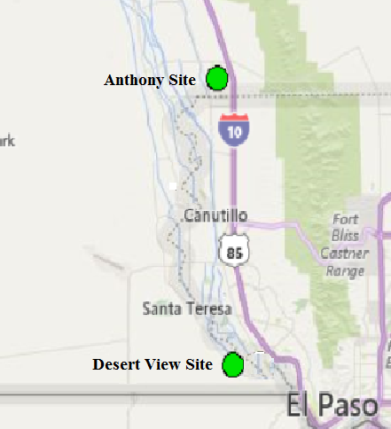

Figure 14

Particulate Matter PM_{2.5} (FRM) Air Quality Control Region 6 (EPA Region 153)

Desert View AQS #: 35-013-0021:
Desert View PM_{2.5} FRM (Primary) Parameter 88101, Method 145, POC 2
Desert View PM_{2.5} FRM (Co-Located) Parameter 88101, Method 145, POC 3
The Desert View site is designated as the bureau’s co-location site using the Thermo 2025i series Partisol PM_{2.5} samplers. In 2018, this site was chosen for co-location due to the area experiencing residential and commercial development nearby in Santa Teresa and on the Mexican side along the US/Mexican border which is just one mile south of the Desert View site. There were no changes implemented in 2021.

Anthony AQS#: 35-013-0016:
Anthony PM_{2.5} FRM Parameter 88101, Method 145, POC 2
The Bureau continues operating a co-located Partisol 2025i FRM PM_{2.5} sampler at the Anthony air monitoring site with the BAM-1020 FEM PM_{2.5} to meet requirements of 40 CFR Part 58 App. A.

2.5 Particulate Matter PM_{2.5} Continuous (BAM-1020 Sampler)

The Bureau currently operates six Method 170 BAM-1020 PM_{2.5} samplers within the air monitoring network designated as SLAMS. Three of the six samplers are in southern New Mexico’s Doña Ana County at the Anthony, Santa Teresa and Las Cruces Office sites. The fourth is in Lea County at the Hobbs monitoring site. The remaining two samplers are in northern New Mexico with the fifth at the Santa Fe Airport monitoring site and the sixth at the Taos monitoring site. Figure 15 indicates the location of the Santa Fe Airport and Taos monitoring sites and Figure 16 indicates the Anthony, Las Cruces Office and Hobbs monitoring sites.

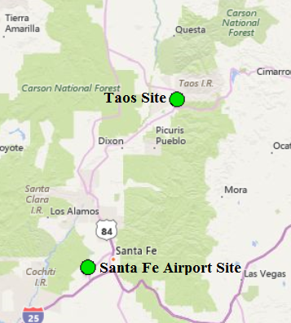

Figure 15

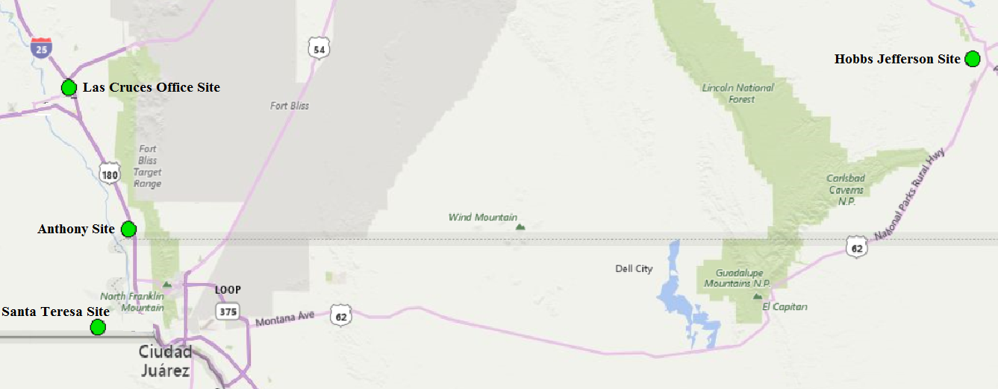

Figure 16

Air Quality Control Region 3 (EPA Region 157)

Santa Fe Airport AQS #: 35-049-0021:
Santa Fe Airport PM_{2.5} Continuous Parameter 88101, Method 170, POC 1
The Bureau continues to operate the Met-One BAM-1020 PM_{2.5} sampler, there were no changes implemented in 2021.

Taos AQS #: 35-055-0005:
Taos PM_{2.5} Continuous Parameter 88101, Method 170, POC 1
The Bureau continues to operate the Met-One BAM-1020 PM_{2.5} sampler. there were no changes implemented in 2021.

Air Quality Control Region 5 (EPA Region 155)

Hobbs Jefferson AQS#: 35-025-0008:
Hobbs Jefferson PM_{2.5} Continuous Parameter 88101, Method 170, POC 2
The Bureau continues to operate the Met-One BAM-1020 PM_{2.5} sampler. there were no changes implemented in 2021.

Air Quality Control Region 6 (EPA Region 153)

Anthony AQS #: 35-013-0016:
Anthony PM_{2.5} Continuous Parameter 88101, Method 170, POC 1
The Bureau continues to operate the Met-One BAM-1020 PM_{2.5} sampler. The Anthony site is the designated co-location site for the FEM Method 170 samplers operating in the network, there were no changes implemented in 2021.

Las Cruces Office AQS #: 35-013-0025:
Las Cruces PM_{2.5} Continuous Parameter 88101, Method 170, POC 2
The Bureau continues to operate the Met-One BAM-1020 PM_{2.5} sampler and is the Bureau’s Regional Transport particulate site, there were no changes implemented in 2021.

Santa Teresa AQS #: 35-013-0022:
Santa Teresa PM_{2.5} Continuous Parameter 88101, Method 170, POC 1
The Bureau continues to operate the Met-One BAM-1020 PM_{2.5} sampler. there were no changes implemented in 2021.

2.6 Particulate Matter PM₁₀ Non-Continuous Federal Reference Method (FRM)
The Bureau operates one non-continuous Thermo Partisol 2025i FRM sampler in the monitoring network as the primary for PM₁₀ particulate matter. The sampler meets the EPA requirement set forth in 40CFR Part58 Appendix D based on population category and concentration of particulate matter 10 microns or less in aerodynamic diameter (PM₁₀). This sampler is currently located at the Anthony air monitoring site which also contains a Met-One BAM-1020 PM₁₀ continuous sampler as the assigned co-located sampler for the PM₁₀ FRM sampler per EPA requirements.

Air Quality Control Region 6 (EPA Region 153)
Anthony PM₁₀ FRM Parameter 81102, Method 127, POC 1
The Bureau continues to operate the Partisol 2025i non-continuous sampler as the designated primary sampler for PM₁₀ particulate matter. Figure 17 indicates the location of the PM₁₀ monitoring site, there were no changes implemented in 2021.

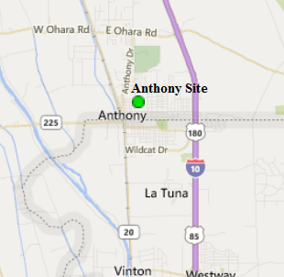

Figure 17

2.7 Particulate Matter PM₁₀ Continuous (BAM Sampler)
The Bureau operates seven Method 122 BAM-1020 PM₁₀ continuous samplers throughout the monitoring network. Figure 18 indicates the location of the northern New Mexico monitoring site where one of the seven BAM-1020 PM₁₀ samplers in the network is operating as a SLAMS monitor. Six of the seven BAM-1020 PM₁₀ continuous samplers are located and operating in the Bureau’s southern network as SLAMS monitors. Figure 19 indicates the locations of the six BAM-1020 PM₁₀ samplers in the southern network.

PM₁₀ Air Quality Control Region 1 (EPA Region 014)

Sub Station Site AQS #:35-045-1005:
Sub Station PM₁₀ Continuous Parameter 81102, Method 122, POC 2
The Bureau continues to operate a Met-One BAM-1020 FEM PM₁₀ sampler as a Special Purpose Monitor (SPM) to obtain representative sampling of PM₁₀ for San Juan County, there were no changes implemented in 2021.

Figure18

PM₁₀ Air Quality Control Region 6 (EPA Region 153)

Anthony AQS #: 35-013-0016:
Anthony PM₁₀ Continuous Parameter 81102, Method 122, POC 2
The Bureau continues to operate the Met-One BAM-1020 FEM PM₁₀ continuous sampler, there were no changes implemented in 2021.

Chaparral AQS #: 35-013-0020:
Chaparral PM₁₀ Continuous Parameter 81102, Method 122, POC 2
The Bureau continues to operate the Met-One BAM-1020 FEM PM₁₀ continuous sampler, there were no changes implemented in 2021.

Desert View AQS #: 35-013-0021:
Desert View PM₁₀ Continuous Parameter 81102, Method 122, POC 2
The Bureau continues to operate the Met-One BAM-1020 FEM PM₁₀ continuous sampler, there were no changes implemented in 2021.

Holman Road AQS #: 35-013-0019:
Holman Road PM₁₀ Continuous Parameter 81102, Method 122, POC 2
The Bureau continues to operate the Met-One BAM-1020 FEM PM₁₀ continuous sampler, there were no changes implemented in 2021.

West Mesa AQS #: 35-013-0024:
West Mesa PM₁₀ Continuous Parameter 81102, Method 122, POC 2
The Bureau continues to operate the Met-One BAM-1020 FEM PM₁₀ continuous sampler, there were no changes implemented in 2021.

PM₁₀ Air Quality Control Region 7 (EPA Region 012)

Deming Airport AQS #: 35-029-0003:
Deming Airport PM₁₀ Continuous Parameter 81102, Method 122, POC 2
The Bureau continues to operate the Met-One BAM-1020 FEM PM₁₀ continuous sampler, there were no changes implemented in 2021.

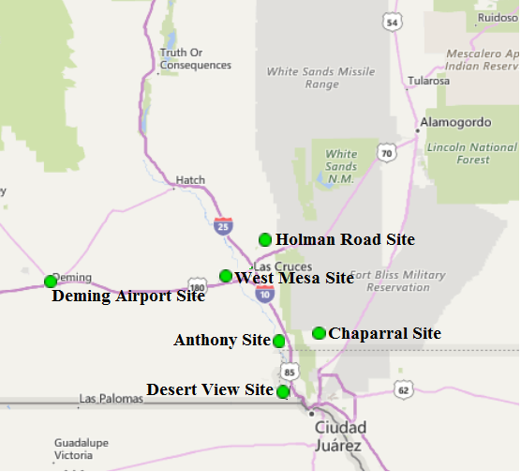

Figure 19

3.0 Other Projects

There are two other projects continuing in New Mexico and are supported by NMED/AQB staff.

- Northern air monitoring staff continue with the NADP-sponsored project to collect passive ammonia monitoring data in San Juan County, New Mexico. This project will continue if federal funds are available. Ammonia is a precursor of fine particulate matter which adversely affects public health and visibility. This continued study will augment the baseline data collected in 2007 to assess any significant changes in ambient ammonia levels.

- NMED-AQB recently obtained approval from EPA on the request to operate a special purpose monitor (SPM) at the Anthony air monitoring site (AQS number 35-013-0016) as there have been issues with the Coefficient of Variation values exceeding prescribed tolerance limits. The bureau will be installing a Met One Instruments E-Sequential FRM PM₁₀ sampler in determining if CV values improve. If CV values improve significantly, the bureau will proceed with requesting funds for purchasing a Met One sampler.

- EPA Region-VI has requested NMED assistance on a collaborative two-year research study anticipated to take place over 2020-2021. However, due to the COVID-19 pandemic the study has yet to commence, but EPA has indicated they intend to start the study in early spring 2021. The purpose of the study is to demonstrate the utility of several next-generation emissions measurement (NGEM) technologies near an oil and gas shale play in the Permian Basin in southeastern New Mexico. These NGEM tools will be evaluated according to their ability to improve detection of fugitive emissions of volatile organic compounds (VOCs) from unanticipated industrial processes that may be contributing to air quality in New Mexico’s control region 5.

4.0 Summary

The intention of the Bureau is to continue to focus on pollutants of concern while also striving to continue to serve the public health needs and to satisfy the expectations of the New Mexico communities. The Bureau will inform EPA Region VI staff early in the process of any plans to make changes or modifications to the ambient air monitoring network, other than those described in this review, to ensure that state and federal priorities continue to be aligned.

4.1 Network Modifications During FY2021

During Fiscal Year 2021 which occurred from July 1, 2020 through June 30, 2021 the Bureau has begun to replace the aging gaseous monitors within the network. Replacement of the monitors are being performed in phases to establish proper communications between the site calibrator and Data Acquisition System, but also to adhere to CO-VID-19 travel and social distance restrictions. Additionally, this will allow time for site operators to learn the operation of the instrumentation and determine if there are any manufacturer discrepancies that may need to be addressed. It’s anticipated that the replacement of the gaseous monitors will be completed by the end of the State’s 2022 fiscal year.

4.2 Pending System Modifications
None.

5.0 Addressing New Monitoring Requirements in Monitoring Network

5.1 Lead (Pb)

Two federal criteria have been set up for Pb monitoring:

• Source-oriented – For sources over 0.5 Tons per year.
• “Non-source”-oriented in every urban area with NCore monitoring sites, that have a population of 500,000 or more.

As stated in previous annual network reviews, based on these criteria, no Pb monitors are required in regions under NMED/AQB jurisdiction.

5.2 Nitrogen Dioxide

Two federal criteria have been set up for NO₂ monitoring:
• Near-road NO₂ monitoring; 1 micro-scale site would be required in Core Based Statistical Areas (CBSA) ≥ 1 million in population at a location of expected highest hourly NO₂ concentrations sited near a major road with high Annual Average Daily Traffic (AADT) counts.
• Community-wide; required in CBSAs ≥ 1 million in population at a location of expected highest NO₂ concentrations representing neighborhood or larger (urban) spatial scale.

Based on these criteria, no new NO₂ monitors are required in the state’s air quality control regions under NMED/AQB jurisdiction.

5.3 Sulfur Dioxide

Two federal criteria have been set up for SO₂ monitoring:

• Based on population per CBSA and amount of SO₂ emissions within that CBSA, that is, the Population Weighed Emissions Index (PWEI) and
• Based on individual state contribution to national SO₂ inventory in the 2005 National Emissions Inventory (NEI).

Based on the PWEI criteria, NMED/AQB would not need to deploy any new monitors. Based on the 2005 NEI criteria, NMED/AQB would need one monitor. This requirement is already being complied with by virtue of the Substation site.

SO₂ Data Requirements Rule
Per EPA Requirement that by July 1, 2016, each air agency was required to identify, for each source area on the list, the approach it will use to characterize air quality to help characterize sources listed as 2,000 tpy or larger, air agencies were to indicate by July 1, 2016 one of the three options to use which were:

Option 1: Ambient air monitoring for a source
Option 2: Air quality modeling for a source
Option 3: Federally enforceable emissions limits applicable to sources less than 2,000 tpy

NMED chose the second option, but this requires operating both SO₂ monitors in the network (1H Sub Station site and the 1ZB Bloomfield site) in order to provide data for modeling. The most recent report shows that our only source of concern, the San Juan Generating Station, has reduced its SO₂ emissions since the December 2017 shut-down of the two boiler units. The modeling data also indicates that SO₂ emissions have reduced.

5.4 Ozone
During FY2020, several New Mexico ozone monitoring sites exceeded the 8-hour standard. This is mostly due to hot and dry conditions exhibited during the summer months, typically June through mid-September in which most exceedances occurred. However, the Carlsbad area high ozone concentrations can be attributed to increased Oil and Gas production which started at the end of 2016. As of late, ozone concentrations have been lower than last year for the same period of time beginning in March. It is presumed that this is related to cooler conditions this year than last year, rather than due to the COVID-19 pandemic and the stay-at-home mandates by the Governor of New Mexico.

The chart below is provided by EPA which tracks the number of ozone exceedances throughout the five Region-6 states. Typically, the October EPA chart is the end of the ozone season which indicates the total number of exceedances that occurred between April 1st through mid-October as well as the number of Air Quality Index Category Totals.

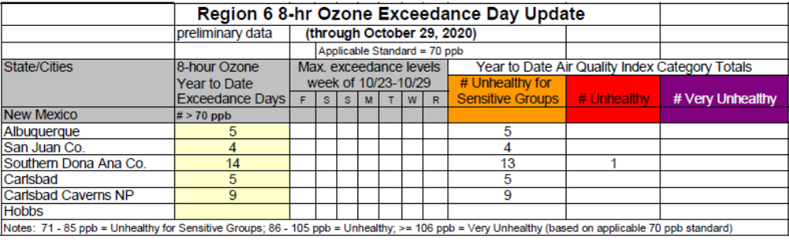 The chart below, also provided by EPA, provides the running 3-year Ozone Design Values for all NMED-AQB monitoring sites that measure ozone. This assists state environmental agencies in determining if the monitoring area is in attainment or non-attainment of the ozone standard and necessary courses of action that need to be implemented to achieve attainment.

Current EPA 3-Year Ozone Design Values 2017 through 2019

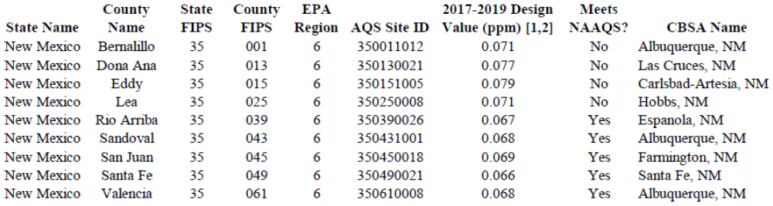

6.0 Other Issues
Position Vacancies:
At present the NMED-AQB Monitoring Section has all eight positions filled. This consists of five Environmental Scientist & Specialist - Operational staff, two Environmental Scientist & Specialist - Supervisor staff members, and one Staff Manager.

A draft of this document was made available to the public April 9th through May 9th, 2021 which was posted on our web page at http://www.env.nm.gov/air-quality/. NMED did not receive any public comments.

Roman Szkoda
Monitoring Program Manager
New Mexico Environment Department
Air Quality Bureau
525 Camino de los Marquez, Suite 1
Santa Fe, New Mexico 87505
roman.szkoda@state.nm.us


