

Air Quality Bureau
2025 Annual Network Review

Table of Contents

Introduction, Public Review and Comment 3

Section 1.0 Overview 3
Site Designation Coding 3
Air Monitoring Network 4
Air Quality Data 4
Overview of Monitored Parameters 4
Monitoring Methodology 5

Section 2.0 - Network Review by Pollutant and Respective Air Quality Control Regions 6
2.1 Nitrogen Dioxide (NO₂) 8
NO₂ - Air Quality Control Region 1 8
NO₂ - Air Quality Control Region 5 9
NO₂ - Air Quality Control Region 6 10
2.2 Ozone (O₃) 11
O₃ - Air Quality Control Region 1 12
O₃ - Air Quality Control Region 2 13
O₃ - Air Quality Control Region 3 14
O₃ - Air Quality Control Region 5 15
O₃ - Air Quality Control Region 6 16
2.3 Sulfur Dioxide (SO₂) 18
2.4 Particulate Matter PM_{2.5} Non-Continuous - Federal Reference Method (FRM) 18
PM_{2.5} - Air Quality Control Region 6 19
2.5 Particulate Matter PM_{2.5} Continuous (BAM) 20
PM_{2.5} - Air Quality Control Region 3 21
PM_{2.5} - Air Quality Control Region 5 21
PM_{2.5} - Air Quality Control Region 6 21
2.6 Particulate Matter PM₁₀ Non-Continuous – Federal Reference Method (FRM) 22
PM₁₀ - Air Quality Control Region 6 22
2.7 Particulate Matter PM₁₀ Continuous (BAM) 22
PM₁₀ - Air Quality Control Region 1 23
PM₁₀ - Air Quality Control Region 6 23
PM₁₀ - Air Quality Control Region 7 24

Section 3.0 - Other Projects 25

Section 4.0 - Summary 25
4.1 Network Modifications During FY2025 26
4.2 Pending/Completed Network Modifications During FY2025 26

Section 5.0 - Addressing New Monitoring Requirements in Monitoring Network 27
5.1 Lead 27
5.2 Nitrogen Dioxide 27
5.3 Sulfur Dioxide 27
5.4 Ozone 31

Section 6.0 - Environmental Justice Concerns 32

Section 7.0 - Other Issues 36

List of Figures

Figure 1 – New Mexico Air Quality Control Regions 6
Figure 2 – Monitoring Network Locations 7
Figure 3 – Air Quality Control Region 1 NO₂ Monitoring Locations 9
Figure 4 – Air Quality Control Region 5 NO₂ Monitoring Locations 10
Figure 5 – Air Quality Control Region 6 NO₂ Monitoring Locations 11
Figure 6 – Northern New Mexico Ozone Monitoring Locations 12
Figure 7 – Southern New Mexico Ozone Monitoring Locations 12
Figure 8 – Air Quality Control Region 1 Ozone Monitoring Locations 13
Figure 9 – Air Quality Control Region 2 Ozone Monitoring Locations 14
Figure 10 – Air Quality Control Region 3 Ozone Monitoring Locations 15
Figure 11 – Air Quality Control Region 5 Ozone Monitoring Locations 16
Figure 12 – Air Quality Control Region 6 Ozone Monitoring Locations 17
Figure 13 – Air Quality Control Region 1 SO₂ Monitoring Locations 18
Figure 14 – Air Quality Control Region 6 PM_{2.5} FRM Monitoring Locations 19
Figure 15 – Air Quality Control Region 3 PM_{2.5} Continuous (BAM) Monitoring Locations 20
Figure 16 – Air Quality Control Region 5 & 6 PM_{2.5} Continuous (BAM) Monitoring Locations 20
Figure 17 – Air Quality Control Region 6 PM₁₀ FRM Monitoring Location 22
Figure 18 – Air Quality Control Region 1 PM₁₀ Continuous (BAM) Monitoring Location 23
Figure 19 – Air Quality Control Region 6 & 7 PM₁₀ Continuous (BAM) Monitoring Locations 24

List of Tables

Table 1 – New Mexico Monitoring Network 2025 36

2025 Network Review
Air Quality Bureau
New Mexico Environment Department
July 1, 2025

Prepared by
Roman Szkoda, Ambient Air Monitoring Program Manager

The purpose of this document is to provide information concerning the operation of the ambient air monitoring network by the New Mexico Environment Department (NMED) Air Quality Bureau (AQB) in Fiscal Year 2025 which covers the period from July 1, 2024 through June 30, 2025.

Introduction

In October 2006, the U.S. Environmental Protection Agency (EPA) issued final regulations concerning state and local agency ambient air monitoring networks. Under 40 CFR, Part 58, Subpart B, States are required to submit an annual monitoring network review to the EPA regional office in Dallas, Texas. This network plan is required to provide the framework for establishment and maintenance of an air quality surveillance system and to list any changes that are proposed to take place to the current network during the 2025 Fiscal Year. NMED must make the annual monitoring network review available for public inspection for at least 30 days prior to submission to EPA.

1.0 Overview

At the end of the state fiscal year June 30, 2025, the Bureau will continue operating the 20 criteria air pollutant monitoring sites located in 11 of the State’s 33 counties. Each air monitoring location is sited to meet the three basic monitoring objectives and at least one of the six federal criteria pollutants: nitrogen dioxide (NO₂), ozone (O₃), carbon monoxide (CO), Lead, particulate matter (PM₁₀ and PM_{2.5}), and sulfur dioxide (SO₂) for ambient air monitoring networks.

In 2024/25, the Ambient Air Monitoring Section had a full-time staff of eight personnel.

Table 1 (Network Element Worksheet) contains the listing of all NMED-AQB ambient air monitoring sites operating at the end of the state fiscal year 2025.

Site Designation Coding
The NMED-AQB’s 20 air monitoring stations each have their own state region designations identified with a numeric-alpha code and site name (e.g., 1ZB Bloomfield). The number and name represent the state’s Air Quality Control Region (AQCR) and the letter(s) identifies the site followed by the name of the site. In addition, each site has a numeric AQS (Air Quality System) identifier code which is based on EPA’s state, county and site ID (e.g., 35-045-1005) designation. The first two numbers identify the state (New Mexico is 35), the second set of three numbers refers to the county where the monitoring site is located. The third set of four numbers is the monitoring site ID number. Figure 1 on page 6 shows the state and EPA air regions. The table below is a complete listing of all 20 air monitoring sites designation code, both state and EPA throughout the network.

NMED Site Designation EPA - AQS Number Designation
1H - Sub Station 35-045-1005
1ZB - Bloomfield 35-045-0009
1NL - Navajo Lake 35-045-0018
2LL - Los Lunas 35-061-0008
2ZJ - Bernalillo 35-043-1001
3CRD - Coyote Ranger District 35-039-0026
3SFA - Santa Fe Airport 35-049-0021
3ZD - Taos 35-055-0005
5ZR - Carlsbad 35-015-1005
5ZS - Hobbs Jefferson 35-025-0008
6CM - Anthony 35-013-0016
6O - La Union 35-013-0008
6Q - Las Cruces Office 35-013-0025
6WM - West Mesa 35-013-0024
6ZL - Holman Road 35-013-0019
6ZK - Chaparral 35-013-0020
6ZM - Desert View 35-013-0021
6ZN - Santa Teresa 35-013-0022
6ZQ - Solano 35-013-0023
7E - Deming Airport 35-029-0003

Air Monitoring Network
NMED-AQB regulates air quality to protect public health and the environment in the State of New Mexico, excluding Bernalillo County. Air monitoring data are required by regulation and are used to determine compliance with U.S. EPA’s National Ambient Air Quality Standards (NAAQS). Other important uses of air monitoring data include the production of a daily Air Quality Index (AQI), daily air quality forecast report, support of short and long-term health risk assessments, identification of localized health concerns, and tracking long-term trends in air quality. New Mexico monitors four of the six NAAQS criteria pollutants: NO₂, O₃, particulate matter (PM₁₀ and PM_{2.5}), and SO₂. NMED-AQB does not monitor for CO or Lead as New Mexico due to EPA criterion monitoring for CO or Lead is not required.

Air Quality Data

Overview of Monitored Parameters – Criteria Pollutants

Nitrogen Dioxide (NO₂)
NO₂ is a highly toxic, reddish-brown gas that is created primarily from fuel combustion in industrial sources and vehicles. It creates an odorous haze that causes eye and sinus irritation, blocks natural sunlight and reduces visibility.

Ozone (O₃)
Ground-level O₃, also known as photochemical smog, is not emitted into the atmosphere as ozone, but rather is formed by the reactions of other pollutants. The primary pollutants entering this reaction, volatile organic compounds (VOCs) and oxides of nitrogen, create ozone in the presence of sunlight. Ozone is a strong irritant of the upper respiratory system and causes damage to field crops.

Sulfur Dioxide (SO₂)
SO₂ is a gaseous pollutant that is emitted primarily by industrial furnaces or power plants burning coal or oil containing sulfur. At high concentrations, breathing can be impaired. Damage to vegetation can also result. The amount of SO₂ emitted from oil and gas refinery flaring depends on the sulfur content in the flared gases. Flaring is a process used to burn combustible components, primarily hydrocarbons, from waste gases generated during industrial operations. The typical flared gases consist largely of low molecular weight hydrocarbons with high heating value, and the emissions of SO₂ can vary significantly based on the sulfur compounds present in the waste gases

Fine Particulate Matter (PM_{2.5})
Fine particulate matter with a diameter of 2.5 microns or less is created primarily from industrial processes and fuel combustion. These particles are breathed deep into the lungs. Exposure to particle pollution is linked to a variety of significant health problems ranging from aggravated asthma to premature death in people with heart and lung disease.

Particulate Matter (PM₁₀)
Particulate matter with a mean diameter of 10 microns or less is emitted from transportation and industrial sources. Exposure to particle pollution is linked to a variety of significant health problems ranging from aggravated asthma to premature death in people with heart and lung disease.

Meteorological Monitoring
NMED-AQB includes meteorological monitoring of the local area because the outcome of air pollutants is influenced by the movement and characteristics of the air mass into which they are emitted. If the air is calm and pollutants cannot disperse, then the concentration of these pollutants will build up. Conversely, if a strong and turbulent wind is blowing, the pollutant will rapidly disperse into the atmosphere and will result in lower concentrations near the pollution source. The measurements of wind speed and direction, temperature, humidity, rainfall, barometric pressure, ultraviolet radiation and solar radiation are important parameters used in the study of air quality monitoring results and to further understand the chemical reactions that occur in the atmosphere.

Monitoring Methodology
The NMED-AQB air monitoring network uses Thermo Environmental Instruments iQ-Series for all gaseous monitoring. The Model 42iQ Chemiluminescence monitor collects NO/NOx/NO₂ data, the Model 43iQ Pulsed Florescence monitor collects SO₂ data, and the Model 49iQ UV Photometric monitor collects Ozone data. For particulate matter sampling, NMED-AQB uses the Met One Instruments BAM-1020 and BAM-1022 continuous particulate matter samplers. The BAM-1020 is solely used for measuring PM₁₀ particulate matter and the BAM-1022 is used for measuring PM_{2.5} particulate matter. The BAM samplers allow for real time data as they provide particulate concentrations continuously. This also has the added benefit of letting the public know of high particulate events (via the Bureau’s web page) allowing citizens that may have respiratory health conditions to take necessary precautions.

2.0 Network Review by Pollutant and Respective Air Quality Control Regions

NMED-AQB has reviewed its current ambient air quality network and proposed changes to the network implemented during Fiscal Year 2025. Current NAAQS, data trends, siting concerns, site access concerns, and other monitoring issues all contribute to any proposed network revisions.
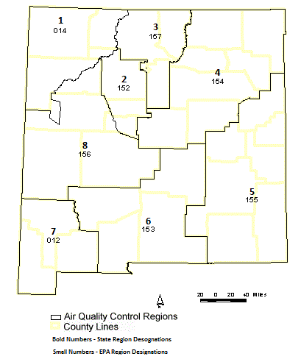

Figure 1

The Bureau’s air monitoring network for 2025 consists of the sites and monitors listed in the Network Elements Spreadsheet (Table 1 on page 41). All site changes (if any) which have occurred or are planned to take place in 2025 are included along with any network modifications for 2025. Figure – 1 above is an overview of the State’s and EPA’s designation of Air Quality Control Regions (AQCRs). Figure – 2 on the next page depicts AQB’s current monitoring network and shows the locations of monitoring sites as of 2025. The number of monitoring locations operated by the State remained unchanged throughout the fiscal year.
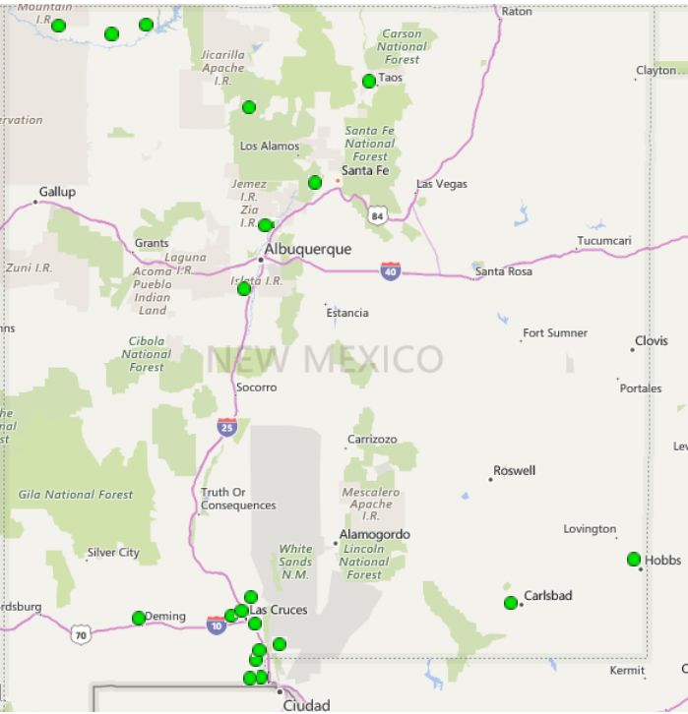
Monitoring Network Locations
Figure 2

Population of Metropolitan Statistical Areas (MSAs)

Albuquerque MSA | Population
Albuquerque Metro  El Paso-Las Cruces MSA  Las Cruces Metro | 923,518  Population  229,366
Farmington MSA  Farmington Metro | Population  120,675
Santa Fe MSA | Population
Santa Fe Metro | 157,756
Carlsbad-Artesia & Hobbs µSA  Carlsbad-Artesia  Hobbs | Population  61,436  75,151
Taos µSA  Taos Micro Area  *NMED has no air monitoring stations in Bernalillo County due to the City of Albuquerque having its own monitoring group which covers the county.  Above population statistics based on US Census Bureau 2024 data. | Population  34,482

Based on the most current population, NMED-AQB meets the air monitoring network requirements set forth in 40 CFR Part 58 Appendices A through E.

2.1 Nitrogen Dioxide (NO₂)
The Bureau operates seven air monitoring sites in the network for Nitrogen Dioxide: three in AQCR-1 which are in San Juan County; two in AQCR-5, one being in Eddy County and the second in Lea County; and two in AQCR-6 both of which operate in Doña Ana County.

Nitrogen Dioxide (NO₂) Air Quality Control Region 1 (EPA Region 014)
The Bureau operates three air monitoring sites in AQCR-1 for Nitrogen Dioxide which are in San Juan County, consisting of the Substation, Bloomfield, and Navajo Lake sites. Figure 3 indicates the location of the monitoring sites.
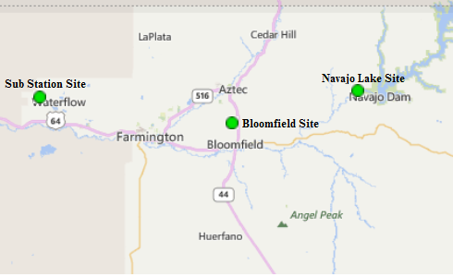

Figure 3

Substation Site AQS #: 35-045-1005:
Substation NO₂ Parameter 42602, Method 074, POC 2
The Bureau continues to operate the NO₂ monitor at the Substation air monitoring site. No changes to instrumentation occurred in FY2025.

Bloomfield Site AQS #:35-045-0009:
Bloomfield NO₂ Parameter 42602, Method 074, POC 1
The Bureau continues to operate the NO₂ monitor at the Bloomfield air monitoring site. No changes to instrumentation occurred in FY2025.

Navajo Lake Site AQS# 35-045-0018:
Navajo Lake NO₂ Parameter 42602, Method 074, POC 1
The Bureau continues to operate the NO₂ monitor at the Navajo Lake air monitoring site. No changes to instrumentation occurred in FY2025.

Nitrogen Dioxide (NO₂) Air Quality Control Region 5 (EPA Region 155)
The Bureau operates two air monitoring sites in AQCR-5, located in Eddy County, and Lea County consisting of the Carlsbad and Hobbs sites. Figure 4 indicates the location of the monitoring sites.
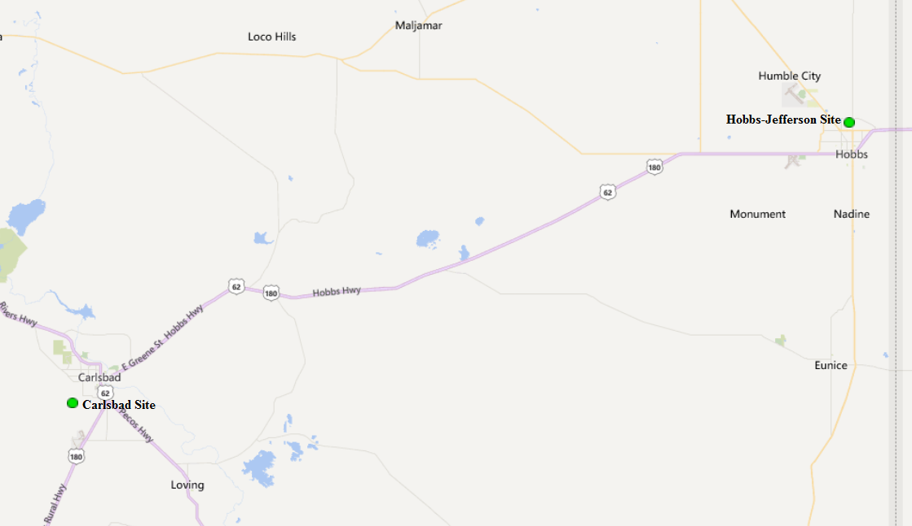

Figure 4

Carlsbad AQS #: 35-015-1005:
Carlsbad NO₂ Parameter 42602, Method 074, POC 1
The Bureau continues to operate the NO₂ monitor at the Carlsbad air monitoring site. No changes to instrumentation occurred in FY2025.

Hobbs Jefferson AQS #: 35-025-0008:
Hobbs NO₂ Parameter 42602, Method 074, POC 1
The Bureau continues to operate the NO₂ monitor at the Hobbs air monitoring site. No changes to instrumentation occurred in FY2025.

Nitrogen Dioxide (NO₂) Air Quality Control Region 6 (EPA Region 153)
The Bureau operates nine air monitoring sites in AQCR-6, located in Doña Ana County. Two of the nine monitoring sites, Desert View and Santa Teresa monitor for NO₂. Figure 5 indicates the location of the NO₂ monitoring sites.

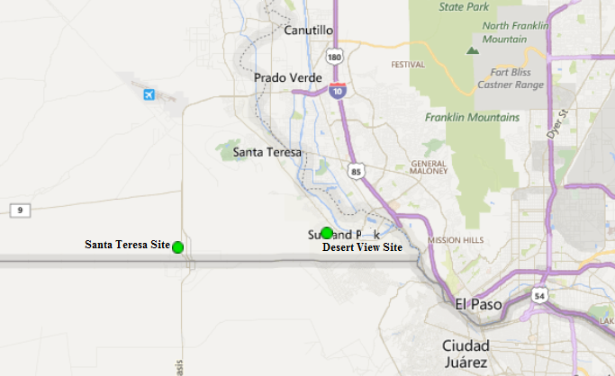

Figure 5

Desert View AQS #: 35-013-0021:
Desert View NO₂ Parameter 42602, Method 074, POC 1
The Bureau continues to operate the NO₂ monitor at the Desert View air monitoring site. No changes to instrumentation occurred in FY2025.

Santa Teresa AQS #: 35-013-0022:
Santa Teresa NO₂ Parameter 42602, Method 074, POC 1
The Bureau continues to operate the NO₂ monitor at the Santa Teresa air monitoring site. No changes to instrumentation occurred in FY2025.

2.2 Ozone (O₃)

The Bureau is continuing the operation of fourteen air monitoring sites in the network for Ozone, seven in northern New Mexico and seven in southern New Mexico. In the northern half of the state there are three sites in AQCR-1which are in San Juan County; two sites in AQCR-2, one being in Sandoval County and the second in Valencia County; and two sites in AQCR-3, one in Santa Fe County and the second in Rio Arriba County. In the southern half of the state, there are two sites in AQCR-5, one in Lea County and the second in Eddy County; and five sites in AQCR-6 which are in Doña Ana County. Figure 6 indicates the location of the northern monitoring sites and Figure 7 indicates the location of the southern monitoring sites.

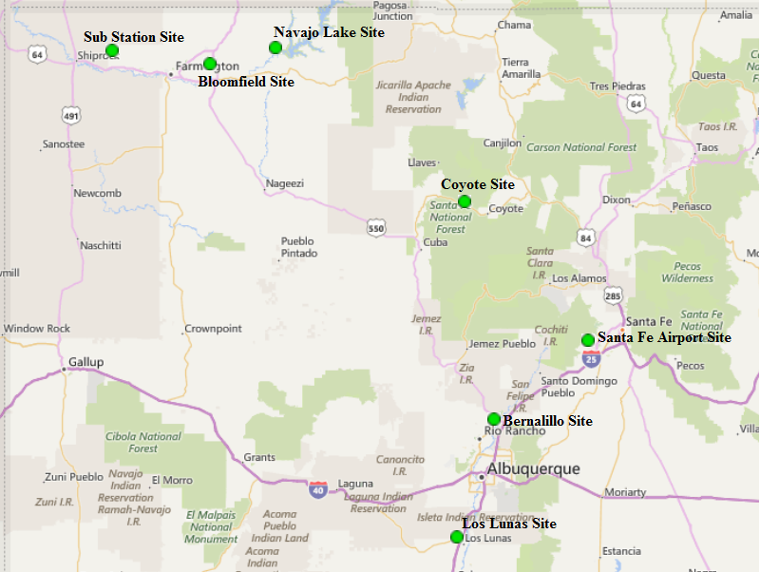

Figure 6

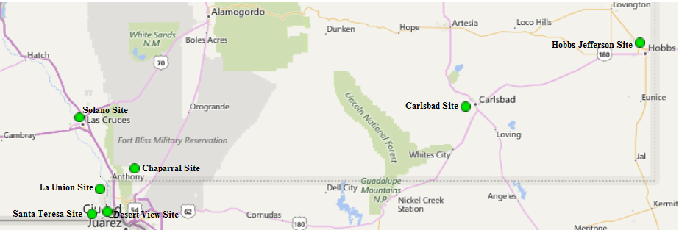

Figure 7

Ozone (O₃) Air Quality Control Region 1 (EPA Region 014)
The Bureau operates three air monitoring sites in AQCR-1 for Ozone in San Juan County, consisting of the Substation, Bloomfield, and Navajo Lake sites. Figure 8 indicates the location of the monitoring sites.

Figure 8

Substation Site AQS #: 35-045-1005:
Substation O₃ Parameter 44201, Method 047, POC 1
The Bureau continues to operate the O₃ monitor at the Substation air monitoring site. No changes to instrumentation occurred in FY2025.

Bloomfield Site AQS #:35-045-0009:
Bloomfield O₃ Parameter 44201, Method 047, POC 1
The Bureau continues to operate the O₃ monitor at the Bloomfield air monitoring site. No changes to instrumentation occurred in FY2025.

Navajo Lake Site AQS# 35-045-0018:
Navajo Lake O₃ Parameter 44201, Method 047, POC 1
The Bureau continues to operate the O₃ monitor at the Navajo Lake air monitoring site. No changes to instrumentation occurred in FY2025.

Ozone (O₃) Air Quality Control Region 2 (EPA Region 152)
The Bureau operates two ozone air monitoring sites in AQCR-2, one located in Sandoval County, and the second in Valencia County, consisting of the Bernalillo and Los Lunas sites respectively. Figure 9 indicates the location of the Bernalillo and Los Lunas sites.

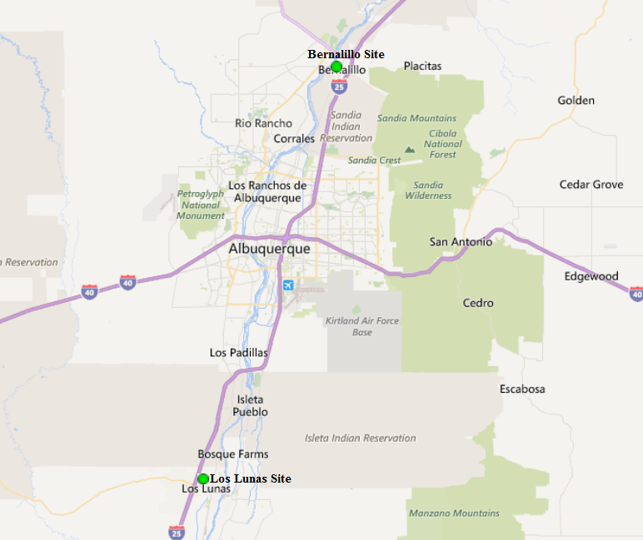

Figure 9

Bernalillo (DOT Yard) Site AQS#: 35-043-1001:
Bernalillo O₃ Parameter 44201, Method 047, POC 1
The Bureau continues to operate the Ozone monitor at the Bernalillo air monitoring site. EPA Region 6 has noted that this site is not required due to the City of Albuquerque (COA) currently operating more than the required Ozone sites for the Albuquerque MSA. However, NMED had requested to continue operating the O₃ monitor at Bernalillo and provided an explanation for continuing ozone monitoring in the 2015 Five-Year Network Assessment. NMED will continue collaborating with EPA Region 6 on appropriateness of continuing to operate the Bernalillo site. No changes to instrumentation occurred in FY2025.

Los Lunas AQS #: 35-061-0008:
Los Lunas O₃ Parameter 44201, Method 047, POC 1
The Bureau continues to operate the Ozone monitor at the Los Lunas air monitoring site. No changes to instrumentation occurred in FY2025.

Ozone (O₃) Air Quality Control Region 3 (EPA Region 157)
The Bureau operates two ozone air monitoring sites in AQCR-3 located in Santa Fe County and Rio Arriba County, consisting of the Santa Fe Airport and Coyote Ranger District sites. Figure 10 indicates the location of the two sites.

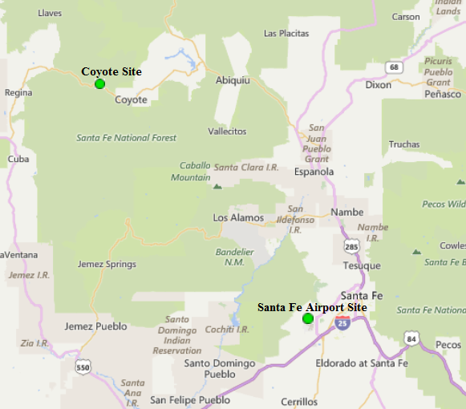

Figure 10

Santa Fe Airport AQS #: 35-049-0021:
Santa Fe Airport O₃ Parameter 44201, Method 047, POC 1
The Bureau continues to operate the Ozone monitor at the Santa Fe Airport air monitoring site. No changes to instrumentation occurred in FY2025.

Coyote Ranger District AQS #: 35-039-0026:
Coyote Ranger District O₃ Parameter 44201, Method 047, POC 1
The Bureau continues to operate the Ozone monitor at the Coyote Ranger District air monitoring site. No changes to instrumentation occurred in FY2025.

Ozone (O₃) Air Quality Control Region 5 (EPA Region 155)
The Bureau operates two ozone air monitoring sites in AQCR-5, located in Eddy County, and Lea County, consisting of the Carlsbad and Hobbs sites. Figure 11 indicates the location of the two sites.

Figure 11

Carlsbad AQS #: 35-015-1005:
Carlsbad O₃ Parameter 44201, Method 047, POC 1
The Bureau continues to operate the Ozone monitor at the Carlsbad air monitoring site. No changes to instrumentation occurred in FY2025.

Hobbs Jefferson AQS #: 35-025-0008:
Hobbs Jefferson O₃ Parameter 44201, Method 047, POC 1
The Bureau continues to operate the Ozone monitor at the Hobbs air monitoring site. No changes to instrumentation occurred in FY2025.

Ozone (O₃) Air Quality Control Region 6 (EPA Region 153)
The Bureau operates a total of eight air monitoring sites in AQCR-6. Five of those sites monitor for Ozone, consisting of the Chaparral, Desert View, La Union, Santa Teresa, and Solano sites. Figure 12 indicates the location of the ozone monitoring sites.

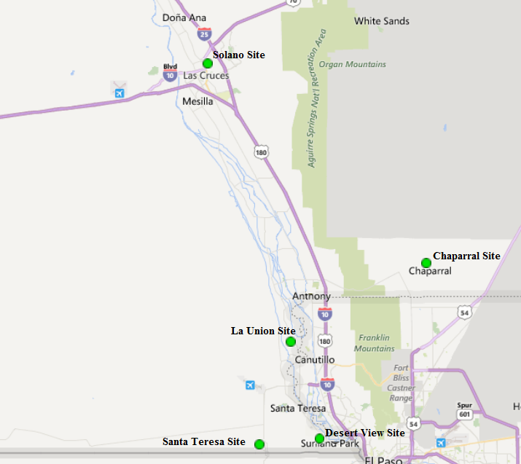

Figure 12

Chaparral AQS #: 35-013-0020:
Chaparral O₃ Parameter 44201, Method 047, POC 1
The Bureau continues to operate the Ozone monitor at the Chaparral air monitoring site. No changes to instrumentation occurred in FY2025.

Desert View AQS #: 35-013-0021:
Desert View O₃ Parameter 44201, Method 047, POC 1
The Bureau continues to operate the Ozone monitor at the Desert View air monitoring site. No changes to instrumentation occurred in FY2025.

La Union AQS #: 35-013-0008:
La Union O₃ Parameter 44201, Method 047, POC 2
The Bureau continues operating the Ozone monitor at La Union. No changes to instrumentation occurred in FY2025.

Santa Teresa AQS #: 35-013-0022:
Santa Teresa O₃ Parameter 44201, Method 047, POC 1
The Bureau continues to operate the Ozone monitor at Santa Teresa air monitoring site. No changes to instrumentation occurred in FY2025.

Solano Road AQS #: 35-013-0023:
Solano Road O₃ Parameter 44201, Method 047, POC 1
The Bureau continues operating the Ozone monitor at Solano Road. No changes to instrumentation occurred in FY2025.

2.3 Sulfur Dioxide (SO₂)
The Bureau discontinued operating the two SO₂ analyzers in the air monitoring network. The analyzers were discontinued on December 22, 2023, due to SO₂ concentrations well below the NAAQS standard of 75ppb. Both sites are in the northern half of the state in AQCR-1 in San Juan County, consisting of the Sub Station and Bloomfield air monitoring sites. Figure 13 below indicates the location of the discontinued SO₂ monitoring sites.
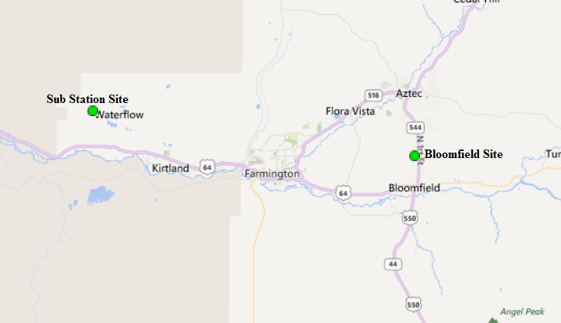

Figure 13

2.4 Particulate Matter PM_{2.5} Non-Continuous Federal Reference Method (FRM)
The Bureau discontinued operating the three Method 145 PM_{2.5} FRM Partisol samplers within the air monitoring network; all three samplers were operating in Doña Ana County, AQCR-6. Figure 14 below indicates the location of the non-continuous FRM PM_{2.5} monitoring sites. NMED replaced all manual FRM samplers with continuous FEM samplers as explained in this section, section 2.5 on page 19, section 2.6 and section 2.7 on page 22.

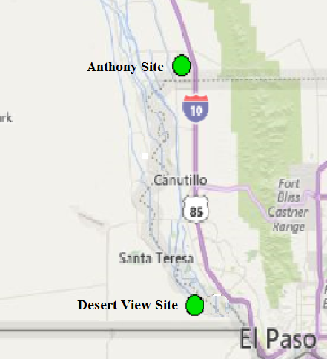

Figure 14

Particulate Matter PM_{2.5} (FRM) Air Quality Control Region 6 (EPA Region 153)

Desert View AQS #: 35-013-0021:
Desert View PM2.5 FEM (Primary) Parameter 88101, Method 209, POC 4 (as of July 13, 2023)
Desert View PM2.5 FEM (Collocated) Parameter 88101, Method 209, POC 5 (as of July 13, 2023)

The Desert View site is designated as one of the Bureau’s co-location sites using Met One Instruments BAM-1022 PM_{2.5} samplers. In 2018, this site was chosen for co-location due to the area experiencing residential and commercial development nearby in Santa Teresa and on the Mexican side along the US/Mexican border which is just one mile south of the Desert View site. These units will operate as the primary and co-located PM_{2.5} samplers.

Anthony AQS #: 35-013-0016:
Anthony PM_{2.5} FRM Parameter 88101, Method 145, POC 2 (Discontinued May 12, 2023)
Anthony PM_{2.5} FEM Parameter 88101, Method 209, POC 3 (as of May 12, 2023)
Anthony PM_{2.5} FRM Parameter 88101, Method 545, POC 5 (as of January 4, 2025)

The Bureau discontinued operating the co-located Partisol 2025i FRM PM_{2.5} sampler at the Anthony air monitoring site along with the primary BAM-1020 FEM PM_{2.5} sampler. NMED requested to replace these units in the 2022 ANR with Met One Instruments BAM-1022 FEM PM_{2.5} samplers. However, as stated above, EPA Region 6 informed NMED-AQB that one FRM PM_{2.5} particulate sampler is required to operate within a SLAMS network by regulation. NMED-AQB installed a Met One Instruments Environmental Sequential sampler which has been in operation since January 4, 2025.

2.5 Particulate Matter PM_{2.5} Continuous (BAM-1022 Sampler)

The Bureau operated six Method 170 BAM-1022 PM_{2.5} samplers within the air monitoring network designated as SLAMS. Three of the six samplers are in southern New Mexico’s Doña Ana County at the Anthony, Santa Teresa and Las Cruces Office sites. The fourth is in Lea County at the Hobbs monitoring site. The remaining two samplers are in northern New Mexico with the fifth at the Santa Fe Airport monitoring site and the sixth at the Taos monitoring site. Figure 15 indicates the location of the Santa Fe Airport and Taos monitoring sites and Figure 16 indicates the Anthony, Las Cruces Office and Hobbs monitoring sites. The samplers were replaced with Met One Instruments model BAM-1022 PM_{2.5} samplers from May to October 2023 as part of EPA funding from the American Rescue Plan. These samplers are more efficient as they do not require a temperature-controlled shelter in which to operate, thus avoiding the need for HVAC contractual work performed on a quarterly basis.
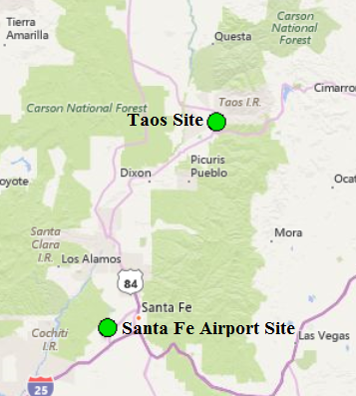

Figure 15

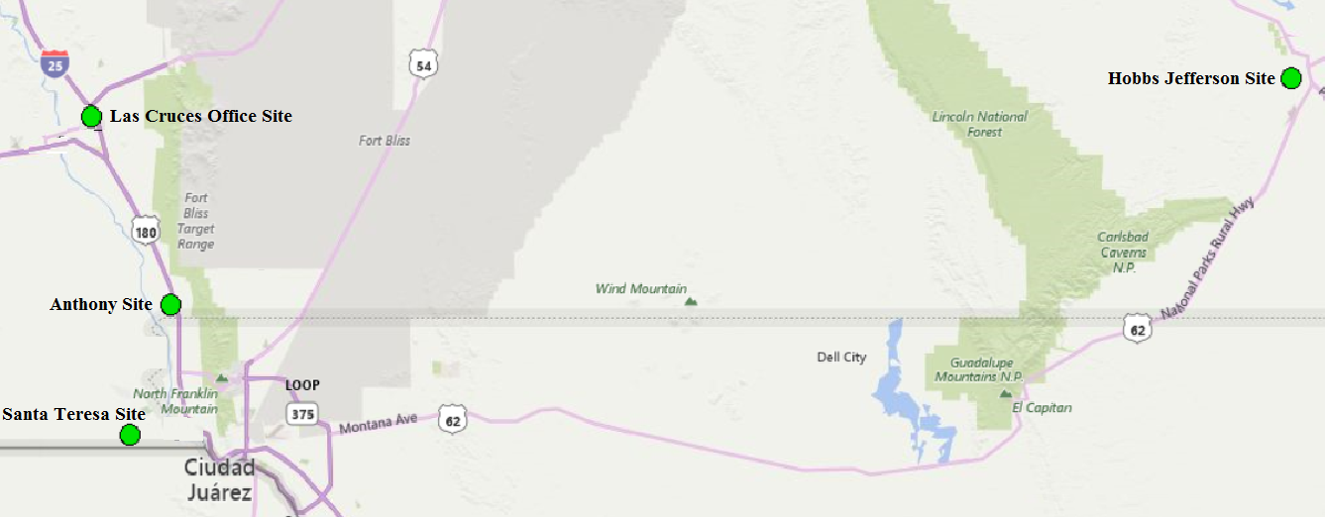

Figure 16

Air Quality Control Region 3 (EPA Region 157)

Santa Fe Airport AQS #: 35-049-0021:
Santa Fe Airport PM_{2.5} Continuous Parameter 88101, Method 209, POC 1

The Bureau continues to operate the continuous PM_{2.5} sample; no changes to monitoring equipment occurred in FY2025.

Taos AQS #: 35-055-0005:
Taos PM_{2.5} Continuous Parameter 88101, Method 209, POC 1
The Bureau continues to operate the continuous PM_{2.5} sampler; no changes to monitoring equipment occurred in FY2025.

Air Quality Control Region 5 (EPA Region 155)

Hobbs Jefferson AQS#: 35-025-0008:
Hobbs Jefferson PM_{2.5} Continuous Parameter 88101, Method 209, POC 2

The Bureau continues to operate the continuous PM_{2.5} sampler; no changes to monitoring equipment occurred in FY2025.

Air Quality Control Region 6 (EPA Region 153)

Anthony AQS #: 35-013-0016:
Anthony PM_{2.5} Continuous Parameter 88101, Method 209, POC 3

The Bureau continues to operate the continuous PM_{2.5} sampler; no changes to particulate monitoring equipment occurred in FY2025. This sampler is the primary PM_{2.5} and has a collocated FRM PM_{2.5} sampler.

Las Cruces Office AQS #: 35-013-0025:
Las Cruces PM_{2.5} Continuous Parameter 88101, Method 209, POC 2

The Bureau continues to operate the continuous PM_{2.5} sampler; no changes to particulate monitoring equipment occurred in FY2025.

Santa Teresa AQS #: 35-013-0022:
Santa Teresa PM_{2.5} Continuous Parameter 88101, Method 209, POC 1
The Bureau continues to operate the continuous PM_{2.5} sampler; no changes to particulate monitoring equipment occurred in FY2025.

2.6 Particulate Matter PM₁₀ Non-Continuous Federal Reference Method (FRM)
The Bureau discontinued operating the one non-continuous Thermo Partisol 2025i FRM sampler in the monitoring network as the primary monitor for PM₁₀ particulate matter. The sampler was replaced with a Met One Instruments BAM-1020. The Thermo Partisol sampler was located at the Anthony air monitoring site which also contained a Met-One BAM-1020 PM₁₀ continuous sampler as the assigned collocated sampler for the PM₁₀ FRM sampler per EPA requirements. Figure 17 indicates the location of the Anthony Site.

EPA Region 6 informed NMED-AQB that only one continuous particulate sampler is required to operate within a SLAMS network by regulation and that the collocated sampler could be discontinued. The Air Quality Bureau requested discontinuation of the sampler and EPA Region 6 granted approval by letter dated December 20th, 2024. The collocated sampler was discontinued as of January 3, 2025.

Air Quality Control Region 6 (EPA Region 153)
Anthony PM₁₀ FEM Parameter 81102, Method 122, POC 3

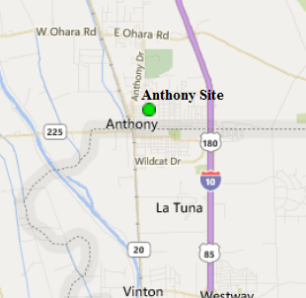

Figure 17

2.7 Particulate Matter PM₁₀ Continuous (BAM Sampler)
The Bureau operates seven Method 122 BAM-1020 PM₁₀ continuous samplers throughout the monitoring network. Figure 18 indicates the location of the northern New Mexico monitoring site where one of the seven BAM-1020 PM₁₀ samplers in the network is operating as a SLAMS monitor. Six of the seven BAM-1020 PM₁₀ continuous samplers are located and operating in the Bureau’s southern network as SLAMS monitors. Figure 19 indicates the locations of the six BAM-1020 PM₁₀ samplers in the southern network.

PM₁₀ Air Quality Control Region 1 (EPA Region 014)

Sub Station Site AQS #:35-045-1005:
Sub Station PM₁₀ Continuous Parameter 81102, Method 122, POC 2
The Bureau continues to operate a Met-One BAM-1020 FEM PM₁₀ sampler to obtain representative sampling of PM₁₀ for San Juan County. No changes to particulate monitoring equipment occurred in FY2025.

Figure18

PM₁₀ Air Quality Control Region 6 (EPA Region 153)

Anthony AQS #: 35-013-0016:
Anthony PM₁₀ Continuous Parameter 81102, Method 122, POC 3
The Bureau continues to operate the Met-One BAM-1020 FEM PM₁₀ continuous sampler, the collocated BAM-1020 FEM PM₁₀ sampler was discontinued in December 2024. No other changes to sampling equipment occurred in FY2025.

Chaparral AQS #: 35-013-0020:
Chaparral PM₁₀ Continuous Parameter 81102, Method 122, POC 2
The Bureau continues to operate the Met-One BAM-1020 FEM PM₁₀ continuous sampler. No other changes to sampling equipment occurred in FY2025.

Desert View AQS #: 35-013-0021:
Desert View PM₁₀ Continuous Parameter 81102, Method 122, POC 2
The Bureau continues to operate the Met-One BAM-1020 FEM PM₁₀ continuous sampler. No other changes to sampling equipment occurred in FY2025.

Holman Road AQS #: 35-013-0019:
Holman Road PM₁₀ Continuous Parameter 81102, Method 122, POC 2
The Bureau continues to operate the Met-One BAM-1020 FEM PM₁₀ continuous sampler.

West Mesa AQS #: 35-013-0024:
West Mesa PM₁₀ Continuous Parameter 81102, Method 122, POC 2
The Bureau continues to operate the Met-One BAM-1020 FEM PM₁₀ continuous sampler. No changes to sampling equipment occurred in FY2025.

PM₁₀ Air Quality Control Region 7 (EPA Region 012)

Deming Airport AQS #: 35-029-0003:
Deming Airport PM₁₀ Continuous Parameter 81102, Method 122, POC 2
The Bureau continues to operate the Met-One BAM-1020 FEM PM₁₀ continuous sampler. No changes to particulate monitoring equipment occurred in FY2025.

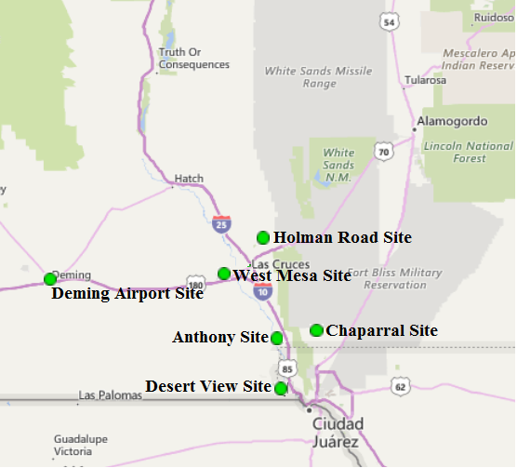

Figure 19

3.0 Other Projects

There are three other projects continuing in New Mexico and are supported by NMED-AQB staff.

- Northern air monitoring staff continue with the NADP-sponsored project to collect passive ammonia monitoring data in San Juan County, New Mexico. This project will continue if federal funds are available. Ammonia is a precursor of fine particulate matter which adversely affects public health and visibility. This continued study will augment the baseline data collected in 2007 to assess any significant changes in ambient ammonia levels. Additionally, the RadNet study will also continue as long as federal funds are available for the study. The nationwide RadNet system monitors the nation's air, precipitation and drinking water to track radiation in the environment. Over time, RadNet sample testing and monitoring results show the fluctuations in normal background levels of environmental radiation. The RadNet system will also detect higher than normal radiation levels during a radiological incident. RadNet has 140 stationary air monitors located across all 50 states. RadNet stationary monitors run 24 hours a day, 7 days a week, and send near-real-time measurements of gamma radiation to EPA’s National Analytical Radiation Environmental Laboratory (NAREL). Computers continuously review this data. If there is a meaningful increase in radiation levels, laboratory staff are alerted and then investigate the cause

- NMED-AQB installed the Synspec GC955 BTEX analyzer at the Carlsbad air monitoring station as part of the American Rescue Plan Carlsbad Community project. The analyzer was purchased and delivered in June and installation was performed in July 2023. Analyzer training was conducted at the Carlsbad site on November 1, 2023, and the analyzer started collecting data the same day. This project period is from April 1, 2023, to March 31, 2026, according to the project plan.

- As stated in the 2024 Annual Network Review, AQB will replace all monitoring site calibrators due to age and normal wear and tear of the equipment. New calibration equipment has been purchased and received and awaiting deployment. It was anticipated to have all new calibrators installed by the end of 2024, but issues with the equipment software’s inability to activate the external solenoid valve to air monitors for zero checks has delayed installation. AQB is working with the equipment manufacturer on a resolution so that the calibrators can be installed and operational by autumn.

4.0 Summary

The intention of the Bureau is to continue to focus on pollutants of concern while also striving to continue to serve the public health needs and to satisfy the expectations of the New Mexico communities. The Bureau will inform EPA Region 6 staff early in the process of any plans to make changes or modifications to the ambient air monitoring network, other than those described in this review, to ensure that state and federal priorities continue to be aligned.

4.1 Network Modifications During FY2025

The Bureau added a Met One Instruments E-SEQ Federal Reference Method (FRM) PM_{2.5} sampler at the Anthony site per request of EPA Region 6. In meeting with EPA Region 6 on September 30, 2024, the Air Quality Bureau was informed by EPA that at least one FRM was still required to operate within an air monitoring network and should be collocated with the continuous PM_{2.5} sampler at NMED’s Anthony air monitoring site. The Bureau complied with installing the sampler and it has been operational since January 4, 2025.

4.2 Pending System Modifications
Per the 2024 Annual Network Review, the existing 18 meteorological towers throughout the monitoring network were to be replaced in 2024 due to age. The towers have been purchased and are awaiting deployment, which has been delayed due to staff shortage in the Quality Assurance unit as well as excessive lead times in acquiring the necessary signal cables for the meteorological sensors.
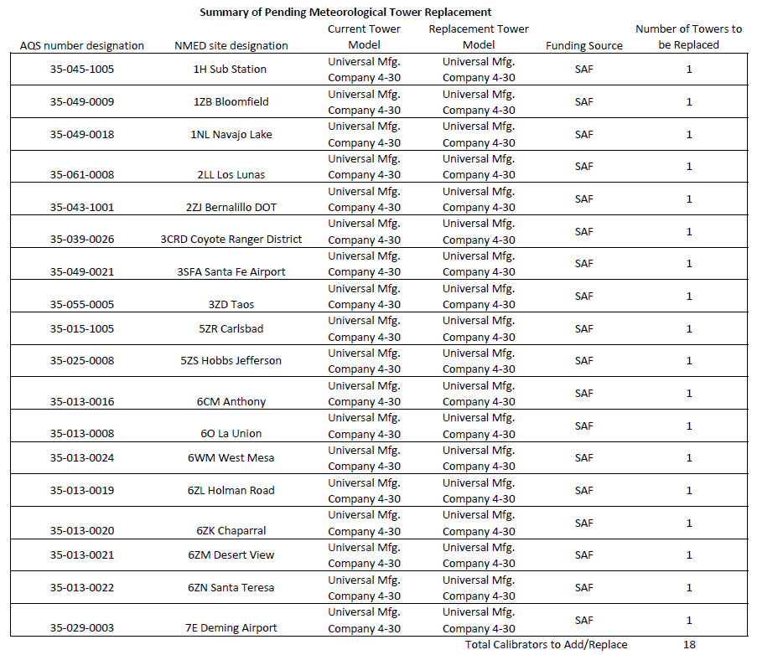

5.0 Addressing New Monitoring Requirements in Monitoring Network

5.1 Lead (Pb)

Two federal criteria have been set up for Pb monitoring:

• Source-oriented – For sources over 0.5 Tons per year.
• “Non-source”-oriented in every urban area with NCore monitoring sites, that have a population of 500,000 or more.

As stated in previous annual network reviews, based on these criteria, no Pb monitors are required in regions under NMED-AQB jurisdiction.

5.2 Nitrogen Dioxide

Two federal criteria have been set up for NO₂ monitoring:
• Near-road NO₂ monitoring; 1 micro-scale site would be required in Core Based Statistical Areas (CBSA) ≥ 1 million in population at a location of expected highest hourly NO₂ concentrations sited near a major road with high Annual Average Daily Traffic (AADT) counts.
• Community-wide; required in CBSAs ≥ 1 million in population at a location of expected highest NO₂ concentrations representing neighborhood or larger (urban) spatial scale.

Based on these criteria, no new NO₂ monitors are required in the state’s air quality control regions under NMED-AQB jurisdiction.

5.3 Sulfur Dioxide

Two federal criteria have been set up for SO₂ monitoring:
• Population per CBSA and amount of SO₂ emissions within that CBSA, e.i., the Population Weighed Emissions Index (PWEI).
• Individual state contribution to national SO₂ inventory in the 2020 National Emissions Inventory (NEI).
Data was obtained from the EPA site: www.epa.gov/air-emissions-inventories and calculated to determine the PWEI values for SO₂.

Based on the 2020 NEI criteria as listed in the PWEI calculation table below, NMED-AQB would not require any SO₂ monitoring within the State. However, due to increased oil and gas production in southeast New Mexico the PWEI for SO₂ indicates an increase and AQB requested and received concurrence from EPA Region 6 to install an SO₂ Special Purpose Monitor (SPM) at NMED’s Hobbs monitoring site to determine if adding an SO₂ monitor to the SLAMS network is warranted. The PWEI for SO₂ below reflects 2020 data and is the most current available. The EPA will update and make available the PWEI for SO₂ in March 2026.

COUNTY | TIER | COUNTY FIPS | POLLUTANT | POLLUTANT TYPE | EMISSIONS (TONS)
San Juan | Fuel Comb. Elec. Util. | 045 | Sulfur Dioxide | CAP | 1355.221
San Juan | Petroleum & Related Industries | 045 | Sulfur Dioxide | CAP | 169.291
San Juan | Fuel Comb. Industrial | 045 | Sulfur Dioxide | CAP | 89.003
San Juan | Miscellaneous | 045 | Sulfur Dioxide | CAP | 18.586
San Juan | Fuel Comb. Other | 045 | Sulfur Dioxide | CAP | 14.981
San Juan | Highway Vehicles | 045 | Sulfur Dioxide | CAP | 4.342
San Juan | Waste Disposal & Recycling | 045 | Sulfur Dioxide | CAP | 2.837
San Juan | Off-Highway | 045 | Sulfur Dioxide | CAP | 1.330
San Juan | Storage & Transport | 045 | Sulfur Dioxide | CAP | 0.021
 |  |  |  | Total SO₂ Emissions | 1655.612
 |  |  |  | San Juan CBSA Population | 120418
 |  |  |  | Population x SO₂ | 199365517.4
 |  |  |  | PWEI-San Juan Co. | 199.366
 |  |  |  | SO₂ monitors required | 0
COUNTY | TIER | COUNTY FIPS | POLLUTANT | POLLUTANT TYPE | EMISSIONS (TONS)
Sandoval | Petroleum & Related Industries | 043 | Sulfur Dioxide | CAP | 76.864
Sandoval | Fuel Comb. Industrial | 043 | Sulfur Dioxide | CAP | 24.469
Sandoval | Fuel Comb. Other | 043 | Sulfur Dioxide | CAP | 19.071
Sandoval | Waste Disposal & Recycling | 043 | Sulfur Dioxide | CAP | 10.280
Sandoval | Highway Vehicles | 043 | Sulfur Dioxide | CAP | 5.476
Sandoval | Miscellaneous | 043 | Sulfur Dioxide | CAP | 3.866
Sandoval | Off-Highway | 043 | Sulfur Dioxide | CAP | 0.381
Sandoval | Other Industrial Processes | 043 | Sulfur Dioxide | CAP | 0.251
 |  |  |  | Total SO₂ Emissions | 140.659
 |  |  |  | Sandoval CBSA Population | 153501
 |  |  |  | Population x SO₂ | 21591231.61
 |  |  |  | PWEI-Sandoval Co. | 21.591
 |  |  |  | SO₂ monitors required | 0
COUNTY | TIER | COUNTY FIPS | POLLUTANT | POLLUTANT TYPE | EMISSIONS (TONS)
Valencia | Fuel Comb. Industrial | 061 | Sulfur Dioxide | CAP | 11.356
Valencia | Fuel Comb. Other | 061 | Sulfur Dioxide | CAP | 5.387
Valencia | Highway Vehicles | 061 | Sulfur Dioxide | CAP | 2.231
Valencia | Fuel Comb. Elec. Util. | 061 | Sulfur Dioxide | CAP | 2.010
Valencia | Off-Highway | 061 | Sulfur Dioxide | CAP | 1.680
Valencia | Waste Disposal & Recycling | 061 | Sulfur Dioxide | CAP | 1.132
Valencia | Miscellaneous | 061 | Sulfur Dioxide | CAP | 1.126
 |  |  |  | Total SO₂ Emissions | 24.923
 |  |  |  | Valencia CBSA Population | 78080
 |  |  |  | Population x SO₂ | 1945959.061
 |  |  |  | PWEI-Valencia Co. | 1.946
 |  |  |  | SO₂ monitors required | 0
COUNTY | TIER | COUNTY FIPS | POLLUTANT | POLLUTANT TYPE | EMISSIONS (TONS)
Rio Arriba | Petroleum & Related Industries | 039 | Sulfur Dioxide | CAP | 26.089
Rio Arriba | Fuel Comb. Industrial | 039 | Sulfur Dioxide | CAP | 18.731
Rio Arriba | Miscellaneous | 039 | Sulfur Dioxide | CAP | 9.392
Rio Arriba | Fuel Comb. Other | 039 | Sulfur Dioxide | CAP | 5.919
Rio Arriba | Highway Vehicles | 039 | Sulfur Dioxide | CAP | 1.447
Rio Arriba | Waste Disposal & Recycling | 039 | Sulfur Dioxide | CAP | 1.088
Rio Arriba | Off-Highway | 039 | Sulfur Dioxide | CAP | 0.287
Rio Arriba | Storage & Transport | 039 | Sulfur Dioxide | CAP | 0.016
Rio Arriba | Other Industrial Processes | 039 | Sulfur Dioxide | CAP | 0.012
 |  |  |  | Total SO₂ Emissions | 62.981
 |  |  |  | Rio Arriba CBSA Population | 40048
 |  |  |  | Population x SO₂ | 2522274.577
 |  |  |  | PWEI-Rio Arriba Co. | 2.522
 |  |  |  | SO₂ monitors required | 0
COUNTY | TIER | COUNTY FIPS | POLLUTANT | POLLUTANT TYPE | EMISSIONS (TONS)
Santa Fe | Miscellaneous | 049 | Sulfur Dioxide | CAP | 62.032
Santa Fe | Fuel Comb. Other | 049 | Sulfur Dioxide | CAP | 22.584
Santa Fe | Fuel Comb. Industrial | 049 | Sulfur Dioxide | CAP | 18.496
Santa Fe | Highway Vehicles | 049 | Sulfur Dioxide | CAP | 6.020
Santa Fe | Waste Disposal & Recycling | 049 | Sulfur Dioxide | CAP | 4.558
Santa Fe | Off-Highway | 049 | Sulfur Dioxide | CAP | 3.800
Santa Fe | Fuel Comb. Elec. Util. | 049 | Sulfur Dioxide | CAP | 0.012
 |  |  |  | Total SO₂ Emissions | 117.501
 |  |  |  | Santa Fe CBSA Population | 155664
 |  |  |  | Population x SO₂ | 18290622.53
 |  |  |  | PWEI-Santa Fe Co. | 18.291
 |  |  |  | SO₂ monitors required | 0
COUNTY | TIER | COUNTY FIPS | POLLUTANT | POLLUTANT TYPE | EMISSIONS (TONS)
Taos | Miscellaneous | 055 | Sulfur Dioxide | CAP | 25.284
Taos | Fuel Comb. Other | 055 | Sulfur Dioxide | CAP | 7.143
Taos | Fuel Comb. Industrial | 055 | Sulfur Dioxide | CAP | 3.793
Taos | Waste Disposal & Recycling | 055 | Sulfur Dioxide | CAP | 1.702
Taos | Highway Vehicles | 055 | Sulfur Dioxide | CAP | 1.176
Taos | Off-Highway | 055 | Sulfur Dioxide | CAP | 0.271
 |  |  |  | Total SO₂ Emissions | 39.371
 |  |  |  | Taos CBSA Population | 34580
 |  |  |  | Population x SO₂ | 1361436.836
 |  |  |  | PWEI-Taos County | 1.361
 |  |  |  | SO₂ monitors required | 0
COUNTY | TIER | COUNTY FIPS | POLLUTANT | POLLUTANT TYPE | EMISSIONS (TONS)
Eddy | Petroleum & Related Industries | 015 | Sulfur Dioxide | CAP | 35048.697
Eddy | Fuel Comb. Industrial | 015 | Sulfur Dioxide | CAP | 435.393
Eddy | Miscellaneous | 015 | Sulfur Dioxide | CAP | 6.381
Eddy | Fuel Comb. Other | 015 | Sulfur Dioxide | CAP | 5.240
Eddy | Highway Vehicles | 015 | Sulfur Dioxide | CAP | 3.157
Eddy | Waste Disposal & Recycling | 015 | Sulfur Dioxide | CAP | 3.157
Eddy | Off-Highway | 015 | Sulfur Dioxide | CAP | 1.736
Eddy | Other Industrial Processes | 015 | Sulfur Dioxide | CAP | 0.291
Eddy | Fuel Comb. Elec. Util. | 015 | Sulfur Dioxide | CAP | 0.071
Eddy | Storage & Transport | 015 | Sulfur Dioxide | CAP | 0.033
 |  |  |  | Total SO₂ Emissions | 35504.155
 |  |  |  | Eddy CBSA Population | 60400
 |  |  |  | Population x SO₂ | 2144450973
 |  |  |  | PWEI-Eddy Co. | 2144.451
 |  |  |  | SO₂ monitors required | 0
COUNTY | TIER | COUNTY FIPS | POLLUTANT | POLLUTANT TYPE | EMISSIONS (TONS)
Lea | Petroleum & Related Industries | 025 | Sulfur Dioxide | CAP | 43445.955
Lea | Fuel Comb. Industrial | 025 | Sulfur Dioxide | CAP | 3114.303
Lea | Fuel Comb. Elec. Util. | 025 | Sulfur Dioxide | CAP | 9.315
Lea | Fuel Comb. Other | 025 | Sulfur Dioxide | CAP | 5.096
Lea | Highway Vehicles | 025 | Sulfur Dioxide | CAP | 3.574
Lea | Miscellaneous | 025 | Sulfur Dioxide | CAP | 2.290
Lea | Waste Disposal & Recycling | 025 | Sulfur Dioxide | CAP | 1.270
Lea | Off-Highway | 025 | Sulfur Dioxide | CAP | 0.539
Lea | Storage & Transport | 025 | Sulfur Dioxide | CAP | 0.029
 |  |  |  | Total SO₂ Emissions | 46582.371
 |  |  |  | Lea CBSA Population | 72452
 |  |  |  | Population x SO₂ | 3374985939
 |  |  |  | PWEI-Lea Co. | 3374.986
 |  |  |  | SO₂ monitors required | 0
COUNTY | TIER | COUNTY FIPS | POLLUTANT | POLLUTANT TYPE | EMISSIONS (TONS)
Doña Ana | Fuel Comb. Industrial | 013 | Sulfur Dioxide | CAP | 31.557
Doña Ana | Fuel Comb. Elec. Util. | 013 | Sulfur Dioxide | CAP | 16.211
Doña Ana | Fuel Comb. Other | 013 | Sulfur Dioxide | CAP | 13.750
Doña Ana | Miscellaneous | 013 | Sulfur Dioxide | CAP | 9.434
Doña Ana | Off-Highway | 013 | Sulfur Dioxide | CAP | 7.814
Doña Ana | Highway Vehicles | 013 | Sulfur Dioxide | CAP | 7.704
Doña Ana | Waste Disposal & Recycling | 013 | Sulfur Dioxide | CAP | 6.488
Doña Ana | Petroleum & Related Industries | 013 | Sulfur Dioxide | CAP | 1.560
Doña Ana | Other Industrial Processes | 013 | Sulfur Dioxide | CAP | 0.047
 |  |  |  | Total SO₂ Emissions | 94.566
 |  |  |  | Doña Ana CBSA Population | 222285
 |  |  |  | Population x SO₂ | 21020641.3
 |  |  |  | PWEI-Doña Ana Co. | 21.021
 |  |  |  | SO₂ monitors required | 0
COUNTY | TIER | COUNTY FIPS | POLLUTANT | POLLUTANT TYPE | EMISSIONS (TONS)
Luna | Fuel Comb. Industrial | 029 | Sulfur Dioxide | CAP | 18.425
Luna | Fuel Comb. Other | 029 | Sulfur Dioxide | CAP | 7.970
Luna | Off-Highway | 029 | Sulfur Dioxide | CAP | 5.530
Luna | Miscellaneous | 029 | Sulfur Dioxide | CAP | 2.264
Luna | Highway Vehicles | 029 | Sulfur Dioxide | CAP | 1.855
Luna | Petroleum & Related Industries | 029 | Sulfur Dioxide | CAP | 0.731
Luna | Waste Disposal & Recycling | 029 | Sulfur Dioxide | CAP | 0.586
Luna | Other Industrial Processes | 029 | Sulfur Dioxide | CAP | 0.380
 |  |  |  | Total SO₂ Emissions | 37.741
 |  |  |  | Luna CBSA Population | 25749
 |  |  |  | Population x SO₂ | 971787.7318
 |  |  |  | PWEI-Luna Co. | 0.972
 |  |  |  | SO₂ monitors required | 0

SO₂ Data Requirements Rule
Per EPA Requirement that by July 1, 2016, each air agency was required to identify each source area on the list, the approach it will use to characterize air quality to help characterize sources listed as 2,000 tpy or larger, air agencies were to indicate by July 1, 2016, one of the three options to use which were:

Option 1: Ambient air monitoring for a source
Option 2: Air quality modeling for a source
Option 3: Federally enforceable emissions limits applicable to sources less than 2,000tpy

NMED chose the second option, but this requires operating both SO₂ monitors in the network (1H Sub Station site and the 1ZB Bloomfield site) in order to provide data for modeling. The most recent report shows that our only source of concern, the San Juan Generating Station, reduced its SO₂ emissions since the December 2017 shut-down of the two boiler units. The San Juan Generator Station ceased operating in 2022. The modeling data also indicates that SO₂ emissions have decreased.

5.4 Ozone

During FY 2025 the exceedances of the 8-hour standard did increase from the year prior. This can be partially attributed to the South Fork and Salt fires that occurred in May and June of 2024 in the Ruidoso, New Mexico area. These two wildfires along with wildfires in Texas had significant impact on air quality in southern and southeast New Mexico in addition to the oil and gas industries’ ozone emissions.

The chart below,provided by EPA, shows the number of ozone exceedances throughout the five Region 6 states. Typically, the October EPA chart is the end of the ozone season which indicates the total number of exceedances that occurred between April 1st through mid-October as well as the number of Air Quality Index Category Totals. However, this year EPA Region 6 provided data from April 1st through November 21st as indicated in the table below.

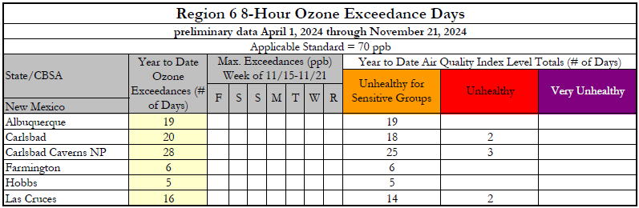

The chart below, also provided by EPA, provides the running 3-year Ozone Design Values for all NMED-AQB monitoring sites that measure ozone. This assists state environmental agencies in determining if the monitoring area is in attainment or non-attainment of the ozone standard and necessary courses of action that need to be implemented to achieve attainment.

Current EPA 3-Year Ozone Design Values 2021 through 2023

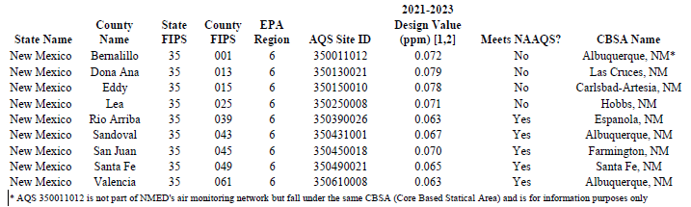

6.0 Environmental Justice Concerns
The NMED-AQB is committed to addressing environmental justice concerns related to the air quality network. Based on EPA’s EJ Screen for ozone and PM_{2.5}, NMED’s air monitoring network provides representative data and each of the monitoring sites have appropriate number of sampling equipment. Additionally, monitoring sites are located in areas that coincide with the pollution concentration percentages. Due to current administration federal personnel cuts, EJ Screens provided were obtained from NetAssess2025.
Currently, the Air Quality Bureau is operating a Synspec GC 955 BTEX analyzer purchased through American Rescue Plan to monitor volatile organic compound (VOC) air pollutants from oil and gas sources for a period of three years at the existing Carlsbad monitoring site.

The rural nature of these communities suggests that minimal data has been historically obtained due to a lack of monitoring for VOC to adequately assess relative risk. These communities are at an increased risk of the adverse health effects from air pollution from increased oil and gas sources. Monitoring for aromatic VOC will focus resources on the most concerning air pollutants that pose a risk to the health and well-being of the most vulnerable residents.
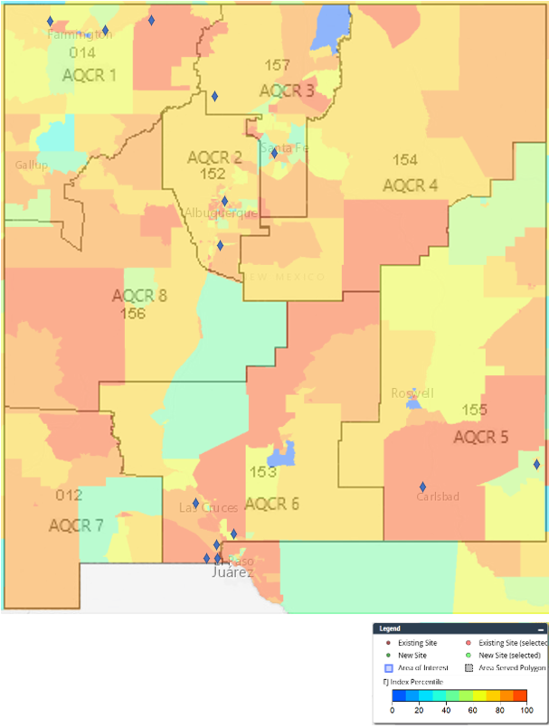

Ozone EJ Screen

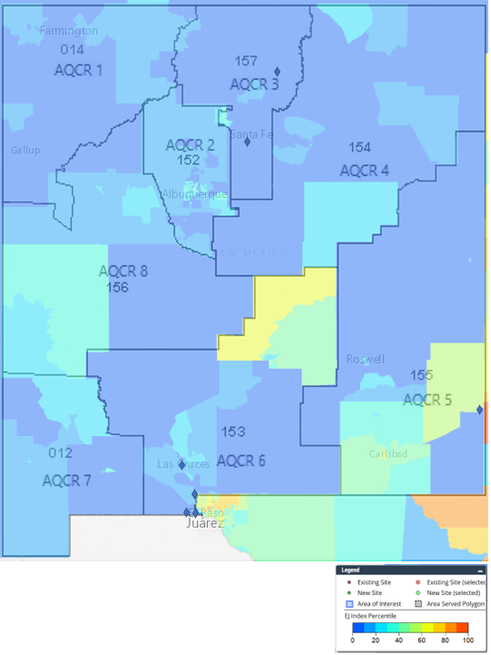
PM_{2.5} EJ Screen

7.0 Other Issues
Position Vacancies:
At present the NMED-AQB Monitoring Section has all 8 positions filled with no vacancies. This consists of two Environmental Scientist & Specialist - II staff, three Environmental Scientist & Specialist - III staff, two Environmental Scientist & Specialist – Supervisor staff and one Staff Manager.

A draft of this document was made available to the public May 9 through June 8, 2025 which was posted on our public notice web page at https://www.env.nm.gov/public-notices/ and provided the public portal for the public to comment at: https://nmed.commentinput.com/comment/search. In addition, we also provided a draft of this document on our Air Quality Bureau Monitoring webpage at https://www.env.nm.gov/air-quality/monitoring/.

Roman Szkoda
Monitoring Program Manager
New Mexico Environment Department
Air Quality Bureau
525 Camino de los Marquez, Suite 1
Santa Fe, New Mexico 87505
roman.szkoda@env.nm.gov
