***State of New Mexico***

***ENVIRONMENT DEPARTMENT***

***Office of the Secretary***

Harold Runnels Building

1190 Saint Francis Drive, PO Box 5469

Santa Fe, NM 87502-5469

Telephone (505) 827-2855 Fax (505) 827-2836

www.env.nm.gov

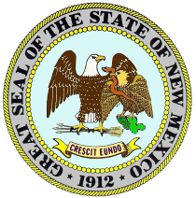

***MICHELLE LUJAN GRISHAM***

*Governor*

***HOWIE C. MORALES***

*Lt. Governor*

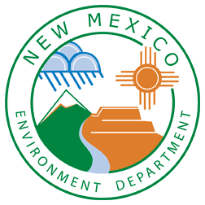

***JAMES C. KENNEY***

*Cabinet Secretary*

***JENNIFER J. PRUETT***

*Deputy Secretary*

**Meeting Announcement**

**New Mexico Environment Department**

**Wastewater Technical Advisory Committee**

**Date: February 19, 2021**

**Time: 9:30 am to 12:00 pm**

**Location: Due to the current Public Health Emergency (“Emergency”) under the Governor’s Executive Order No. 2020-004, and in accordance with the Attorney General’s guidance for open meetings during the Emergency, this meeting will be held remotely.**

***Members of the public may attend the meeting by telephone at the following number:***

**1-(800)-747-5150 – access code: 1647266**

**Purpose: Quarterly WTAC Meeting**