
New Mexico Environment Department

Solid Waste Bureau 2024
Annual Report Instructions

Summary
The Solid Waste Bureau is receiving Annual Reports through the online Annual Report database. These step‐by‐step instructions will guide you through this reporting process.

All open, permitted landfills, transfer stations, and processing facilities and all open, registered compost and recycling facilities are required to complete the New Mexico Environment Department Solid Waste Bureau Annual Report, in accordance with the New Mexico Solid Waste Rules (20.9.5.16.D NMAC and 20.9.3.27.J NMAC).

New for 2024 reporting: Closed landfills that are required to submit Annual Reports as part of an approved closure/post-closure plan will now be required to report through the online database to submit the Annual Reporting Information form, Environmental Monitoring Summary form, an updated Financial Assurance Estimate Summary and current required financial assurance attachments such as fund balance documents, surety bonds, letters of credit, certificate of insurance, bond ratings and financial statements.

Note: Registered collection centers are not required to complete the Annual Report.

Things to Know
- Complete the online Annual Report for calendar year 2024 by February 14, 2025.
- The supplemental forms can be found here at: https://www.env.nm.gov/forms/. Complete the required forms and save them to your computer as electronic files. Convert material amounts into TONS (see conversion factors in Appendix D: Conversion Factors in these Instructions).

- Note: All material entered must be accounted for in the outgoing section. Material tons should match across rows. If there are any deviations please provide an explanation in the Annual Reporting Information supplemental form.
- Do not use the back arrow in your browser to move between web pages. Instead, use the Back to Master Table or Back to List buttons to navigate.

Note: If you have trouble with the check buttons/checkboxes try using Microsoft Edge instead of other internet browsers.
- Save your work as you go. Look for the Save button at the bottom of each page you edit.
- Landfill operators should submit their complete Environmental Monitoring Reports, as required by their landfill permits, to the Permit Section Manager throughout the year. This applies to both active permitted landfills and landfills in post‐closure care. For more information, contact the Permit Section at 505‐827‐0197.
- Facilities are required to keep a copy of each Annual Report on-site through the completion of post‐closure care. Annual Reports can be kept as either electronic files or paper files. After completing your report, you will be able to save and/or print the Annual Report for your facility’s records. (See Section 8: Submit Annual Report in these instructions).
- Make sure to press the Submit Annual Report button to upload your data once you are ready to upload your 2024 information. Your Annual Report is not submitted until you press the Submit Annual Report button.
Note: You will receive a confirmation email when documents are successfully submitted.

How to Log in to the Solid Waste Bureau Annual Report Database
Follow the instructions in Appendix A: How to Register and Log in to the SWB Annual Report Database in order to register a User ID and password for your facility. If you had registered for the SWB Annual Report Database in a previous year, use your existing User ID and password to log in. If you have forgotten your User ID, you can contact the Solid Waste Bureau Outreach Section to send it to you.
https://sep.net.env.nm.gov/sep/login‐form
Once you have logged in as a registered user, you will be able to add additional users from your facility, if you choose (See Section 7: Contacts in these instructions).

Facility List (also called Master Table)
When you log in to the Solid Waste Bureau Annual Report you will see the Facility List (see image on next page). If you are reporting for a single facility, you will only see that facility listed. If you are reporting for multiple facilities under one username, you will see all facilities that you are responsible for reporting on listed on this page.
Please review the contact and location information for your facility on this page. If any information needs to be updated, please explain the required changes on the Annual Reporting Information supplemental form (See Section 6: Documents in these Instructions).
If all information shown here is correct, no action is needed.
As you continue to input data into the Annual Report tabs, you may return to this page by clicking the Back to Master Table button.

Instruction Sections
These instructions describe the tabs that make up the Annual Report (shown below). The following numbered sections of the instructions describe in full how to complete each tab:
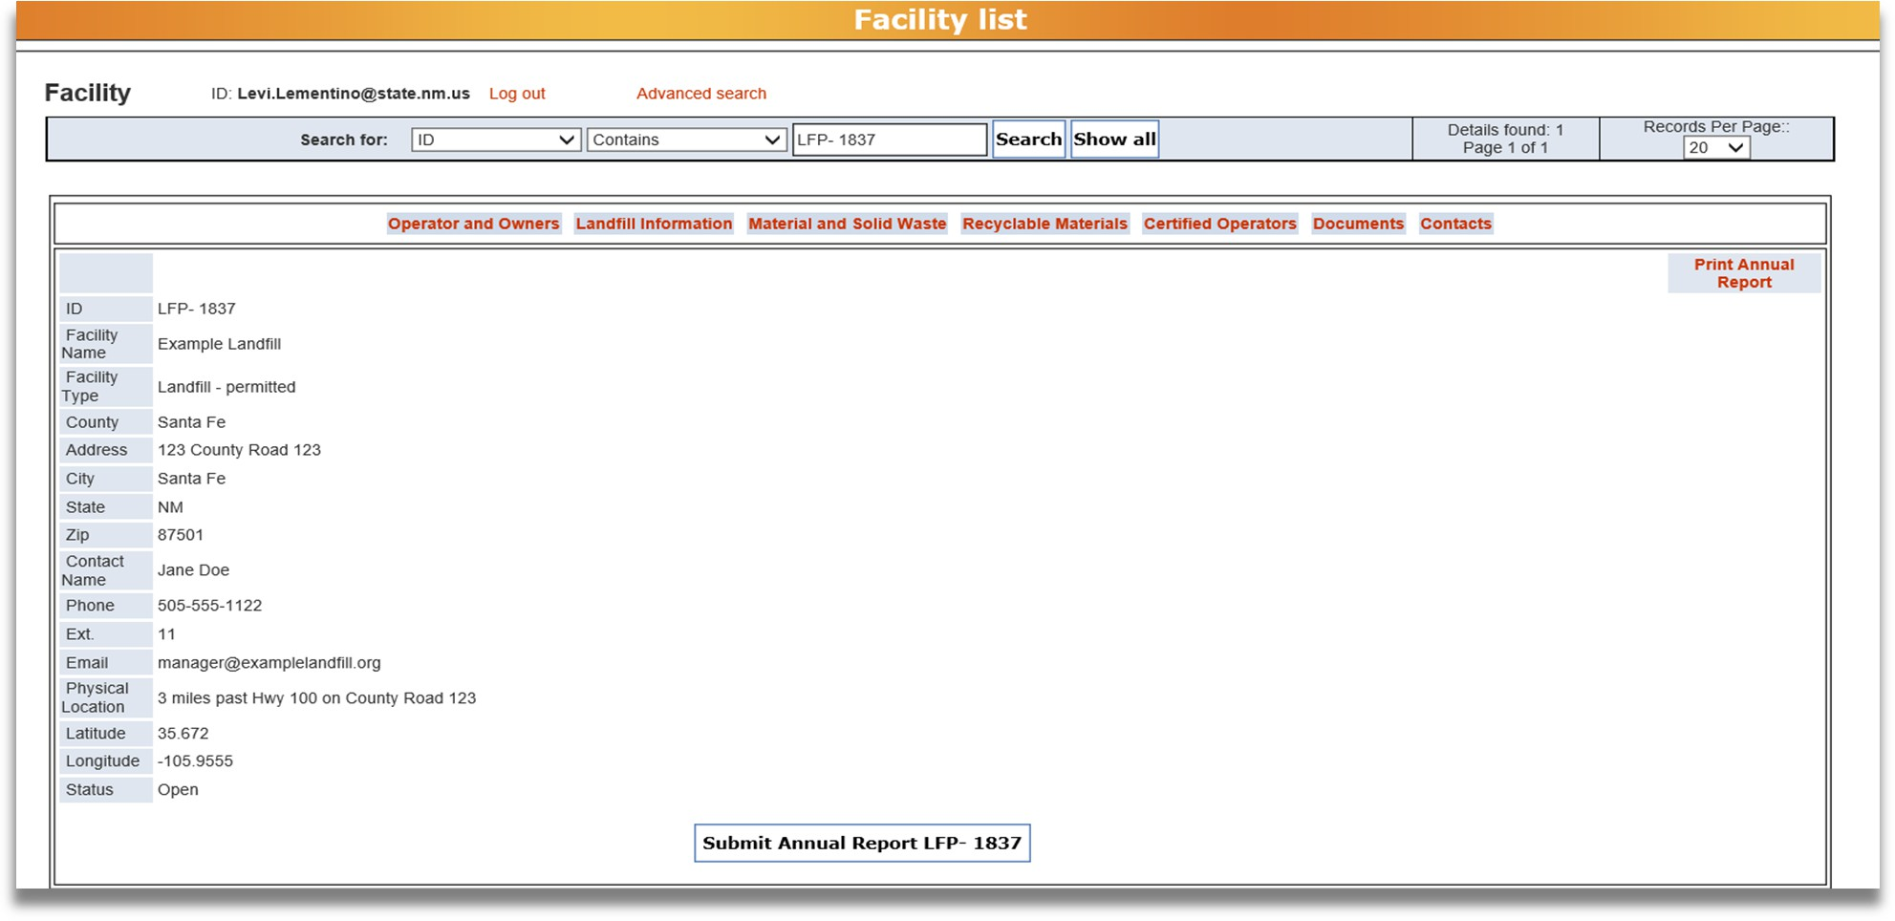








1
2
3
4
5
6
7
8

Operator and Owners
- Landfill Information (available only to active and permitted landfills)

- Material and Solid Waste
- Recyclable Materials
- Certified Operators
- Documents

- Contacts

- Submit the Annual Report
These Instructions also describe the following:
- Troubleshooting Appendices

Operator and Owners
This tab is available to all facilities and lists the facility owner and operator information.

How to get to the Operator and Owners tab
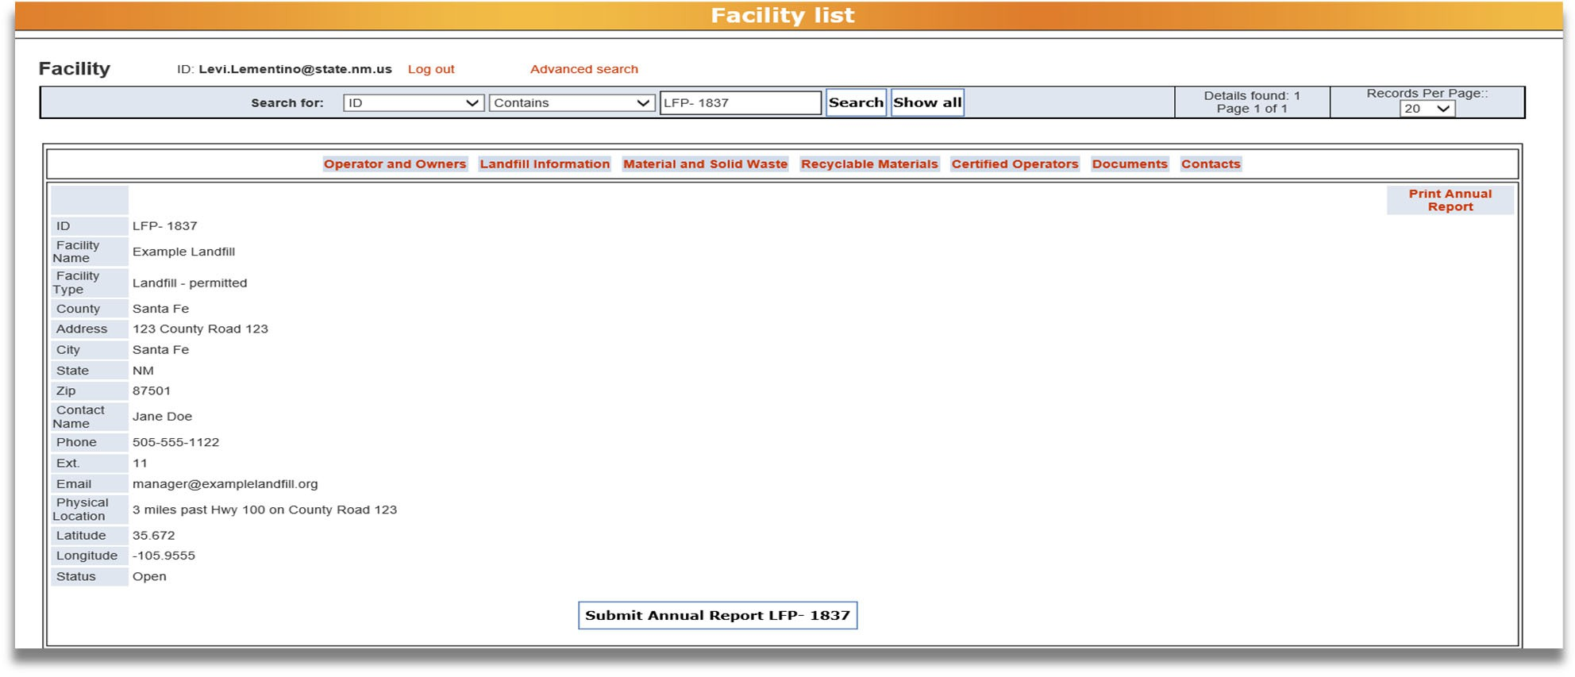
From the Facility List view, click on the Operator and Owners tab to open a window where you will review the operator and owner information.

How to complete the Operator and Owners tab
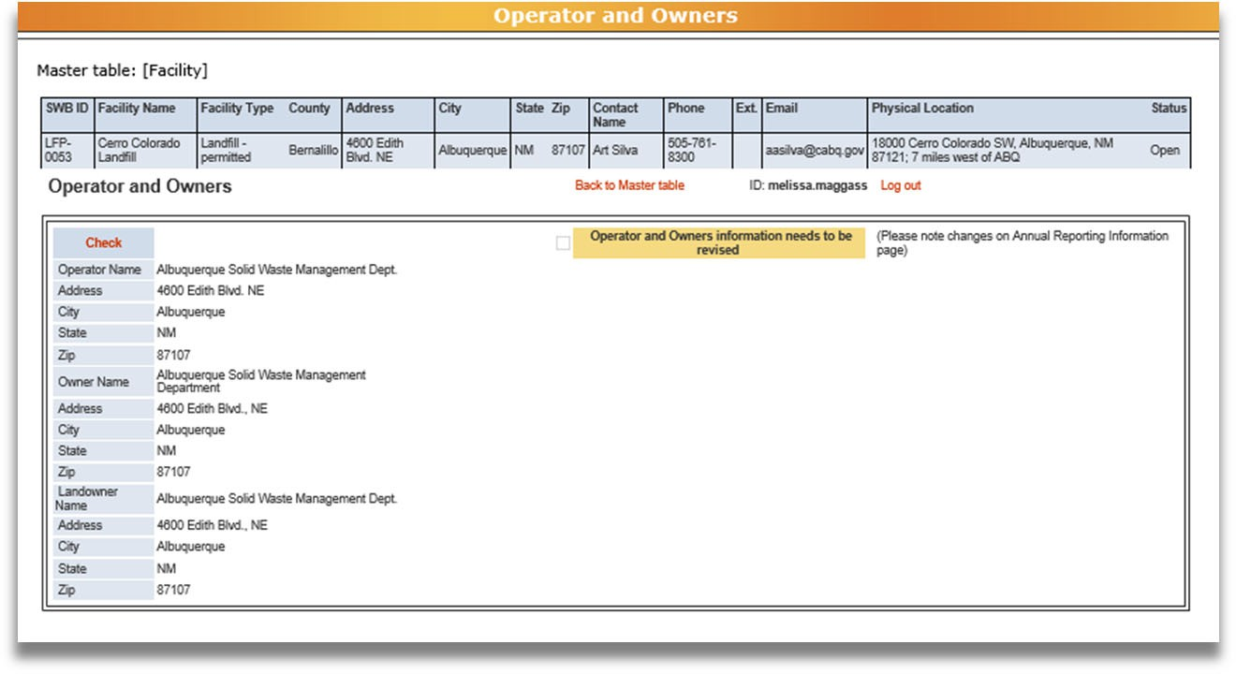



1
2
3
Review the information about the facility operator, facility owner, and landowner. If any of the information needs to be updated, 1. Check the box by clicking on the Check button and a 2. checkmark will appear next to “Operator and Owners information needs to be revised.” (Do not click the Check button, if no changes are needed.) Please explain the requested changes on the Annual Reporting Information supplemental form, which you will attach to the “Document” tab (see Section 6: Documents in these Instructions).
Note: once you click the Check button, it will change to say Uncheck. To uncheck the box, click the Uncheck button.
Once you have reviewed the information and checked the box to revise the operator and owner information, return to the Facility List view by clicking 3, the Back to Master Table button.
Note: If you have trouble with the check buttons/checkboxes try using Microsoft Edge instead of other internet browsers.

Landfill Information
This tab is only available to open-active and permitted landfills and collects data regarding landfill capacity and closures. Some of the data entered under this tab will come from the Landfill Capacity Worksheet supplemental form, which can be found on the NMED Solid Waste Bureau’s All Applications Forms and Guidance webpage under the Solid Waste Bureau Annual Reporting drop‐down. Link: https://www.env.nm.gov/forms/

How to get to the Landfill Information tab
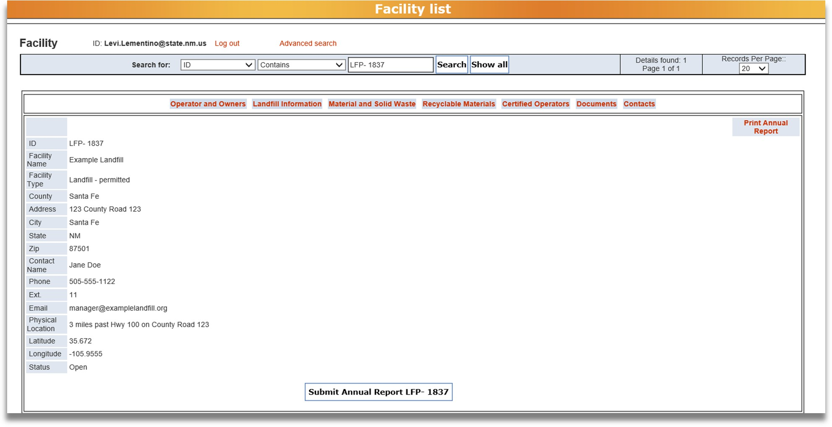
From the Facility List, click on the Landfill Information tab to open window where you will enter your data.

How to edit the Landfill Information tab
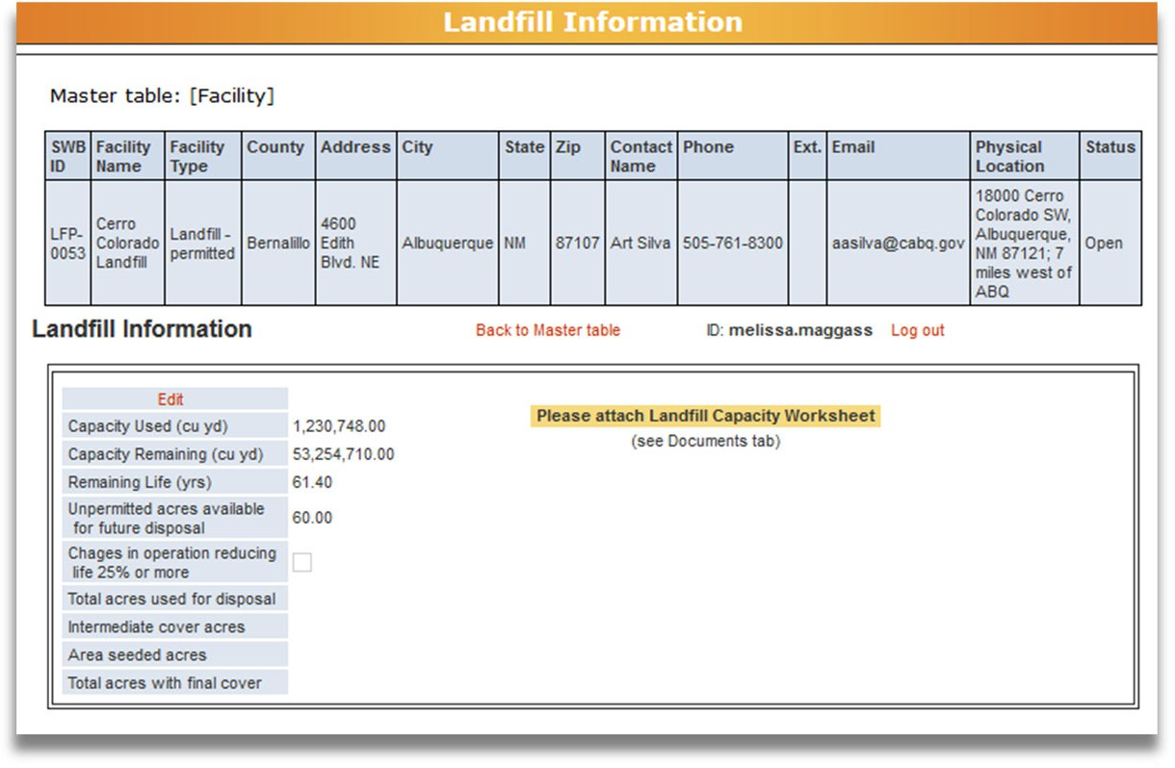
To enter data about your landfill, click the Edit button. In addition to editing the data on this tab, be sure to attach the Landfill Capacity Worksheet used to calculate these numbers to the “Documents” tab (see Section 6: Documents in these Instructions).
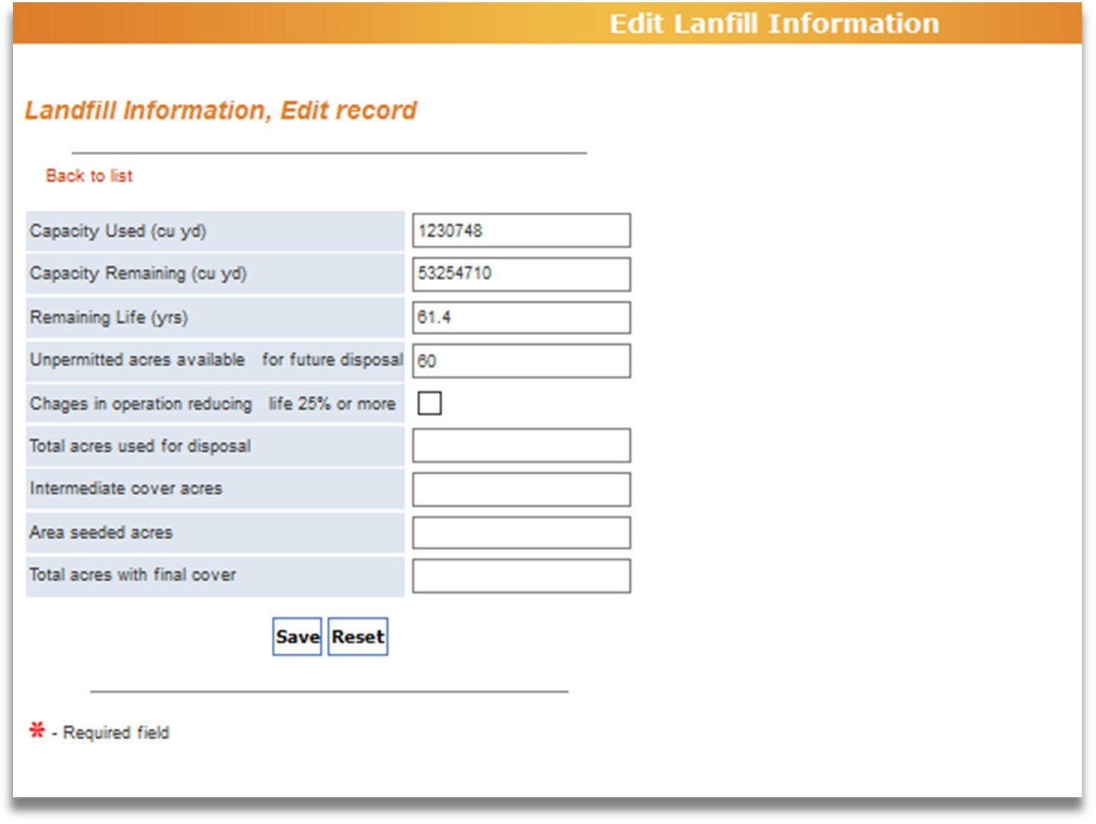










1
2
3
4
5
10
6
7
8
9
Use this diagram of highlighted numbers to refer to the next two pages.

Landfill Capacity Information

Capacity Used (cubic yards)
Report the landfill capacity used in cubic yards during January 1 – December 31 of the reporting year.

Capacity Remaining (cubic yards)
Report the remaining permitted capacity available for future disposal in cubic yards. This number is calculated on the Landfill Capacity Worksheet. Remaining permitted capacity means the space remaining in the landfill that is available for disposal as of December 31 of the reporting year. Future proposed expansions not included in the approved permit area may not be included in the capacity calculation.

Remaining Life (years)
Report the expected number of years of permitted disposal capacity that is available based on the facility’s site‐specific operating criteria that is calculated in the Landfill Capacity Worksheet.

Unpermitted Acres Available for Future Disposal
Report the number of acres, not currently permitted, that may be used for future disposal.

Changes in Operation Reducing Life 25% or more
If there have been operational changes during the reporting year that will reduce the active life of the landfill by 25% or more, check the box. In this case, the facility is also required to submit a report to the Permit Section Manager detailing changes per 20.9.5.16.D(7) NMAC.

Landfill Closure Activities

Total Acres used for Disposal
Provide the total number of acres that have been used for solid waste disposal as of December 31 of the reporting year. Include the total number of acres used for disposal from the initial acceptance of solid waste (that is, when the landfill first opened) up to December 31 of this reporting year.

Intermediate Cover (Acres)
Enter the number of acres that have received intermediate cover. (All areas of the landfill that will be or have been inactive for more than 60 days must have an intermediate cover).

Area Seeded (Acres)
Enter the number of acres that have been seeded. (All areas of the landfill that will be or have been inactive for more than 2 years must have an intermediate cover and be seeded to establish vegetative cover).

Total Acres with Final Cover
Enter the number of acres that have received final cover and have been closed according to an approved Closure Plan since the initial acceptance of waste through December 31 of this reporting year.

Saving or Resetting Data

Save/Reset
When you have entered all the data for your landfill, click the Save button to save the data, or click the Reset button to delete your entry and start over.

How to know if the data was saved to the database
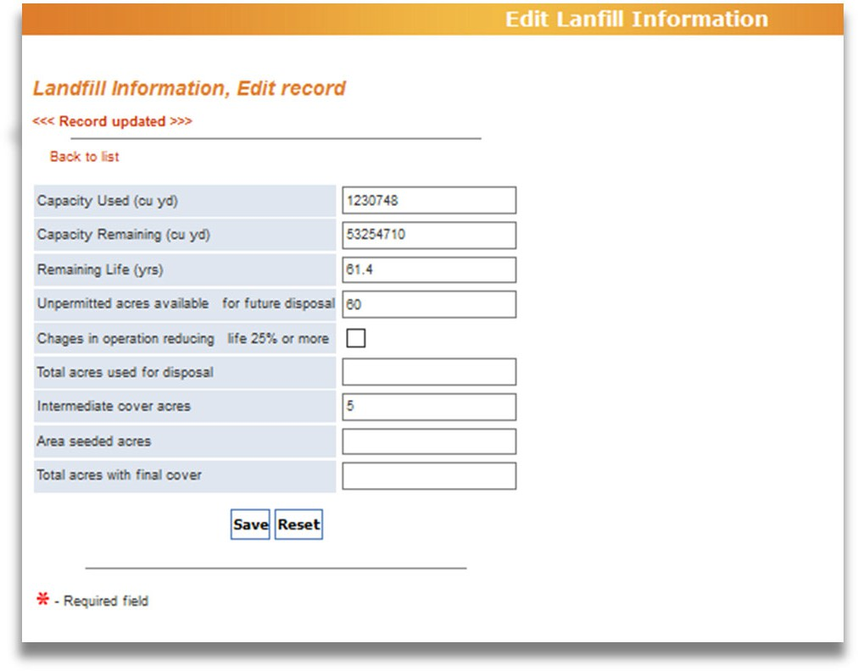



1
2

After clicking the Save button, 1. you will see a notification saying, “Record Updated” To return to the Landfill Information tab, 2. click the Back to List button.

Material and Solid Waste
ALL reporting facilites will enter data under this tab.
In this tab you will report the origin, type, and amount of waste/materials managed. The amounts managed must be reported in TONS. If your facility records material amounts as volume (for example, cubic yards or gallons), use the conversion factors in Appendix D: Conversion Factors to convert to tons for reporting. Please note changes in material types collected on the Annual Reporting Information supplemental form.
Note: Do not use commas for numbers entered in text fields.

Facility Specific Instructions

Landfills
  - Provide the amount in tons for every type of material managed. For definitions of material types, see Appendix B.

Transfer Stations
  - Provide the amount in tons for every type of material collected or managed. For definitions of materials types, see Appendix B.

Composting Facilities
  - Finished compost is considered a product and not a waste material. Do not report the quantities of finished compost produced.
  - Provide the amount in tons for each type of material diverted from the waste stream and used as feedstock for compost production. For definitions of material types, see Appendices B and C.
  - Additional types of compostable materials managed will be reported under the Recyclable Materials tab.
  - For biosolids composting, please note the conversion factors for wet or dry weight of this material.

Recycling Facilities
  - Provide the amount in tons for each type of material collected at the facility.
  - Additional types of recyclable materials managed will be reported in the Recycled Materials tab. For definitions of material types, see Appendices B and C.

Note: All facilities no longer accepting a material type or experiencing significant changes in the types or amounts of materials managed, please provide an explanation in the Annual Reporting Information supplemental form.

How to get to the Material and Solid Waste tab
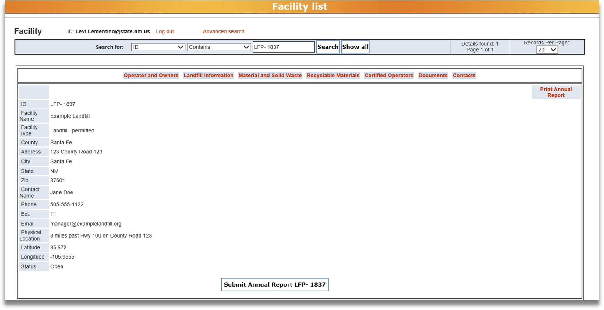
From the Facility List, click on the Material and Solid Waste tab to open window where you will enter your data regarding specific materials managed at your facility.

How to add data to the Material and Solid Waste tab
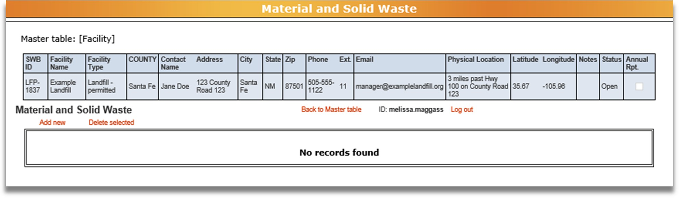
From the Material and Solid Waste tab, click the Add New button to enter new data. Clicking the
Add New button will bring up the screen below.
Note: a separate entry is required for each material type sent to each facility. For example, if your facility sent MSW to two locations (Landfill A and Landfill B), you would need to click Add New and enter the amount of material sent to Landfill A, and then click Add New again to enter the amount of material sent to Landfill B.

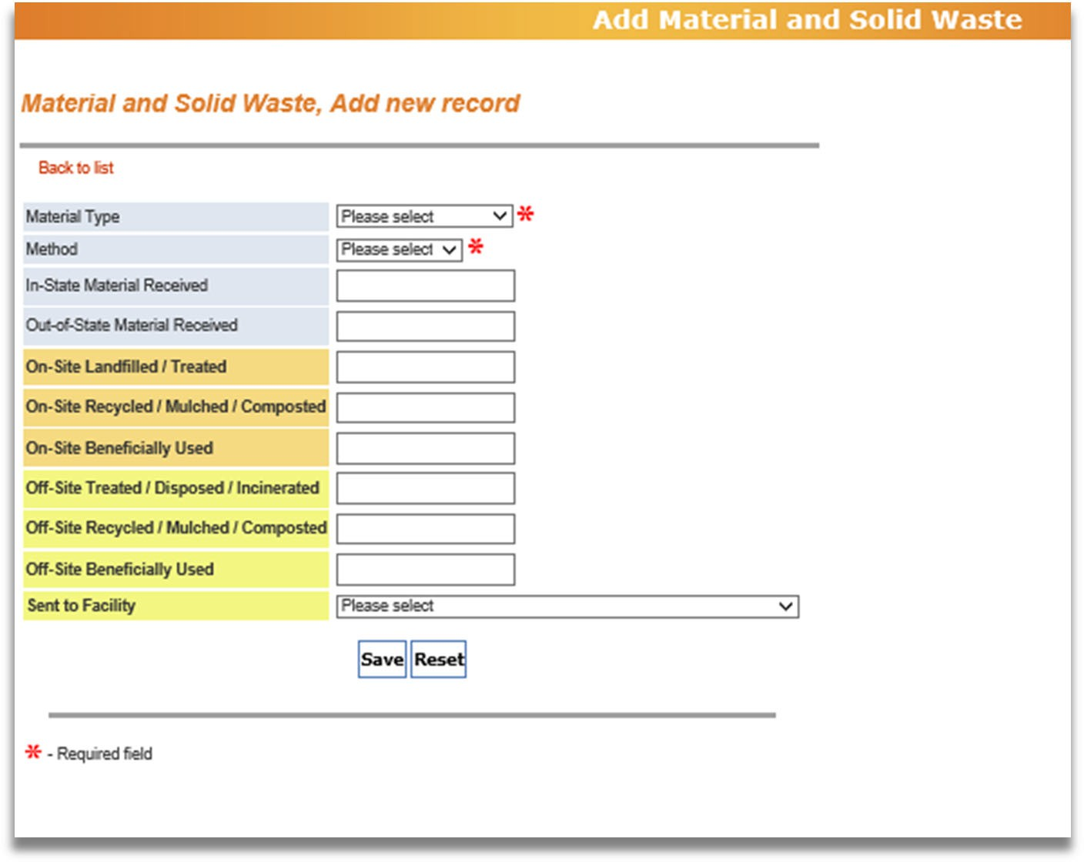
1
2
3
4
5
6
7
8
A separate entry is required for each material type sent to each facility

Material Type
Use the drop‐down arrow to select the material type. For a complete list of material types and their definitions, refer to Appendix B: Material and Solid Waste.
If you need to report a material type that is not specifically included in the drop‐down menu, choose “other” or “other or co‐mingled.”
Note: Be sure to name the type of waste categorized as “other” on the Annual Reporting Information supplemental form.

Method
Use the drop‐down arrow to select whether the material amount was weighed or estimated (calculated using conversion factors; see Appendix D: Conversion Factors).

In‐State Material Received
Enter the tons of material received from within New Mexico. (Remember, the amount of materials in must equal the amount of materials out)

Out‐of‐State Material Received
Enter the tons of material received from outside of New Mexico.

On‐site Landfilled / Treated
On‐Site Recycled / Mulched / Composted On‐Site Beneficially Used
If the material was managed or disposed of on‐site, identify how many tons of the material were managed through each method listed above. For definitions of each type of material management, see Appendix B: Material and Solid Waste.

Off‐Site Treated / Disposed / Incinerated Off‐Site Recycled / Mulched / Composted Off‐Site Beneficially Used
If the material was sent off site, identify how many tons of the material were managed through each method. For definitions of each type of material management, see Appendix B: Material and Solid Waste.

Sent to Facility
If materials were sent off site, use the drop-down list to select the facility the material was sent to. If materials were sent to a facility outside of New Mexico, select “OTHER‐OUT OF STATE.” If the materials were sent to a facility in New Mexico that is not in the dropdown list, please select “OTHER‐IN‐STATE” and name the facility in the General Comments section of the Annual Reporting Information supplemental form (see Section 6: Documents in these Instructions).
Note: If your facility sent the same type of material off‐site to more than one facility (for example, to Landfill A and Landfill B), after saving the data for the material sent to Landfill A, you’ll need to click Add New again to complete the data for the material sent to Landfill B.

Save/Reset
When you have entered all the data for your material, click the Save button to save the data, or click Reset to delete your entry.

How to know if the data was saved to the database
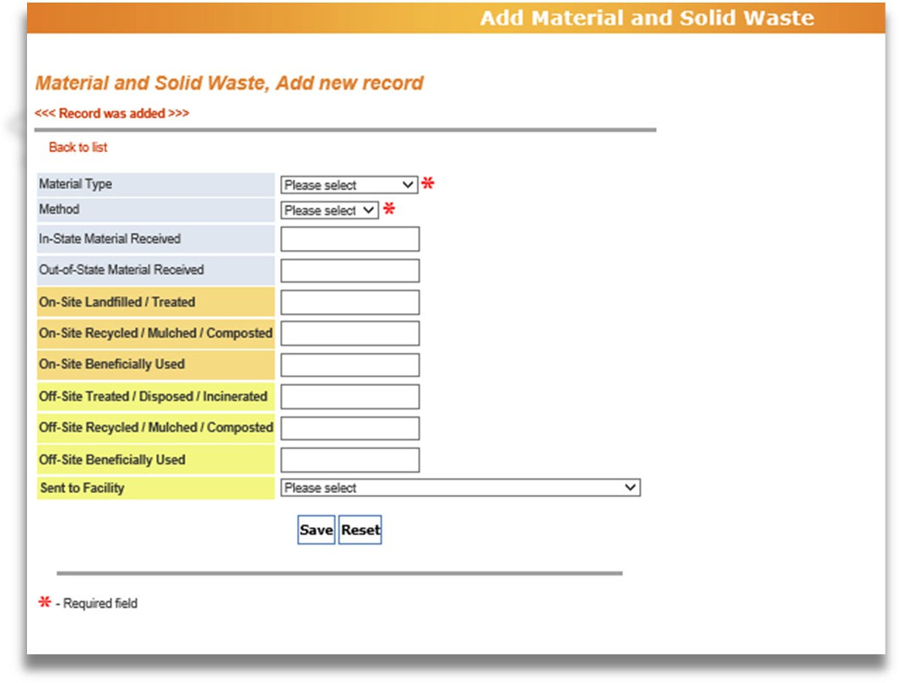


1
2

After clicking the Save button, you will see 1. “Record was added” To return to the Material and Solid Waste tab, click the 2. Back to List button.
To enter data about other materials for the reporting year, go back to the Material and Solid Waste tab, click the Add New button and repeat these steps.

How to delete data from the Material and Solid Waste tab
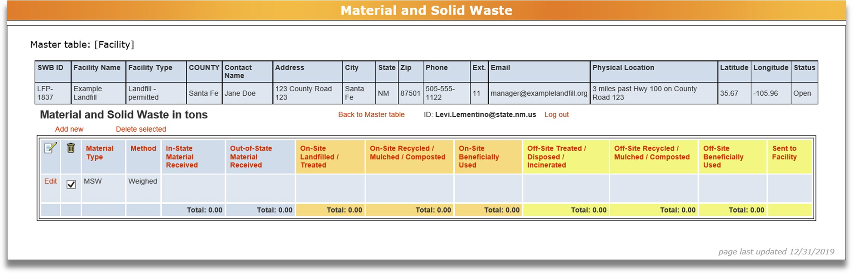



1
2
If you need to delete data from the Material and Solid Waste tab, 1. select the data you want to delete by checking the box next to the material type, and 2. Click the Delete Selected button. After clicking the button, you’ll be asked “Do you really want to delete these records?” Click Ok to delete the selected data or click Cancel if you do not wish to delete selected data.

How to edit data from the Material and Solid Waste tab
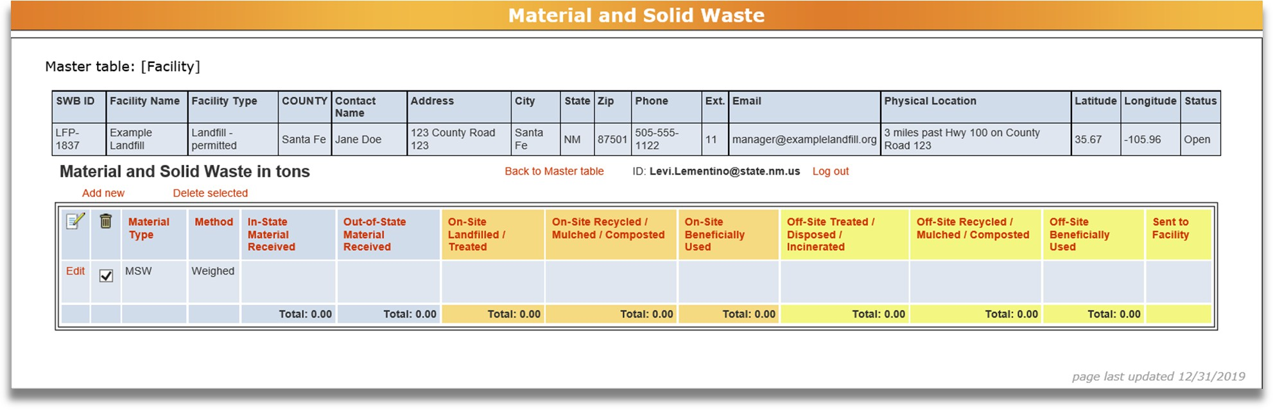


1
To edit an existing entry, 1. click the Edit button in the row you wish to edit, next to the material type. This will take you to a page to edit your data. When you have completed your edits, click Save at the bottom of the page. Then click Back to List to return to the Material and Solid Waste tab.

How to return to the Facility List
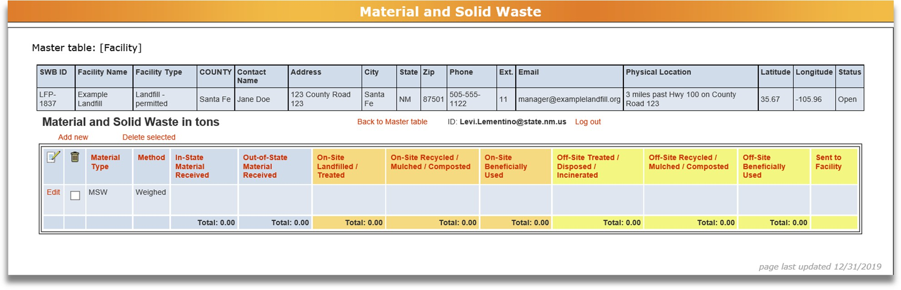

1
When you have finished entering your Material and Solid Waste data and want to return to the Facility List, 1. click the Back to Master Table button.

Recyclable Materials
Any facility that collects, recycles, composts, processes, or beneficially uses materials listed as a type of recyclable material in Appendix C: Recyclable Materials will enter data on this tab. Please see Appendix C: Recyclable Materials for definitions and additional details on each type of recyclable material. Note: some material types collected at your facility for reycling may be found under the “Materials and Solid Waste” tab.

This tab reports on t he origin, type, and amount of recyclable materials managed at a facility. Amounts of materials managed must be reported in TONS. If your facility records the amount of materials managed as volume (for example, cubic yards), use the conversion factors in Appendix D: Conversion Factors to convert to tons.
Note: Do not use commas for numbers entered in text fields.

How to get to the Recyclable Materials tab
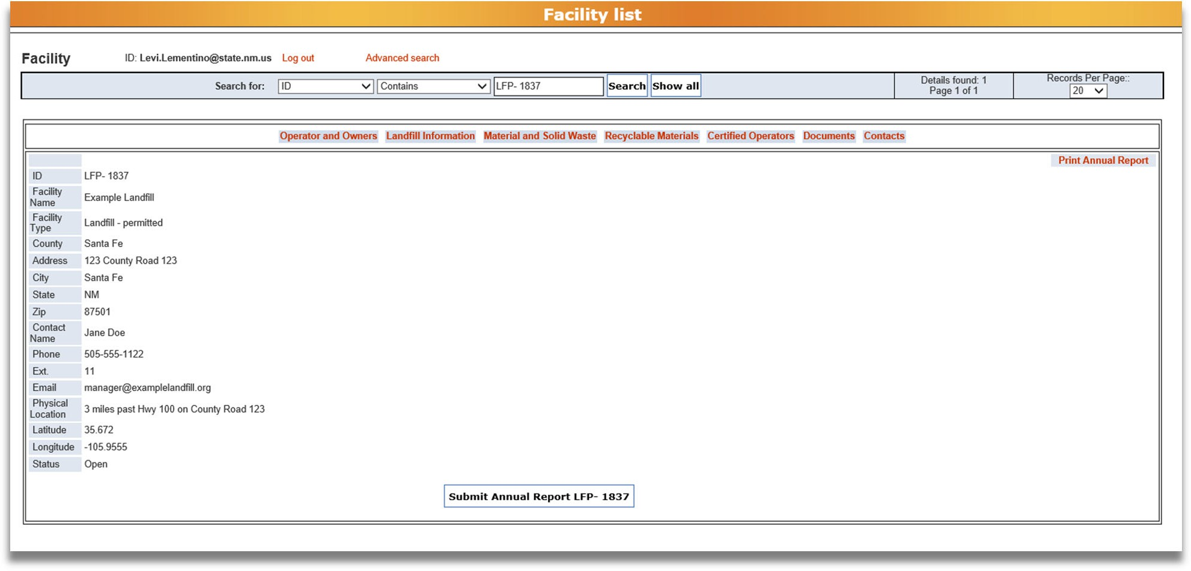
From the Facility List, click the Recyclable Materials tab to enter your data.

How to add data to the Recyclable Materials tab
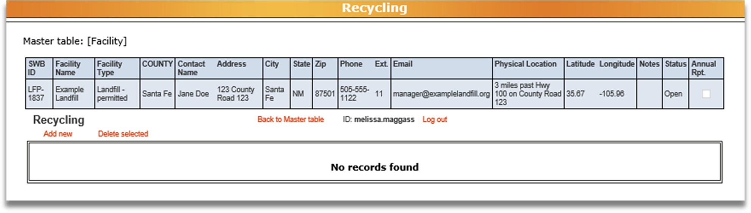
From the Recyclable Materials tab, click the Add New button to enter new data. Clicking the Add New button will bring up the screen below.

Note: when entering data for your facility, a separate entry is required for each material type sent to each facility.For example, if you sent OCC to two locations (Recycling Facility A and Recycling Facility B), you need to click Add New and enter data for the OCC sent to Recycling Facility A, and then click Add New again and enter data for the OCC sent to Recycling Facility B.
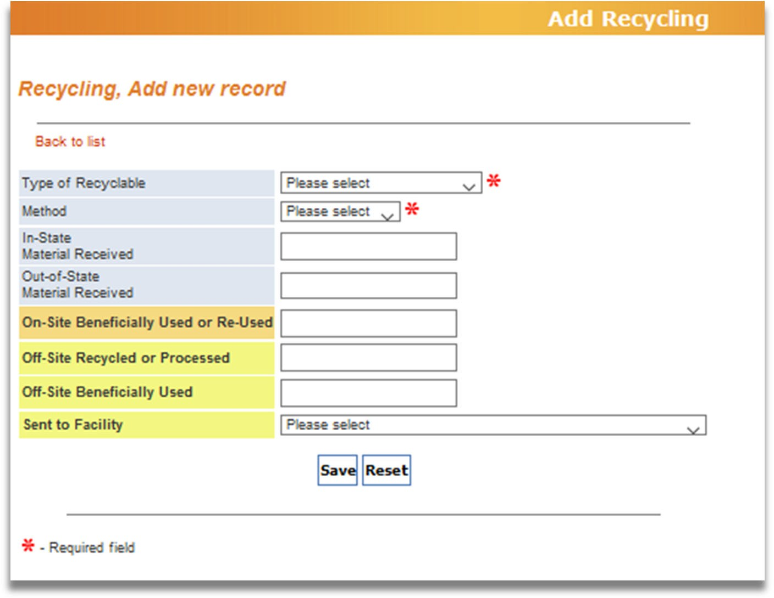





1
2
3
4
5
6
7
8

A separate entry is required for each recyclable material type sent to each facility.

Type of Recyclable
Use the drop‐down arrow to select the type of recyclable material managed. For a list of recyclable materials and their definitions, refer to Appendix C: Recyclable Materials.

Method
Use the drop‐down arrow to select whether the recyclable material amount was weighed (example: using a scale) or estimated (that is, calculated using the conversion factors in Appendix D: Conversion Factors).

In‐State Material Received
Enter the tons of recyclable materials received from within New Mexico.

Out‐of‐State Material Received
Enter the tons of recyclable materials received from outside of New Mexico.

On‐site Beneficially Used or Re‐used
If the recyclable material was managed on‐site, identify how many tons of the material were beneficially used or reused. For definitions of each type of material management, see Appendix C: Recyclable Materials.

Off‐Site Recycled or Processed Off‐Site Beneficially Used
If the recyclable material was sent off‐site, identify how many tons of the material were managed through each method. For definitions of each type of material management, see Appendix C: Recyclable Materials.

Sent to Facility
If recyclable materials were sent off site, select the facility the material was sent to. If materials were sent to a facility outside of New Mexico, select “OTHER‐OUT OF STATE.” If the materials were sent to a facility in New Mexico that is not in the drop‐down list, please select “OTHER‐INSTATE” and name the facility in the General Comments section of the Annual Reporting Information supplemental form (for instructions on how to complete the supplemental forms, see Section 6: Documents of these Instructions).

If your facility sent the same type of material off‐site to more than one facility (for example: Recycling Facility A and Recycling Facility B), after saving the data for the material sent to Recycling Facility A, you’ll need to click Add New again to enter the data for the material sent to Recycling Facility B.

Save/Reset
When you have entered all the data for your recyclable materials, click Save to save the data, or click Reset to delete your entry and start over.

How to know if the data was saved to the database
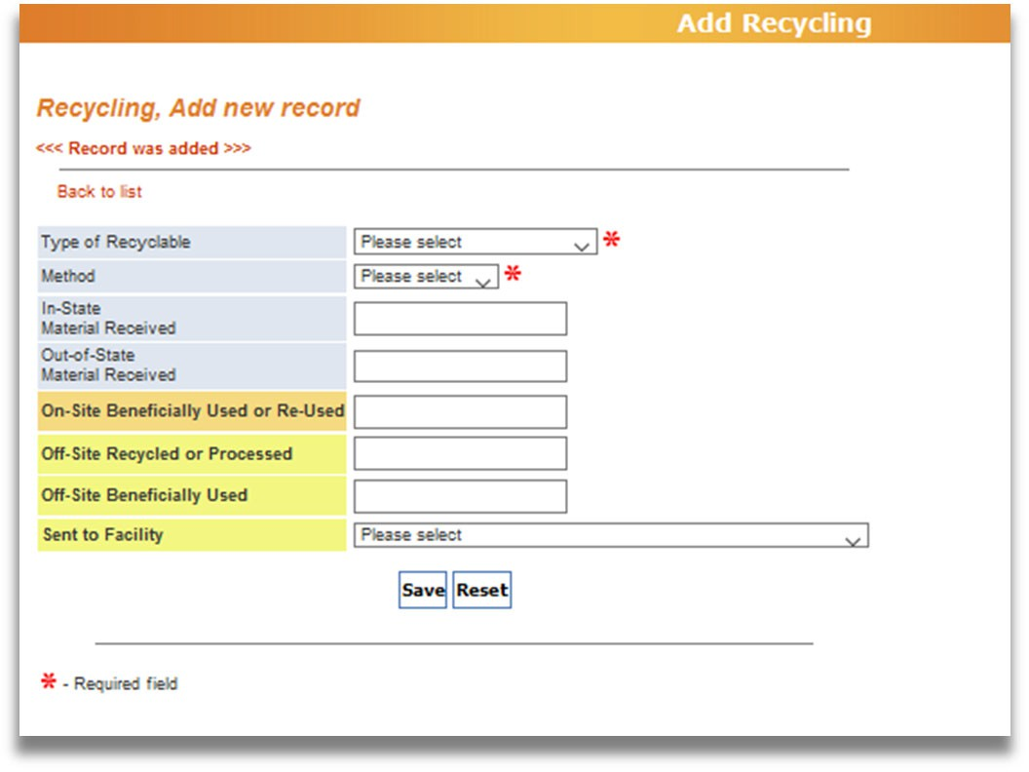



1
2

After clicking the Save button, you will see 1. “Record was added.” To return to the Recyclable Materials tab, 2. click the Back to List button.

How to delete data from the Recyclable Materials tab
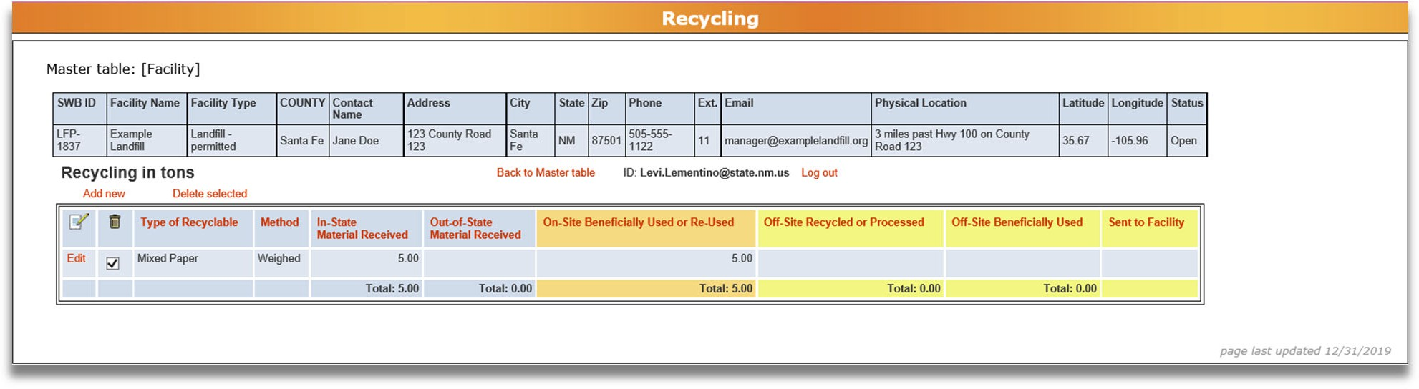


1
2
If you need to delete data from the Recyclable Materials tab, 1. Select the data you want to delete by checking the box next to recyclable type, and 2. Click the Delete Selected button. After clicking the button, you’ll be asked “Do you really want to delete these records?” Click Ok to delete the selected data or click Cancel if you do not wish to delete selected data.

How to edit data from the Recyclable Materials tab
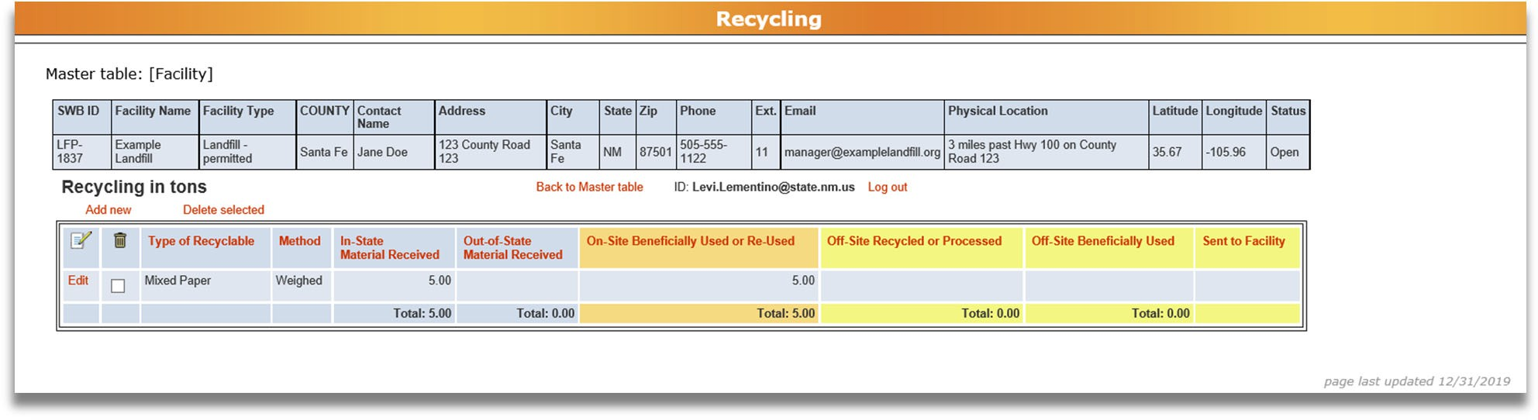


1
To edit an existing row of data, 1. click the Edit button in the row you wish to edit. It will take you to a page to edit your data. When you have completed your edits, click Save at the bottom of the page. Then click Back to List to return to the Recyclable Materials tab.

How to return to the Facility List
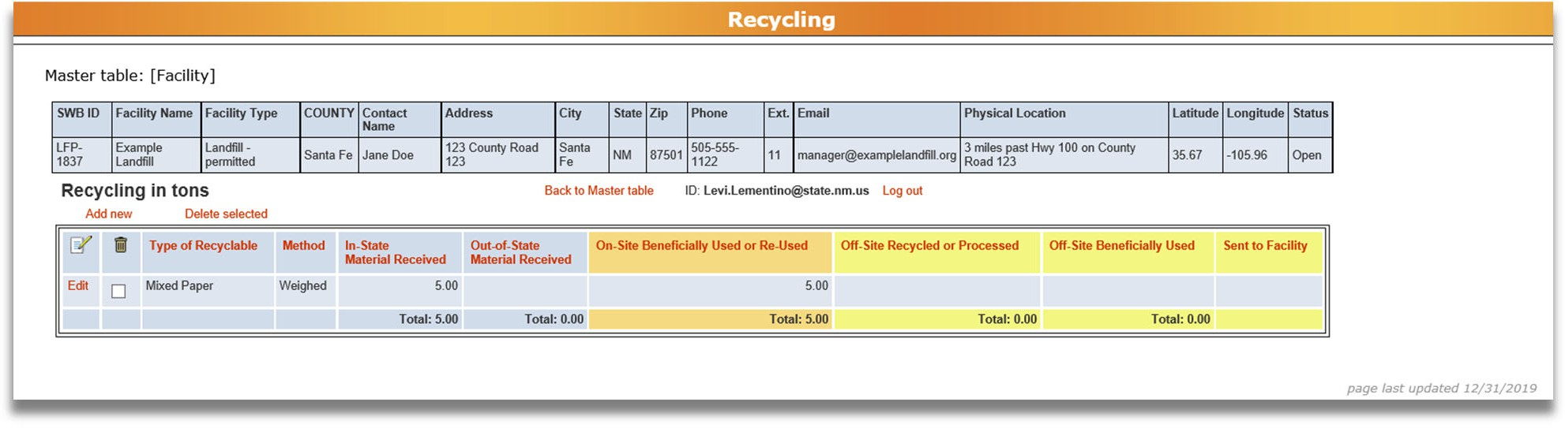
1
When you have finished reporting Recyclable Materials data and want to return to the Facility List, 1. click the Back to Master Table button.

Certified Operators
This tab is available to all facilities and lists the Certified Operators working at the facility.

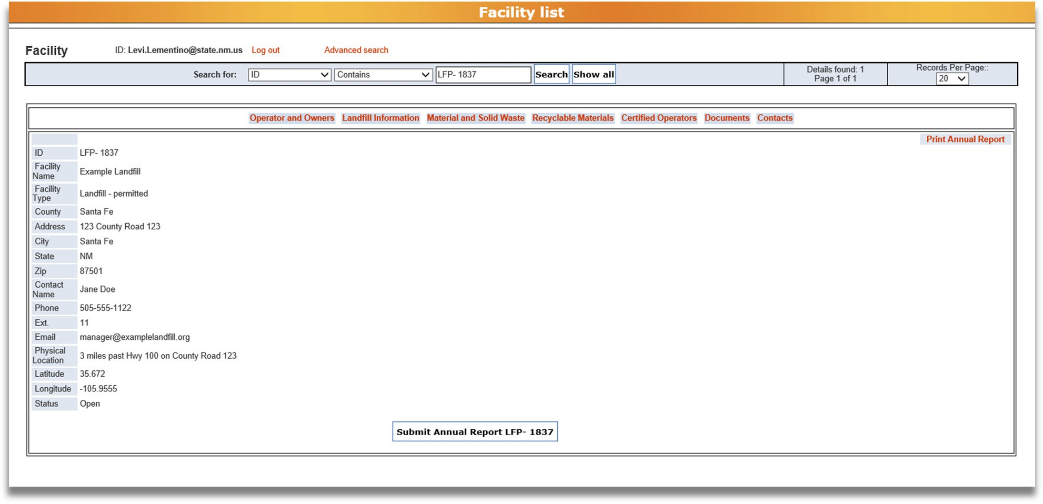
How to get to the Certified Operators tab
From the Facility List, click on the Certified Operators tab to review and update the list of Certified Operators at the facility.

How to complete the Certified Operators tab
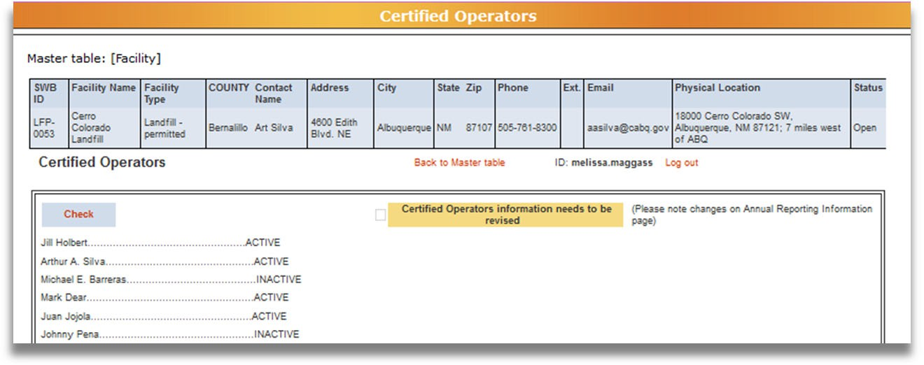



John Doe
John Doe John Doe John Doe John Doe
John Doe
1
2
3

Review the Certified Operators listed as working at the facility. “Active” means that the operator’s certification is currently valid. “Inactive” means the operator’s certification has expired.

Note: please list in the Annual Reporting Information supplemental form, any certified operators that you would like to have deleted from your facility if they are no longer working at facility, or any new certified operators you would like to add to your facility. Please add comment in the Annual Reporting Information form for any changes as well.

If any of the information needs to be updated, 1. Check the box by clicking on the Check button and a 2. checkmark will appear next to “Certified Operators information needs to be revised.” If the information does not need to be updated, do not click the Check button. If changes need to be made, explain the necessary changes on the Annual Reporting Information supplemental form, which you will attach on the Documents tab (see Section 6: Documents in these Instructions). Once you click the Check button, it will change to say Uncheck. To uncheck the box, click the Uncheck button.
Once you have reviewed the information and checked the box if you need to update the list of Certified Operators for your facility, return to the Facility List by 3. clicking the Back to Master Table button.
If you or your operators have any questions about operator certification status, please contact Bill Schueler at: william.schueler@env.nm.gov or (505) 827‐0197.
Note: If you have trouble with the check buttons/checkboxes try using Microsoft Edge, instead of other internet browsers.

Documents
This tab is available to all facilities and is where you attach the supplemental forms to your Annual Report. The supplemental forms can be found on the NMED All Application Forms and Guidance website on the Licences and Permits tab, under the Solid Waste Bureau – “Annual Reporting” drop‐down link: https://www.env.nm.gov/forms/
Download the forms required for your facility type and save to your computer prior to attaching them into the Annual Report database.

Documents to Attach
There are 4 supplemental forms you can attach with your Annual Report:

Annual Reporting Information

All facilities must attach this form
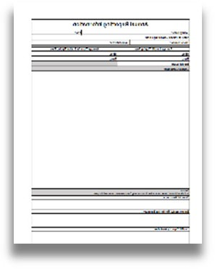
This one‐page form must be completed by all reporting facilities. Download this form from the Solid Waste Bureau website, complete all required sections, save to your computer, and attach on the Documents tab. Report any additional information or comments on this form. Examples include certified operators to remove and changes to material type collected or managed. If the Landfill Capacity Worksheet, Environmental Monitoring Summary, or Financial Assurance Estimate Summary are required but you will not be including them with your Annual Report, please provide an explanation as to why they are not provided and the date you will provide them to the Solid Waste Bureau.

Landfill Capacity Worksheet

All open landfills must attach this form
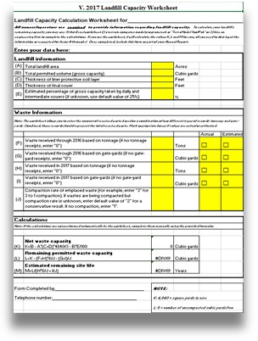
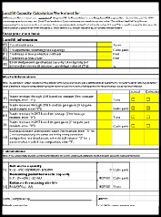
This Excel document must be completed by all open landfills. Download this form from the Solid Waste Bureau website, complete all required sections, save to your computer, and attach on the Documents tab. This worksheet is provided for operators of landfills to estimate the remaining capacity of the landfill. It is only an estimate since generic assumptions are made for the ease of calculations. Please follow the instructions on the worksheet and see the example provided.

Financial Assurance Estimate Summary

Facilities required to have financial assurance must attach this form
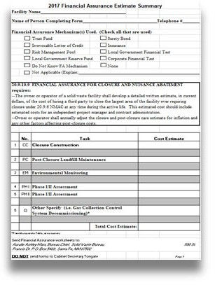
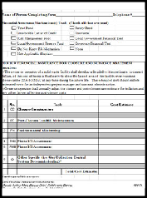
This Excel document must be completed by facilities that are required to have financial assurance. Permitted landfills, permitted transfer stations and large recycling or composting facilities (accepting more than 25 tons per day total, or more than 5 tons per day of material that would otherwise become special waste (such as offal or sludge) are required to submit an updated Financial Assurance Estimate Summary.

Download this form from the Solid Waste Bureau website, complete all required sections, save to your computer, and attach on the Documents tab. Financial assurance must be adjusted annually during the life of the facility and submitted to the Solid Waste Bureau throughout closure and post‐closure care of the facility. Submit only the summary form with your Annual Report.

Note: Do not attach your full Financial Assurance documentation with your Annual Report.

Complete Financial Assurance documentation should be submitted to the Solid Waste Bureau separately by email at: swb.inbox@env.nm.gov

Environmental Monitoring Summary

All landfills must submit this form
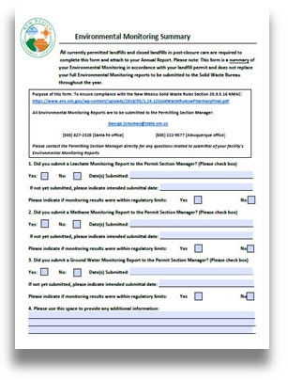
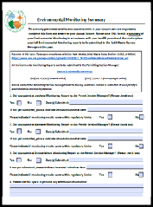
This one‐page form must be completed by all landfills. Download this form from the Solid Waste Bureau website, complete all required sections, save to your computer, and attach on the Documents tab.

Note: Do not attach your full Environmental Monitoring Reports with your Annual Report.
Environmental Monitoring Reports should be submitted throughout the year, in accordance with your landfill permit, to the Permit Section Manager of the Solid Waste Bureau at:
New Mexico Environment Department, Solid Waste Bureau, P.O. Box 5469, Santa Fe, NM 87502.

How to get to the Documents tab
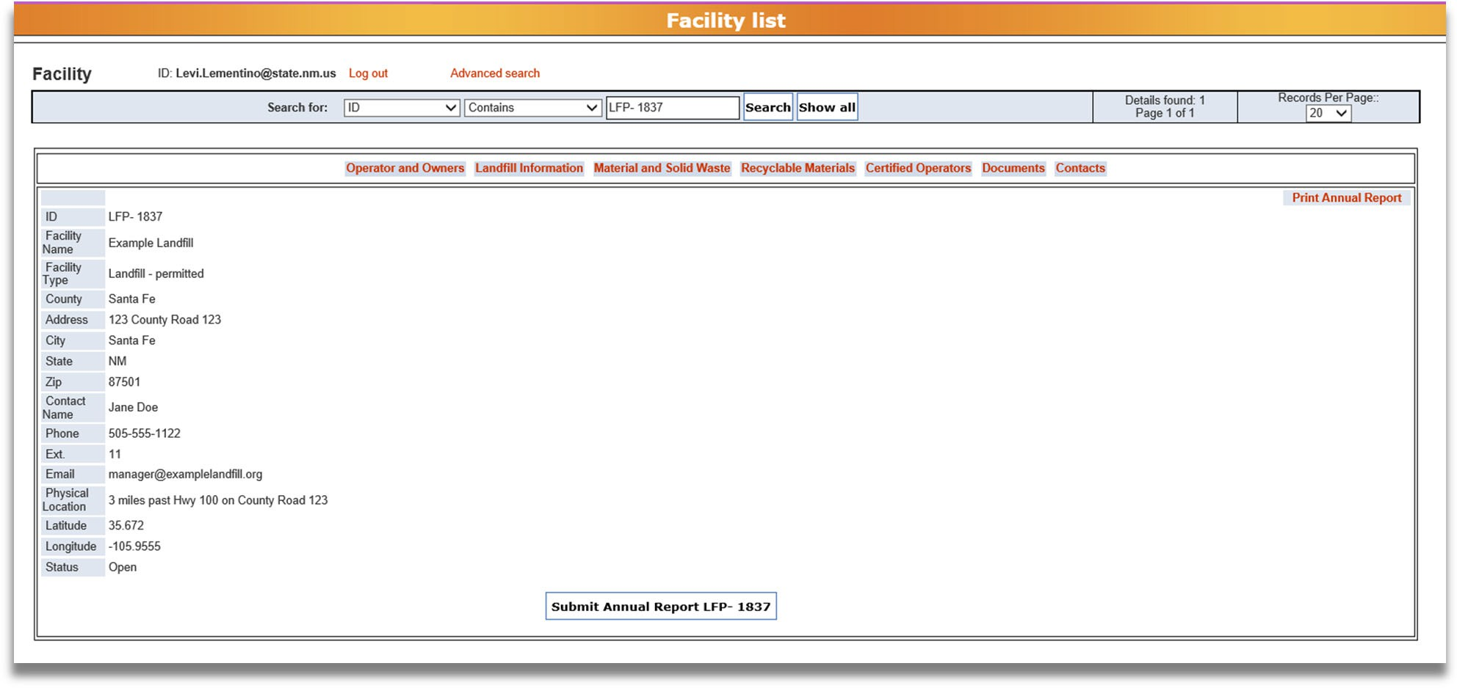
From the Facility List, click on the Documents tab to attach the documents required for your facility.

How to attach a supplemental form on the Documents tab
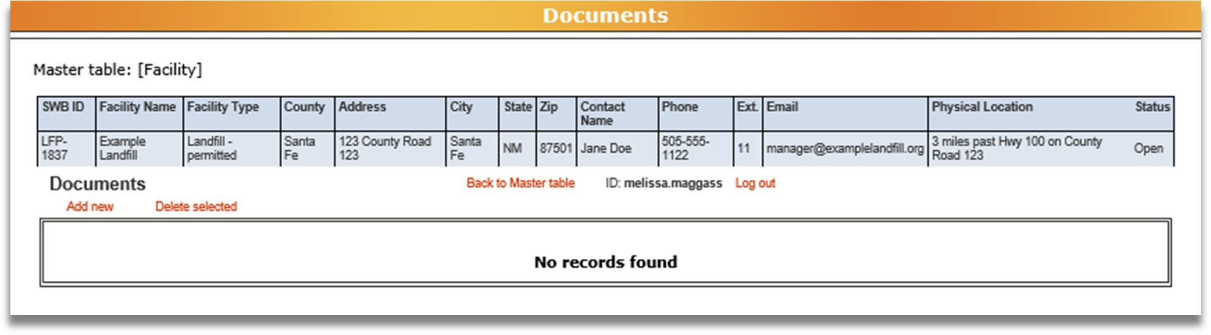
From the Documents tab, click the Add New button to attach a new form. Clicking the Add New
button will bring up the screen below.
Note: you can only attach one form at a time, so repeat this process for each form you need to attach.

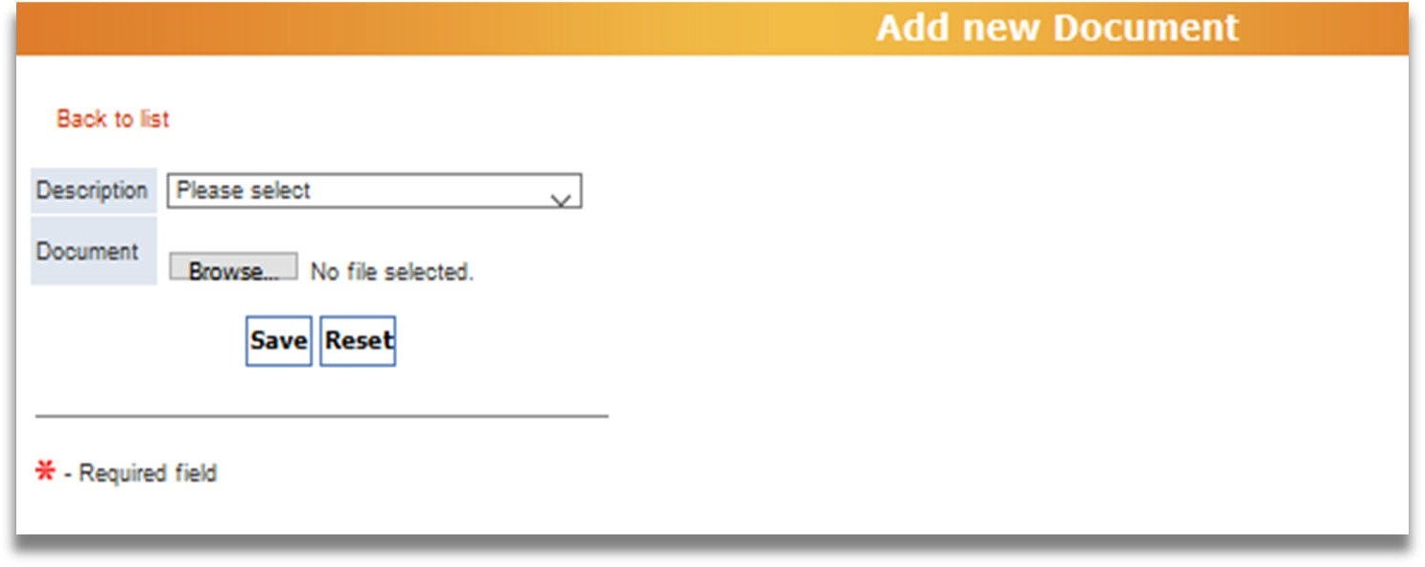
1
2
3

Description
Use the drop down arrow to select which type of supplemental form you are attaching. The four types, described earlier in this section, are:
  - Annual Reporting Information
  - Landfill Capacity Worksheet
  - Financial Assurance Estimate Summary
  - Environmental Monitoring Summary

Document
Use the Browse… button to search your own computer for the file you want to attach. When you have selected the file, the file name will appear to the right of the Browse… button. If you want to change which file you selected, click the Browse… button again and choose the correct file.

Save/Reset
When you have selected the description and the document, click the Save button to attach the file. To erase the description and document, click Reset.

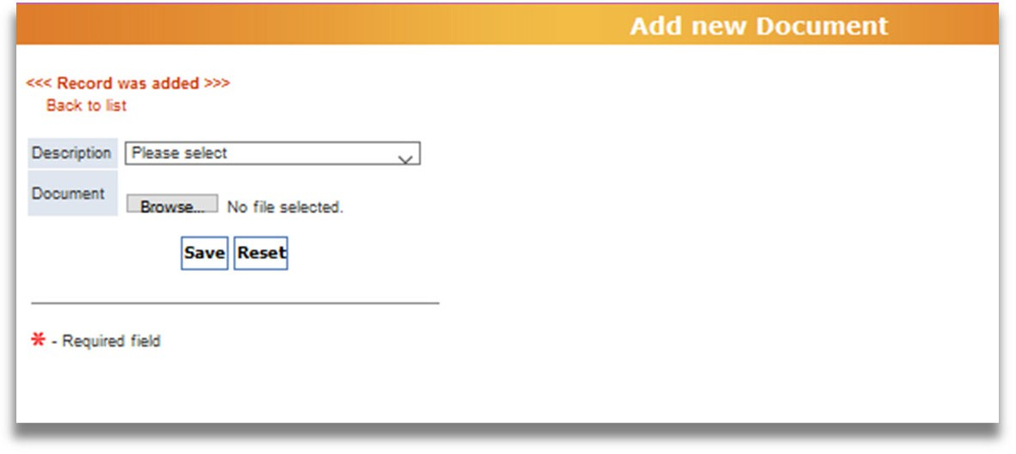


How to know if the form was saved to the database

1
2

After clicking the Save button, 1. you will see this notification saying that the “Record was added.” To return to the Documents tab, 2. click the Back to List button.

How to delete supplemental forms from the Documents tab
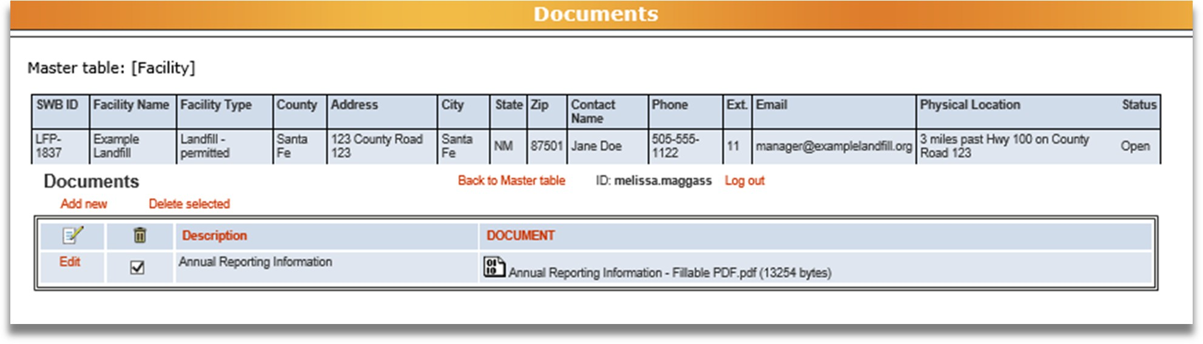


1
2
If you need to delete supplemental forms from the Documents tab, 1. Select the supplemental form you want to delete by checking the box next to the form description, and 2. Click the Delete Selected button. After clicking the button, you’ll be asked “Do you really want to delete these records?” Click Ok to delete the selected supplemental form or click Cancel if you do not want to delete the form.

How to edit a supplemental form on the Documents tab
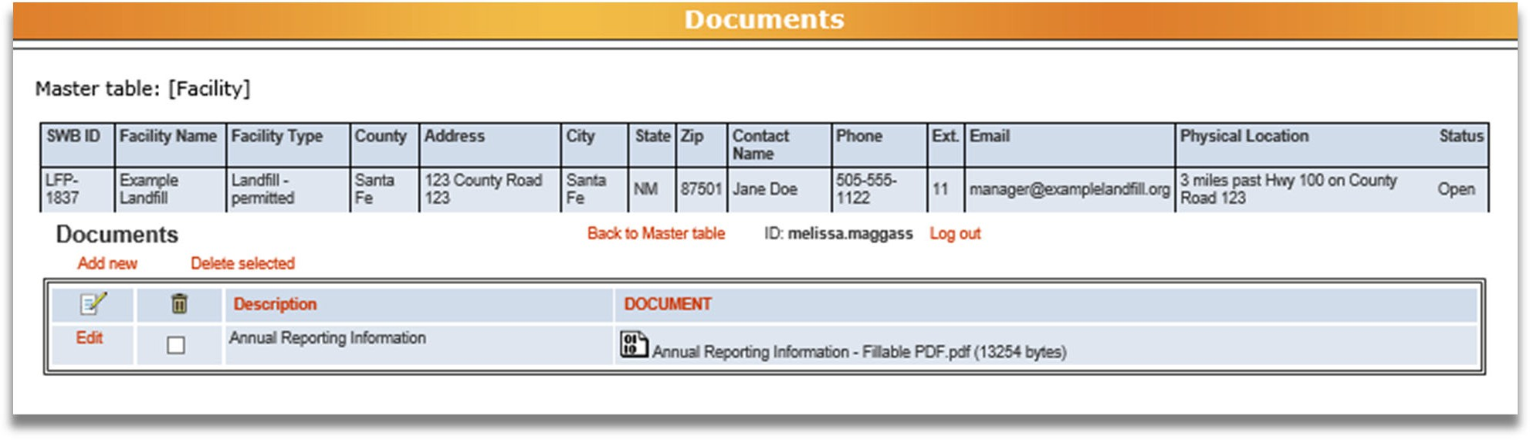

1
To make changes to a supplemental form that you have attached, 1. click the Edit button in the row you wish to edit. This will take you to a page to choose a different description or attach a different document. When you have completed your edits, click the Save button at the bottom of the page. Then click Back to List to return to the Documents tab.

How to return to the Facility List
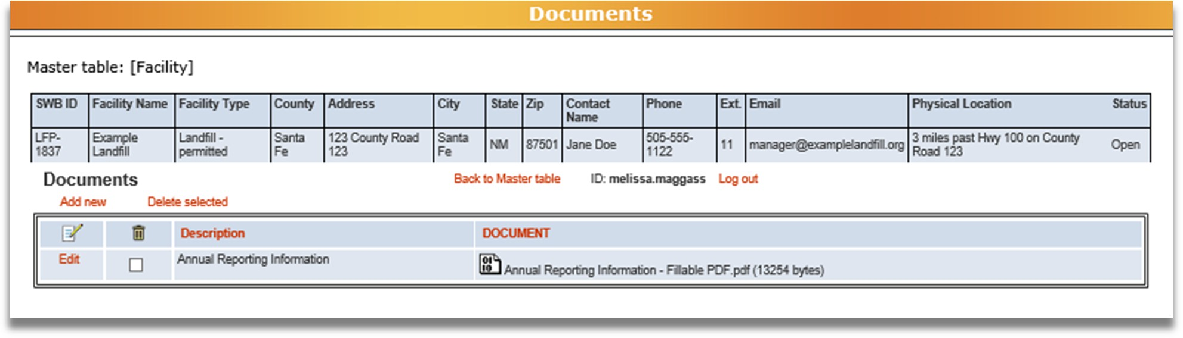

1
To return to the Facility List after you have finished attaching supplemental forms, 1. click the
Back to Master Table button.

Contacts

This tab is available to all facilities and its use is optional. Contact information for additional Annual Report users may be added under this tab so that these individuals will be able to register with NMED for access to the Annual Report database.
Note: Not listing a contact may cause issues with accessing the Annual Report database if that person is trying to submit the annual report.

By entering contact information here, facilities are authorizing these individuals to access, enter data, and submit the Annual Report by using the authorized user’s username and password or by registering separately for access.
A facility may add any individual they choose to authorize to access the Annual Report. Once new users are added, those individuals may register for database access as described in Appendix A.

How to get to the Contacts tab

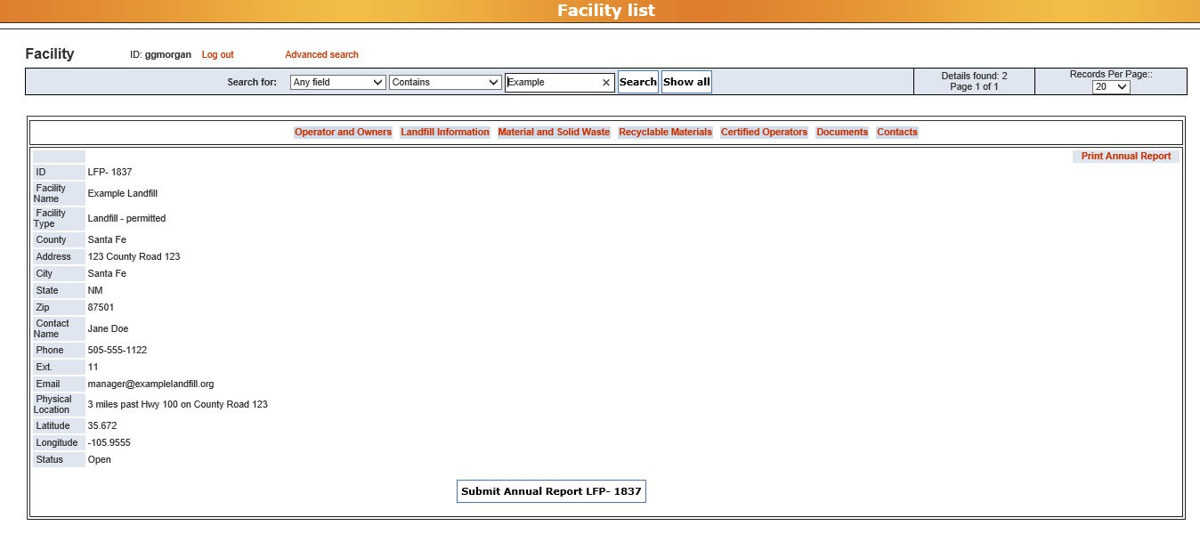
From the Facility List, click the Contacts tab to enter your information.

How to add information to the Contacts tab

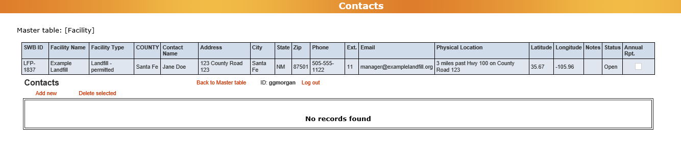
From the Contacts tab, click the Add new button to enter new information. Clicking the Add new button will bring up the screen below.
Note: when entering new contacts for your facility, a separate entry is required for each person authorized to enter or edit Annual Report data.

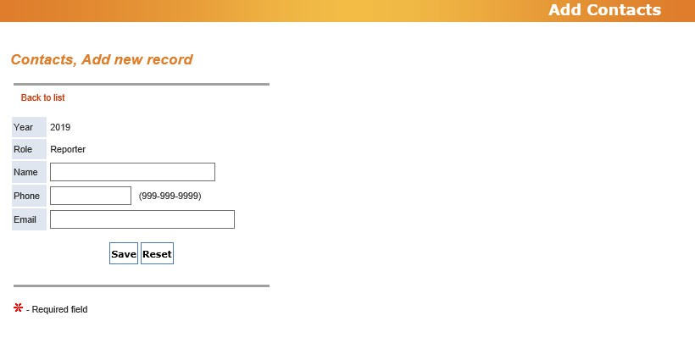




1
2
3
4

Name
Enter the full name of the individual you wish to add as an authorized user of the Annual Report database.

Phone
Enter a number at the facility the individual can be reached at (not a personal number).

Email
Enter the email address associated with this individual for the facility (not a personal email).

Save/Reset
When you have entered all the information for the individual, click Save to save the information, or click Reset to delete your entry.

How to know if the information was saved to the database

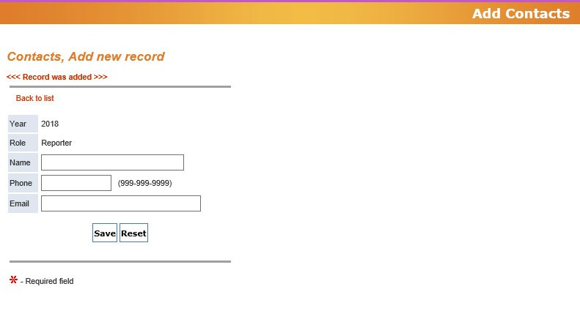


1

2

After clicking the Save button, you will see 1. “Record was Added.” To return to the Contacts
tab, 2. Click the Back to List button.

Click Add New to enter information for each additional authorized user.


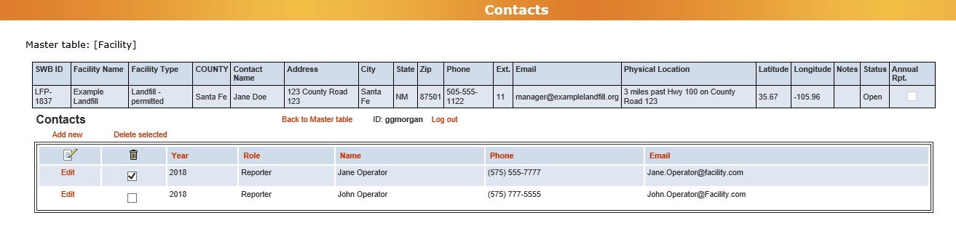


How to delete information from the Contacts tab
1
2

If you need to delete information from the Contacts tab, 1. Select the information you want to delete by checking the box next to the Year, and 2. Click the Delete Selected button. After clicking the button, you’ll be asked “Do you really want to delete these records?” Click Ok to delete the selected information or click Cancel if you do not wish to delete selected information.


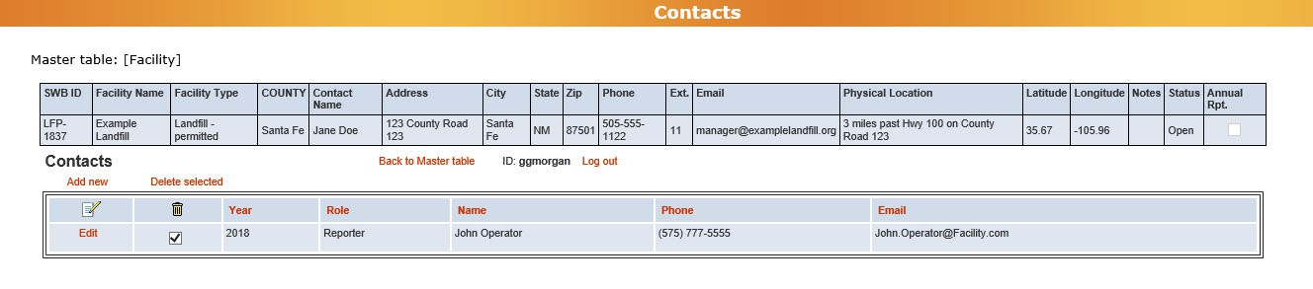

How to edit information from the Contacts tab
1

To edit an existing row of information, 1. Click the Edit button in the row you wish to edit. It will take you to a page to edit your information. When you have completed you edits, click Save at the bottom of the page. Then click Back to List to return to the Contacts tab.


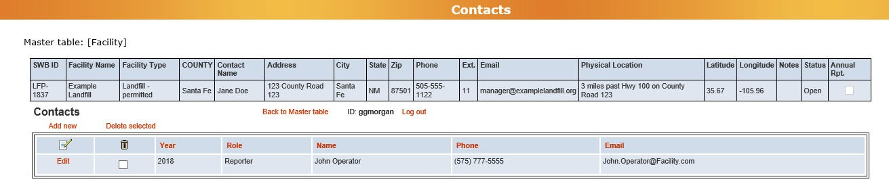
How to return to the Facility List
1

When you have finished entering Contact information and want to return to the Facility List, 1. Click the Back to Master Table button.

Submitting the Annual Report
After you have input and saved the facility data for the reporting year into all the required tabs and you have attached all required supplemental forms, you are ready to submit your Annual Report.
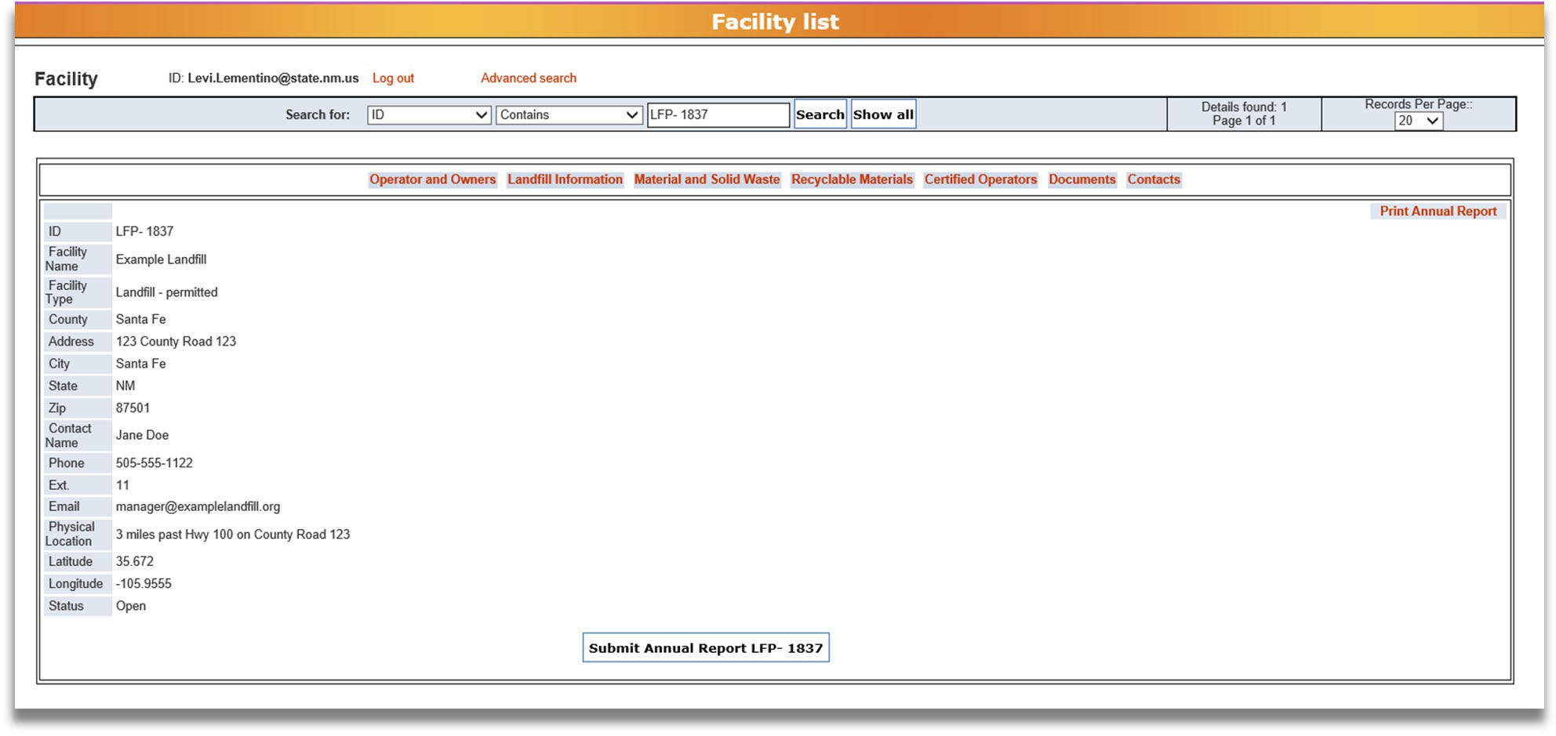
To submit the Annual Report, click the Submit Annual Report button directly below that facility’s information on the Facility List view.
Note: Your Annual Report is not submitted until you press the Submit Annual Report button. You will receive a confirmation email after the Annual Report was successfully submitted.

How to know the Annual Report has been submitted
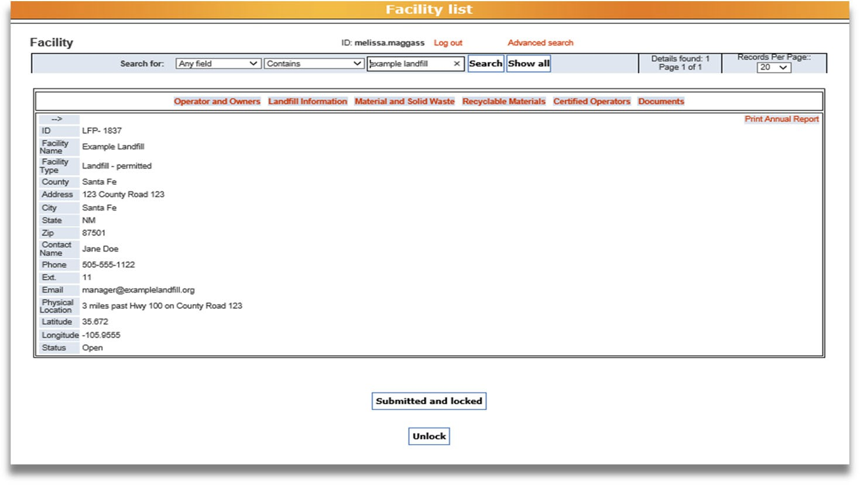

When the Annual Report has been successfully submitted, 1. a “Submitted and Locked” notification will appear.

How to print and save the Annual Report for facility records

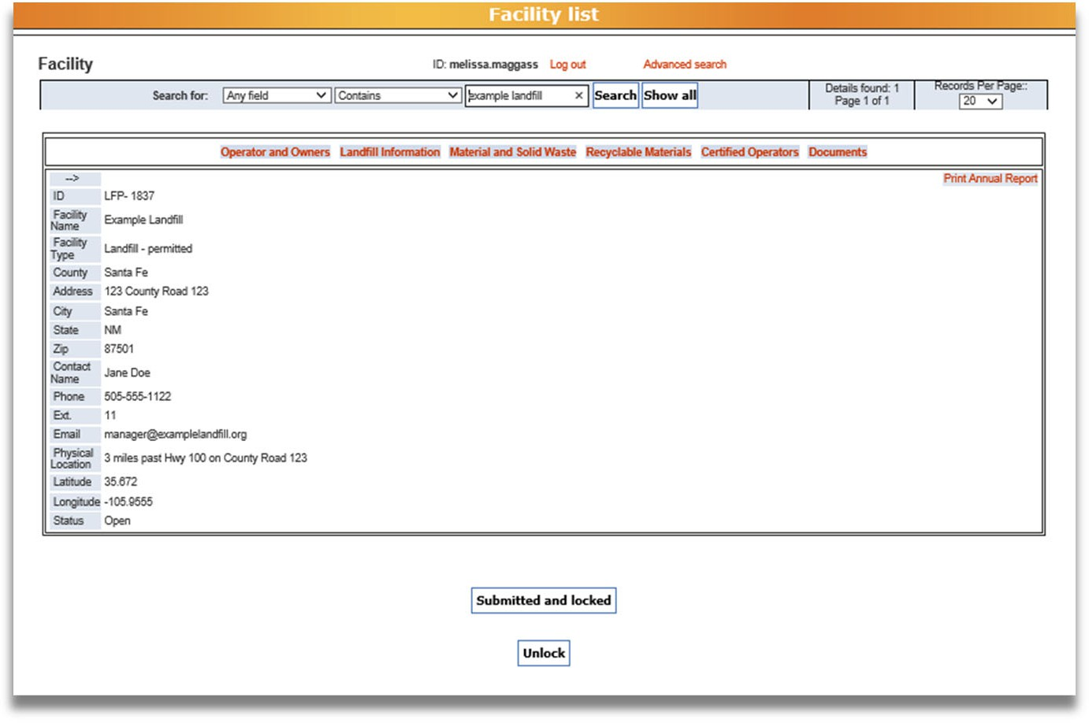

1
1
After submitting the Annual Report, you need to print and/or save the Annual Report for your facility’s records. To print the report, 1. click the Print Annual Report button. Clicking this button opens a new tab in your internet browser with all the content for the Annual Report on a single webpage (pictured below).
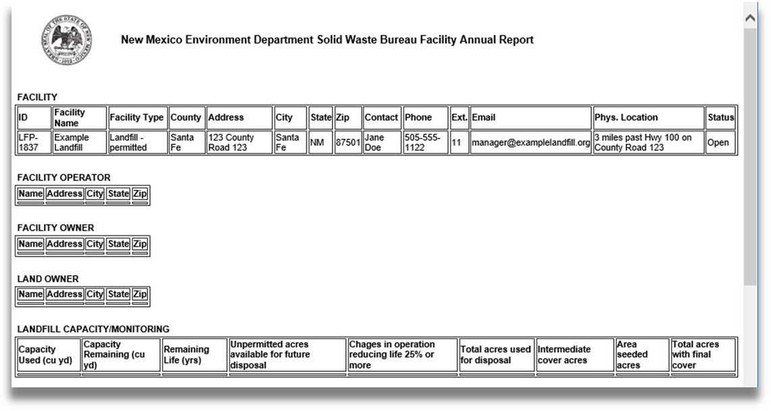
From this webpage, follow your internet browser’s instructions to print a copy of the report. Additionally, the Solid Waste Bureau recommends that from this webpage you save the Annual Report as a PDF to your electronic files for your facility records.

Troubleshooting

Problem: | Try this:
Data is not saved | Use the Back to Master Table or Back to list  buttons, not your browser’s back button.  Click the Save button (at the bottom of the page) before leaving the page.
A facility you sent material to is not on the “Sent to Facility” dropdown list | If the facility was in New Mexico: Choose “OTHER‐INSTATE” and then list the facility’s name on the Annual Reporting Information form (supplemental form; attach on the Documents tab).  If the facility was not in New Mexico: Choose “OTHER OUT‐OF‐STATE.”
You sent one type of material to more than one facility | Click Add New to enter the amount of material you sent to one facility, and then click Add New again to enter the amount of material you sent to another facility.
Your data is not in tons | Use the conversion factor table in Appendix D: Conversion Factors of these Instructions to find a conversion factor for your material and convert the amount into tons.
Checkbox cannot be checked/unchecked | Click on the Check or Uncheck button to the left of the checkbox, not the checkbox itself.
Check or Uncheck button does not work | Use Microsoft Edge instead of other internet browsers.
No Records Found  *Partial amounts of material staying on site | On Material and Solid Waste or Recyclable Materials tabs, click Add New button (on the left side) to add data.  On Documents tab, click Add New button (on the left side) to attach a supplemental form.

Problems Attaching Supplemental Forms | Please attach only these four supplemental forms:  - Annual Reporting Information  - Landfill Capacity Worksheet  - Financial Assurance Estimate Summary (the Excel file only, not the full reports)  - Environmental Monitoring Summary (the 1‐page summary only, not the full reports)  The supplemental forms are available at:  https://www.env.nm.gov/forms/  Click on the Solid Waste Bureau drop‐down tab on the “All Application Forms and Guidance” page then the “Annual Reporting” drop‐down tab to locate the supplemental forms.
Other problems | Use Microsoft Edge instead of other internet browsers.

Questions about: | Contact:
Annual Report System  (registration, login, or problems with database functionality) | Levi Lementino:  Levi.Lementino@env.nm.gov  (505) 827‐0197
Certified Operators | Bill Schueler: William.Schueler@env.nm.gov  (505) 827‐0197
Environmental Monitoring and Financial Assurance | Permit Section: William.Schueler@env.nm.gov  (505) 827‐0197
Other Questions about the Annual Report | Outreach Section  swb.inbox@env.nm.gov  (505) 827‐0197  Matthew Fien Gretton:  Matthew.Gretton@env.nm.gov  Levi Lementino:  Levi.Lementino@env.nm.gov

Appendices
Appendix A. How to Register and Log in to the SWB Annual Report Database Appendix B. Material and Solid Waste (Types and Definitions)
Appendix C. Recyclable Materials (Types and Definitions) Appendix D. Conversion Factors

Appendix A: How to Register and Login to
SWB Annual Report Database

Follow the instructions in this appendix for how to register as a User of the SWB Annual Report Database through the Environment Department’s Secure Extranet Portal (SEP). Once registered as a User, you can login to the Annual Report Database to complete your online SWB Annual Report.

Appendix A: How to Register and Log in to the SWB Annual Report Database

- Go to https://sep.net.env.nm.gov/sep/login‐form .

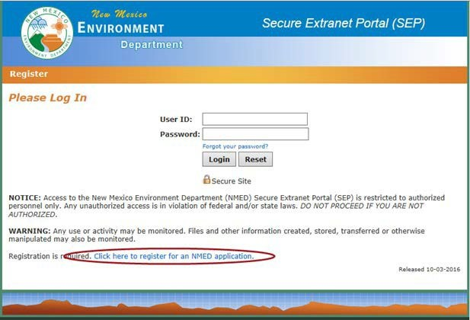
If you have previously registered for access to NMED databases, enter you User ID and password. If not, to register for the SWB Annual Report Database within
NMED’s Secure Extranet Portal (SEP), click on the link that says Click here to
register for an NMED application.

- Fill in your email address twice. Use the email address the Solid Waste Bureau has on file as the contact email for your facility. This will allow you to access the information for your facility.

Enter the Captcha code.
- Click Submit.
NOTE: Check email after submitting. You are not registered till you fill out user profile from link sent to your email.
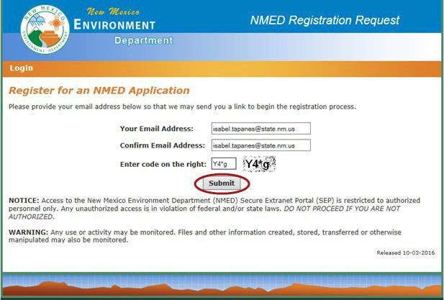

3
4
5
You will receive the confirmation screen below:
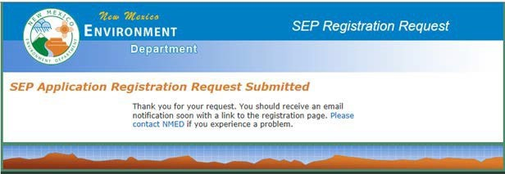

- Open your email and retrieve the SEP Registration Link.
- Click on the link to take you to the User Profile page
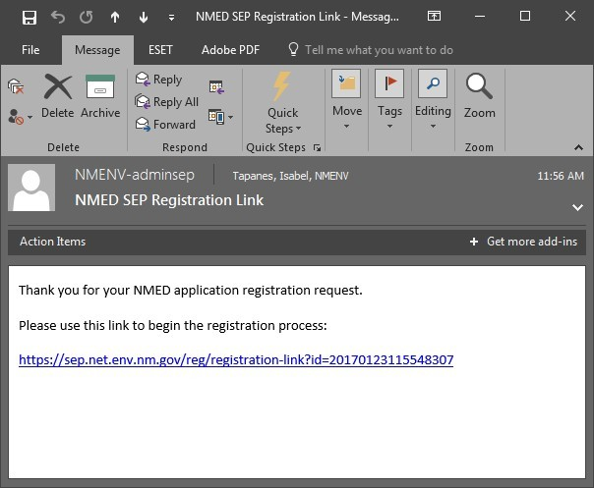


7

- Fill in the fields.
- Create a User ID in the following format: firstname.lastname
- Click Create User Profile

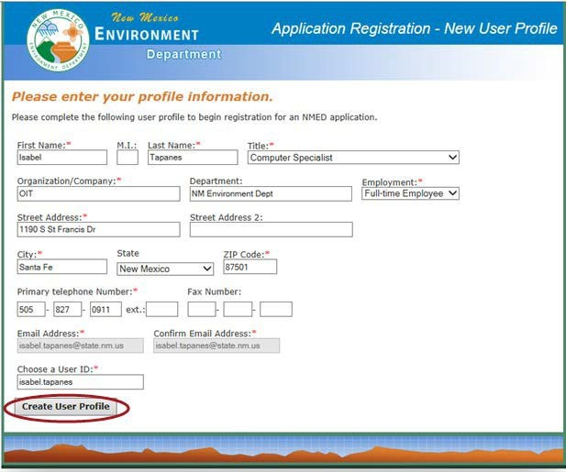
8
9
10

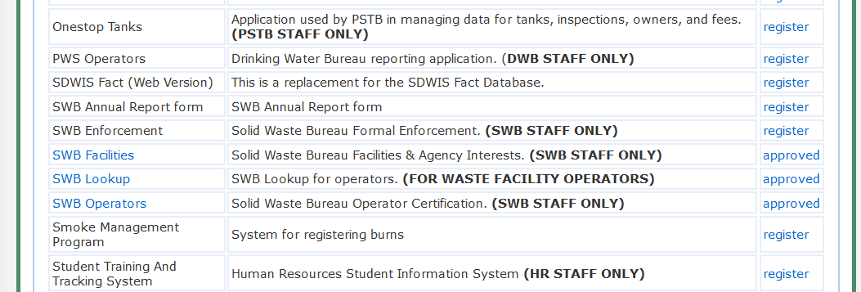
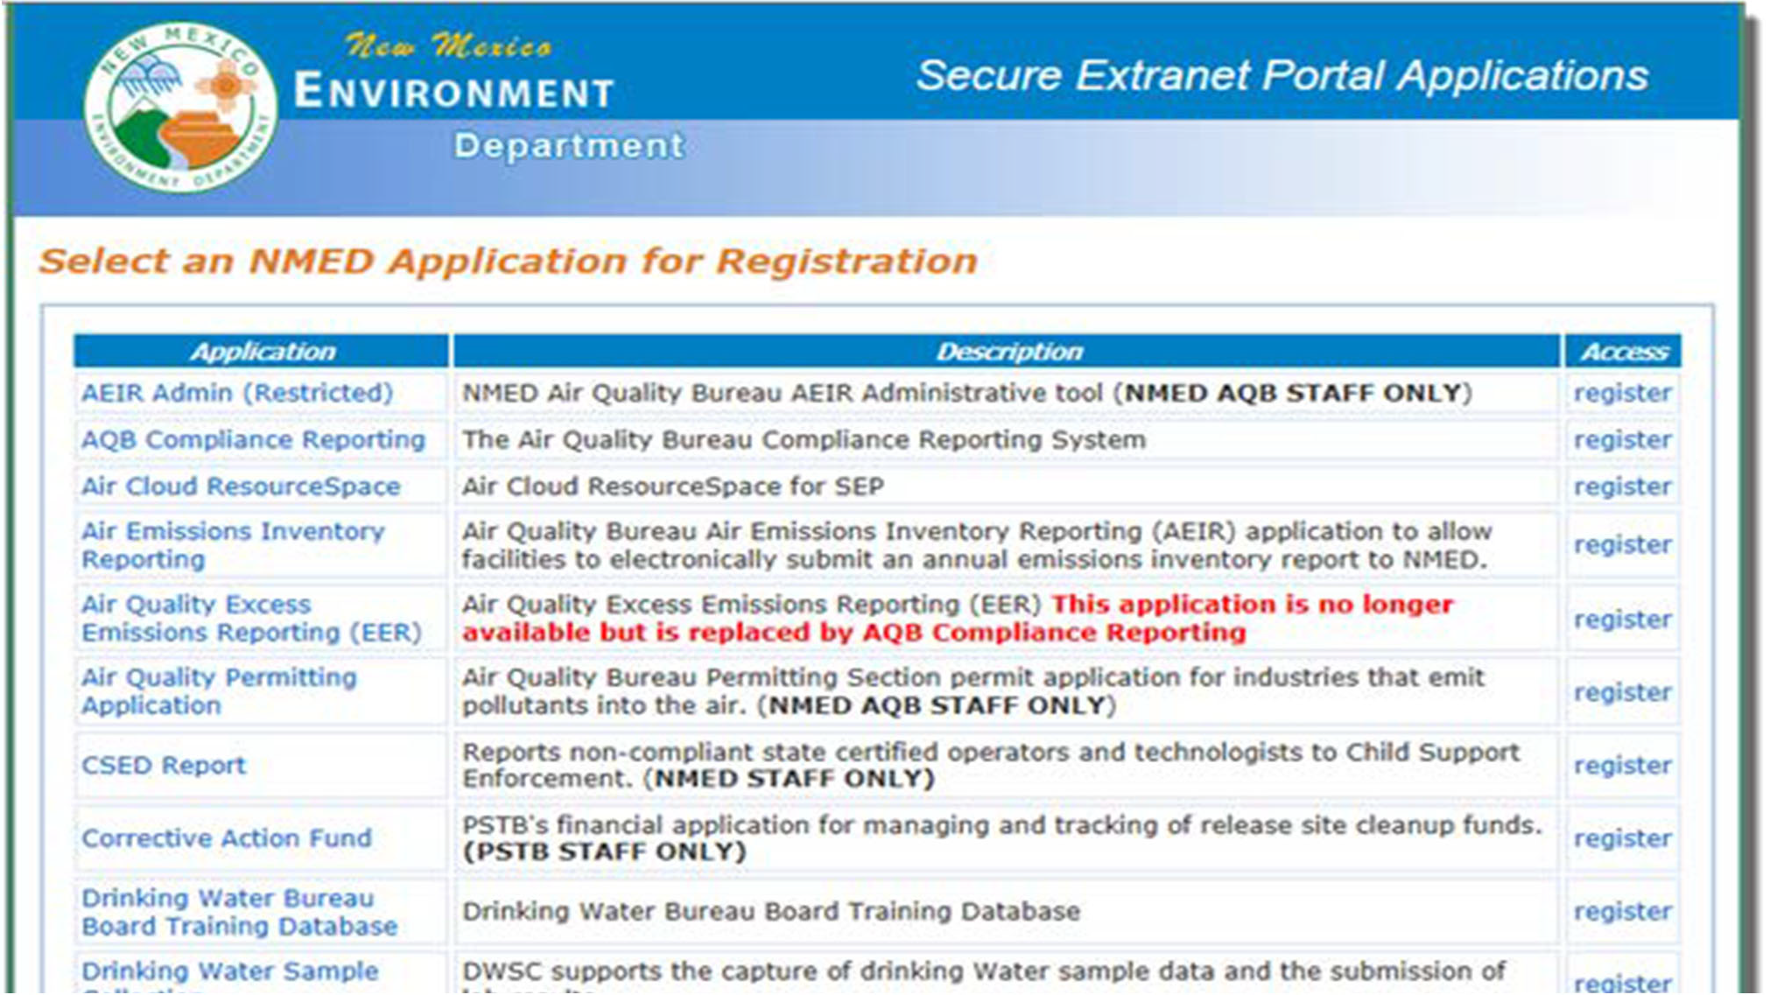
- Scroll down to find SWB Annual Report Form application, click the “register” link to the right.
11

A window like the window below will appear.
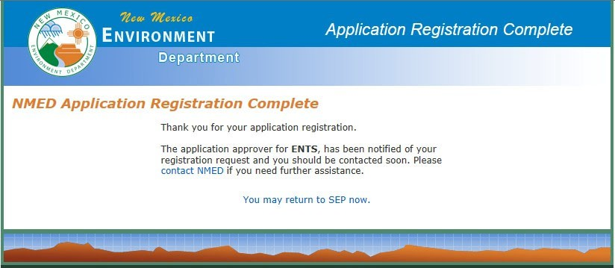

You will be contacted by NMED IT via email or phone once the application is approved for your use. You may then log in to the SWB Annual Report database with in the User ID you created in Step 9 to complete your Annual Report.

Appendix B: Material and Solid Waste

Definitions contained in this appendix are provided to assist facilities with completing the Materials and Solid Waste portion of the Annual Report.
Specific definitions can be found in the New Mexico Solid Waste Rules 20.9.2.7.

Material Type Definitions
Antifreeze | A liquid used as a coolant in many types of motor vehicles and generally contains  ethylene glycol.
Ash (Special Waste) | Ash that results from the incineration or transformation of solid waste and includes both fly ash and bottom ash, and ash from the incineration of densified-refuse- derived fuel and refuse-derived fuel (this does not include fireplace or household  ash).
Bio-Solids (Treated Sewage Sludge) (Special Waste) | Any solid, semi-solid or liquid residue generated during the treatment of domestic sewage in a treatment works. If Bio-Solids are NOT being landfilled but used as a source material for compost, report this amount in the "On-Site Beneficially Used” row or "Off-Site Beneficially Used” row.
Brush/Green Waste | Vegetative waste and yard waste. These wastes must be recorded cumulatively.
Vegetative Waste | Decomposable materials generated by yard and lawn care or land clearing activities and includes, but is not limited to, leaves, grass trimmings, woody wastes such as shrub and tree prunings, bark, limbs, and roots.
Yard Waste | The fraction of municipal solid waste that consists of grass clippings, leaves, brush, and tree prunings arising from general landscape maintenance.
Clean Fill | Materials such as broken concrete, brick, rock, stone, glass, reclaimed asphalt pavement or uncontaminated soil generated from construction and demolition activities. Must be free of other solid waste or hazardous waste.
C & D (Construction/ Demolition / Debris) | Construction waste, demolition waste, and debris waste. These wastes must be recorded cumulatively (see definitions below for description of Construction,  Demotion, and Debris waste).
Construction Waste | Solid waste which is produced or generated during construction, remodeling, or repair of pavements, houses, commercial buildings, and other structures.  Construction wastes include, but are not limited to lumber, wire, sheetrock, broken brick, shingles, glass, pipes, concrete, paving materials, and metal and plastics if the metal or plastics are a part of the materials of construction or empty containers for such materials. Paints, coatings, solvents, Asbestos, any liquid compressed gases or semi-liquids and garbage are not construction wastes.
Debris Waste | Wastes resulting from land clearing operations. Debris wastes include, but are not  limited to wood, brush, leaves, soil, and road spoils.
Demolition Waste | Solid waste which is produced by the destruction of structures and their  foundations and includes the same materials as construction wastes.
HHW - Household Hazardous Wastes | Wastes from products purchased by the general public for household use that, because of their quantity, concentration, or physical, chemical characteristics, may pose a substantial known or potential hazard to human health, or the environment, if improperly treated, disposed, or otherwise managed. Examples are cleaning solvents, sprays, insecticides, herbicides, pharmaceuticals, etc.

Industrial Waste (Special Waste) | Any solid waste generated by manufacturing or industrial process that is not a regulated hazardous waste. Such waste may include, but is not limited to, waste resulting from the following manufacturing processes: Electric power generation; fertilizer/agricultural chemicals; food and related products/by-products; inorganic chemicals; iron and steel manufacturing; leather and leather products; nonferrous metals manufacturing/foundries; organic chemicals; plastics and resins manufacturing; pulp and paper industry; rubber and miscellaneous plastic products; stone, glass, clay, and concrete products; textile manufacturing; transportation equipment; and water treatment. This term does not include mining waste or oil and gas wastes.
Infectious Waste (Special Waste) | Solid waste that carries a probable risk of transmitting disease to humans or animals. Infectious waste that is sent off-site for treatment is reported in the "Off- Site Treated / Disposed / Incinerated” row. Infectious waste that is treated on-site is reported in the "On-Site Landfilled / Treated” row. Infectious waste that has been treated and rendered non-infectious is municipal solid waste. Note: Infectious waste that has not been rendered non-infectious may not be disposed in a landfill.
Lead Acid Batteries | A battery with a core of elemental lead and a capacity of six or more volts. Lead  acid batteries may not be disposed in a solid waste landfill. Lead acid batteries must be sent off-site to be recycled.
Motor Oil | Any oil that has been refined from crude oil, or any synthetic oil, that has been used and as a result of such use is contaminated by physical or chemical impurities. Used oil may not be disposed in a landfill. It must be recycled (or may be burned for energy recovery if the oil does not exceed the allowable level of arsenic, cadmium, lead, flash point and total halogens listed in Table I of 40 CFR 279.11).
Municipal Solid Waste (MSW) | Waste which is normally composed of residential, commercial, and institutional solid waste that is not a special waste. Do not include the amounts of recyclable materials itemized on the Recyclable Materials Tab.
Offal (Special Waste) | Waste parts of butchered animals. If offal is NOT being landfilled but used as a feed stock for compost, report this amount in the "On-Site Beneficially Used” row or the  "Off-Site Beneficially Used” row.
Other Sludges (Special Waste) | Any solid, semi-solid or liquid waste generated by a municipal, commercial or industrial waste water treatment plant, water supply treatment plant or air pollution control facility, but does not include treated effluent (sewage) from a  waste water treatment plant.
Other Special Wastes | Other special wastes that are not specifically identified (examples: Treated  Formerly Characteristic Hazardous Waste (TFCH); Spill of a Chemical Substance or Commercial Products).
Other Wastes | Any wastes that do not meet the previously listed waste types. Please total all other wastes and provide that number in this material type. (Example: Non- domestic oil and gas waste allowed to be disposed in Municipal Landfill as Listed in 19.15.9.712 NMAC—Oil Conservation Division.)

PCS - Petroleum Contaminated Soil (Special Waste) | Soil that, as a result of a release or human usage, has absorbed or adsorbed only petroleum or petroleum by-products at concentrations above those consistent with nearby undisturbed soil or natural earth materials. Petroleum and petroleum by-products include, but are not limited to diesel fuels, kerosene, gasoline, hydraulic fluids, jet engine fuel, and motor oil.
Regulated Asbestos (Regulated Asbestos Containing Material [RACM]- Special Waste) | Any waste material containing more than 1% asbestos as determined using the polarized light microscopy methods specified in 40 CFR Part 763, Subpart F, Appendix A, Section 1, that, when dry, is capable of being crumbled, pulverized or reduced to powder by hand pressure; Or material that is a Category I or Category II non-friable material the is or is likely to be handled in such a manner that would cause the material to become friable.
Scrap Tires | A tire, including a baled tire that is no longer suitable for its originally intended purpose because of wear, damage, defect or obsolescence. Baling of tires is not considered recycling. Transfer Stations and Landfill accepting tires and baling on- site, report amounts in the "On-Site Beneficially Used” row. Transfer Stations and Landfills accepting tires and sending off-site for baling, report amounts in the Off- Site Beneficially Used” row. Transfer Stations and Landfill accepting tires and sending off-site to be made into crumb rubber, report amounts in the "Off-Site Recycled / Mulched / Composted" row.
Waste Origin
In-State Material Received | All materials generated in-state that were received by the facility during the Annual  Reporting Period must be reported in this row.
Out-of-State Material  Received | All materials generated out-of-state that were received by the facility during the  Annual Reporting Period must be reported in this row.
Waste Management Methods
On-site Landfilled / Treated | Waste that was landfilled or treated on-site must be reported in this row. Waste received at a facility that was later sent off-site for management through landfilling or treatment must not be reported in this row. Instead it must be reported in the "Off-Site Treated / Disposed / Incinerated" row.  Infectious waste that was treated and rendered non-infectious on-site must be reported in this row. Once infectious waste is treated, do not report the same tonnage as “Off-Site Treated / Disposed / Incinerated”. Report this quantity only once (Infectious waste that has not been treated nor rendered non-infectious can not be landfilled. Do not report untreated infectious waste in this row).
On-Site Recycled / Mulched / Composted | Waste that was stabilized on-site through a controlled aerobic decomposition process must be reported in this row. Record the materials used in the making of compost. Finished composted material is considered a product and not a waste. Do not report the quantities of finished compost produced on this Tab. Record waste that was mulched on-site in this row.

On-Site Beneficially Used | Material/waste that was beneficially used or reused on-site must be reported in this row (Examples: Crushed concrete or ground asphalt used for road building on a landfill site; Clean fill used as alternative daily cover (if approved by the department); Scrap tires or tire bales used in engineering projects on-site).
Off-Site Treated / Disposed  / Incinerated | Waste that was not treated, disposed, or incinerated at the receiving facility but was instead sent off-site to another facility for management must be reported in this row. (Examples: Waste received at a transfer station that was later sent off- site to a landfill for disposal; an infectious waste sent off-site to an incinerator to  be rendered non-infectious.)
Off-Site Recycled / Mulched / Composted | Material that was removed from the incoming waste stream or collected, sorted or baled and sent off-site to be recycled, mulched or composted must be reported on this row (Examples: Lead acid batteries segregated from the waste stream and sent off-site to a recycling facility for recycling; Vegetative waste sent to an off-site composting facility to be composted or mulched; Scrap tires sent off-site to be made into crumb rubber).
Off-Site Beneficially Used | Material/waste that was sent off-site to be beneficially used or reused must be reported in this row (Examples: Crushed concrete or ground asphalt used for road building off-site; Scrap tires collected on-site but sent off-site to be baled,  retreaded or reused).
Sent To | If material was sent off-site please select the facility that received the material  from the drop-down menu

Appendix C: Recyclable Materials

Definitions contained in this appendix are provided to assist facilities with completing the Recyclable Materials portion of the Annual Report.
Specific definitions can be found in the New Mexico Solid Waste Rules 20.9.2.7.

Material Type Definitions
Mixed Paper | Refers to a mixture, unsegregated by color or quality, of at least two of the following paper wastes: newspaper, corrugated cardboard, office paper, computer paper, white paper, coated paper stock, or other paper waste. Mixed paper  definitions vary by receiving mills.
Old Corrugated Cardboard (OCC) | Corrugated containers recovered and marketed to mills for use in manufacturing new corrugated containers. Identified by a wavy inner layer.
Old Newspaper (ONP) | Includes all reading material printed on “groundwood” paper, such as newspapers, newspaper inserts, advertising mailings, many catalogs and magazines, and many government publications and forms. Groundwood is produced by mechanical grinding to break down lignin fibers when pulping the wood. It is identified by sight, touch, or application of a test chemical. Many glossy publications like magazines are groundwood coated with clay for better color and photographic reproduction. Modern de-inking processes can reclaim newspaper and glossy stock for manufacture of new newsprint or other paper products such as brown paper towels, egg cartons, or cereal boxes that are gray on the inside surface.
Office Paper | Office bond paper, white ledger paper, laser printer paper, file stock and photocopy paper with presentation quality fiber content and consistency.
Phone Books | Telephone books distributed by companies such a Qwest, Dex etc.
Chip Board | Cereal, cracker, shoe, and gift boxes, etc. Also known as box board or liner board.  It does not have a wavy center layer.
Plastic | Plastic containers used to hold consumer products, such as milk, juice, water,  shampoo, or detergent.
Aluminum | Aluminum containers used to hold consumer products, such as milk, juice, water,  shampoo, or detergent.
Steel Cans | Steel containers used to hold consumer products, such as milk, juice, water,  shampoo, or detergent.
Glass | Glass containers used to hold consumer products, such as milk, juice, water,  shampoo, or detergent.
Scrap Metal/White Goods | Miscellaneous scrap metal and major household appliances that have been separated for recycling such as washing machines and dryers. (Does not include  car bodies, industrial equipment, etc.).
Carpet Padding | Carpet cushion, also known as carpet underlay.
Pallets | A portable wooden platform used for storing or moving cargo or freight.
Electronic Scrap | Also called E-Waste or E-Scrap; this term refers to discarded computers, CRTs, TVs,  VCRs, faxes, cell phones, and similar electronic products.
Plastic Film | Highly flexible sheetings of various thicknesses that do not hold their shape against the pull of gravity (as opposed to rigid plastics). Most common resins, including PET, HDPE, LDPE, PP, and PVC, can be formed into film. Plastic film is used for agricultural coverings, greenhouse roofing, grocery bags, food industry wraps, dry cleaning bags, trash bags, etc. Film can be opaque or clear, and has a very low  weight to volume ratio.

Other Plastics | This category includes non-container, high-end, durable and engineering plastics, and multi-resin or multi-material combinations. Examples include plastic refuse  carts or nursery plant containers.
Household Items | Furniture, books, small appliances, building materials, etc. that were diverted from  the waste stream and can be reused.
Textiles/Clothing | Clothing, towels, bedding, curtains, etc. that were diverted from the waste stream  and are able to be reused.
Other or Commingled | Any material, not listed above, that was diverted from the waste stream and is able to be reused or recycled; or single-stream, commingled recycled materials  that are not separated before shipment.
Waste Origin
In-State Material Received | All materials generated in-state that were received by the facility during the Annual  Reporting Period must be reported in this row.
Out-of-State Material  Received | All materials generated out-of-state that were received by the facility during the  Annual Reporting Period must be reported in this row.
Management Methods
Beneficially Used (On-Site) | Material that was removed from the incoming waste stream or collected that  could be beneficially used or reused on-site must be reported in this row
Beneficially Used (Off-Site) | Material that was removed from the incoming waste stream or collected and sent off-site to be beneficially used or reused must be reported in this row. (Examples: Electronic equipment collected and sent to electronic reverberators for repair and  resale or reuse.)
Off-Site Beneficially Used | Material/waste that was sent off-site to be beneficially used or reused must be reported in this row. (Examples: Crushed concrete or ground asphalt used for road building off-site; Scrap tires collected on-site but sent off-site to be baled,  retreaded or reused.)
Sent To | If material was sent off-site please select the facility that received the material  from the drop-down menu

Appendix D: Conversion Factors

Use this Appendix as a guide for volume-to-weight conversion factors for various material types managed by your solid waste facility.

VOLUME-TO-WEIGHT CONVERSION FACTORS
Materials: | Volume * | Weight in Pounds *
PAPER:
Mixed Paper Grades/Junk Mail, loose | One cubic yard | 363.5
Corrugated Cardboard (OCC), baled | One cubic yard | 1,100
Corrugated Cardboard (OCC), baled | 30" x 60" x 48" | 900
Corrugated Cardboard (OCC) , compacted | One cubic yard | 500
Corrugated Cardboard (OCC), flattened, loose | 40 cubic yard roll-off | 2000
Newsprint (ONP), loose | One cubic yard | 600
Newsprint (ONP), compacted | One cubic yard | 875
Newsprint (ONP) | 12" stack | 35
Office paper | 40" x 48" x 40" | 650
Office paper | One cubic yard | 400
Phone Books | 12" stack | 25
CONTAINERS:
Mixed PET, dairy, whole loose | One cubic yard | 30 (Average)
Mixed PET, dairy & other rigid, whole, loose | One cubic yard | 40 (Average)
PET (soda bottles), whole, loose | One cubic yard | 35
PET (soda bottles), whole, loose | Gaylord | 45
PET (soda bottles), whole, baled | 30" x 48" x 60" | 600
HDPE (dairy only), baled | 30" x 48" x 60" | 650
HDPE (mixed), baled | 30" x 48" x 60" | 750
HDPE (whole) uncompacted | One cubic yard | 24
HDPE (whole) compacted | One cubic yard | 270
Aluminum Containers, whole | One cubic yard | 62
Aluminum Containers, flattened | One cubic yard | 250
Steel Cans, whole | One cubic yard | 150
Steel Cans, flattened | One cubic yard | 850
Glass Whole Containers | One cubic yard | 1,000
Glass Whole Container | Full grocery bag | 15
OTHER MATERIALS
Scrap Metal | One cubic yard | 850
Scrap Metal--Used Major Appliances (average of all types and brands) | One appliance (average) | 150
Pallets | One, average size | 40
Pallets | Five cubic yards | 2000
Electronic Scrap | CRT (Computer Monitor) | 50
Electronic Scrap | TV | 90
Plastic Film, baled | 30" x 42" x 48" | 1,100
Plastic Film, baled | semi-trailer load | 44,000
Other Plastics:
Mixed rigid, no film, granulated | Gaylord | 750
Mixed rigid and densified by mixed plastic mold technology | One cubic foot | average 60
PS, granulated or peanuts | One cubic yard | 9
Household Hazardous Waste | One gallon | 10
Latex Paint | One gallon | 10.9
Mixed Textiles, loose | One cubic yard | 225
Mixed Textiles, baled | One cubic yard | 540
Mixed Textiles, baled | 31" x 45" x 60" | 885
Carpet Padding | One cubic yard | 84
* Formula for converting cubic yards to tons:
# of cubic yards x weight in pounds ÷ 2000 pounds = tons

VOLUME-TO-WEIGHT CONVERSION FACTORS

Materials: | Volume * | Weight in Pounds *
MIXED MUNICIPAL SOLID WASTE (MSW)
MSW, (uncompacted) | One cubic yard | 150-300 (200 Average)
MSW, (compacted in truck) | One cubic yard | 500-1,000
MSW, compacted in packer truck | 3.3 cubic yards | 2000 (Average)
C & D—Mixed (Per Florida Department of Environmental Protection - FDWP) | One cubic yard | 484
Concrete | One cubic yard | 1,855
Asphalt Paving | One cubic yard | 1944
Brick, Ceramic, Porcelain | One cubic yard | 3,024
Asphalt/tar Roofing | One cubic yard | 2,919
Wood scrap | One cubic yard | 330
SPECIAL WASTE
Industrial Waste (Similar to MSW and C & D categories)
Friable Asbestos/other Regulated Asbestos (Similar different type of C & D) | One cubic yard | Varies
Infectious Waste (Similar to MSW categories)
Ash | One cubic yard | 945-1080
PCS (Petroleum Contaminated Soils) | One cubic yard | 1900
Offal (animal and fish scraps) | One cubic yard | 1350
Sewage Sludge dry | One cubic yard | 945
Sewage Sludge wet | One cubic yard | 1215
Other Sludges (dry-wet) | One cubic yard | 945-1215
Other Materials
Vegetative--Food Waste | One cubic yard | 1,070
Yard Waste, raw, mulched (either for composting or land application) | One cubic yard | 350
Yard Waste, finished compost | One cubic yard | 1,400
Brush, loose | One cubic yard | 300
Scrap Tire-Passenger** | One passenger | 22.5
Scrap Tire-Truck** | One truck tire | 110
Used Motor Oil*** | One gallon | 8
Antifreeze*** | One gallon | 8
Lead Acid Batteries**** | One vehicle battery | 40
* Formula for converting cubic yards to tons:
# of cubic yards x weight in pounds ÷ 2000 pounds = tons

**Formula for converting tires to tons:
# of tires x weight in pounds ÷ 2000 pounds = tons
***Formula for converting gallons to tons:
# of gallons x weight in pounds ÷ 2000 pounds = tons

****Formula for converting # of Lead Acid Batteries to tons:
# of batteries x weight in pounds ÷ 2000 pounds = tons
Gaylord size most commonly used in 40" x 48" x 36"; weight of empty Gaylord approx. 45 pounds One cubic foot = 7.5 gallons or 1728 cubic inches
One cubic yard = 36" x 36" x 36" or 46,656 cubic inches One cubic yard = 202 gallons or 27 cubic feet
18 bushel hamper = 0.83 cubic yards
SOURCES: National Recycling Coalition Measurement Standards and Reporting Guidelines; EPA; FDEP, FEECO and CIWMB 2006

