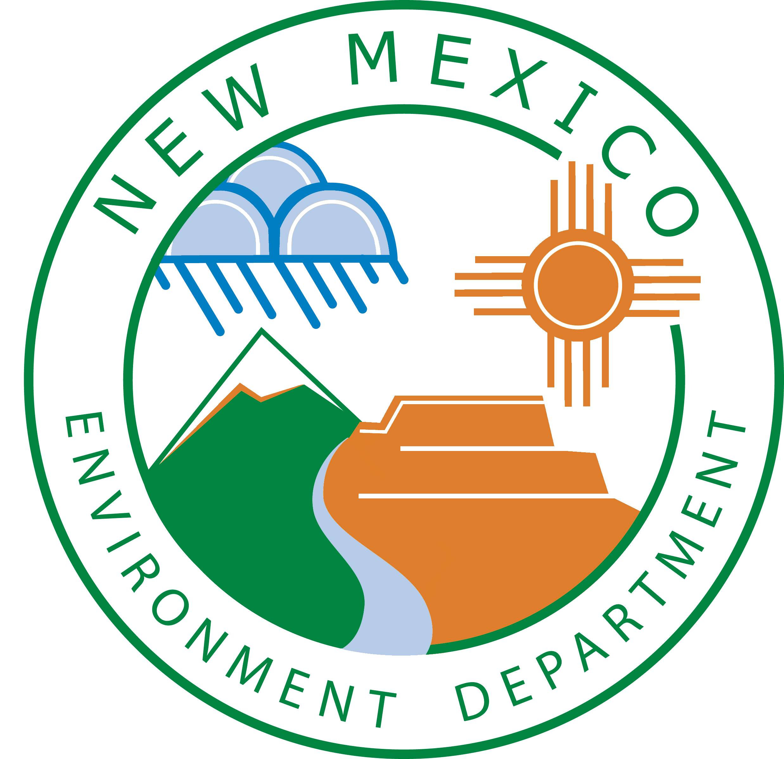
New Mexico Environment Department
Protecting Our Environment, Preserving The Enchantment
Solid Waste Bureau
Waste Screening and Inspection Plan Guidance

As required by the Solid Waste Rules, owners and operators of solid waste facilities must develop and implement plans for load inspections to prevent the disposal of unauthorized waste:

“20.9.5.8 NMAC GENERAL OPERATING REQUIREMENTS FOR ALL SOLID WASTE FACILITIES

B. Owners and operators of a solid waste facility shall:

(2) implement a plan approved by the secretary to inspect loads to detect and prevent the disposal of unauthorized waste, including:
(a) inspection frequency;
(b) inspection personnel;
(c) method of inspection; and
(d) a training program for the facility employees in the identification of unauthorized waste, including hazardous waste, hot waste, and PCBs.”

Required Elements of a Waste Screening and Inspection Plan:

Waste Screening and Inspection Plans should contain the following information:

- Inspection frequency
- Randomly inspect one per day or 1 percent of incoming loads per day (annual average), whichever is greater (i.e., 149 or less loads = one inspection; 150-249 loads = two inspections; 250-349 loads = three inspections, etc.).
- Special waste and or targeted loads: inspect these in addition to randomly chosen loads.

- Inspection personnel identified

- Inspection methods described in detail
- Method of random vehicle selection, i.e. what process is used to ensure each load has the same chance of being selected?
- Record of inspection information (date and time; name of employee conducting inspection; commercial hauler name and driver name; vehicle description and license number; pertinent observations made during inspection; unauthorized materials detected; generator of unauthorized materials, if known; actions taken to manage, reject and assure proper disposition of the materials).
- Location of waste inspections (should be adjacent to current tipping area or upon a designated waste screening area (must be over a lined area)).
Page 1 of 2
Rev. 12.2024
New Mexico Environment Department-Solid Waste Bureau 1190 St. Francis Drive, Santa Fe, NM 87505
505-827-0197 www.env.nm.gov/solid-waste

- Use of handheld tools to open bags, spreading and visual examination of waste.
- Segregation of suspicious waste.
- Sampling and testing of suspicious waste, if necessary (e.g., use of field screening instruments or sample collection for laboratory analysis).
- Tools and equipment used for inspection and purpose of each tool/equipment (should minimally include rake(s), camera, load inspection sheets, and preferably also include GPS unit, flags, sample jars/baggies, permanent marker, and labels).
- PPE used or otherwise available during waste inspection (should include, but not be limited to, boots, eye protection, leather and plastic/latex gloves, Tyvek® booties and dust masks (if authorized by facility management)).
- Description of management of suspicious wastes (including procedures/actions if suspicious waste is identified; list of agencies to be contacted; procedures/actions in the event waste is determined to be a hazardous waste, special waste or otherwise regulated waste (e.g., TSCA waste such as PCBs)).

- Training program for identification of unauthorized waste
- Person conducting training at the landfill and landfill staff required to be trained are identified.
- Tailor training specific to job duties, i.e. persons tasked with performing waste screens should have detailed training regarding inspection procedures, while other staff should, at a minimum, be able to identify suspect unauthorized waste.
- Documents, reference materials, figures, diagrams, photographs, etc. that will be used in the on-site waste inspection training program (such items must be included in the body of the Waste Screening and Inspection Plan or as an attachment to the Plan). An example of a document that could be used in the training program is “Waste Screening at Solid Waste Facilities in New Mexico” dated August 2009, which was prepared by the Solid Waste Bureau for use in waste screening training courses. This document is available on the Solid Waste Bureau’s website at the following address:
https://www.env.nm.gov/solid-waste/guidance-documents-and-policies/
- Optional: Identification of formal, off-site waste inspection training courses (off-site training courses are encouraged, but not required, and do not take the place of mandatory on-site waste inspection training).
- Training frequency (upon hiring or prior to first load inspection, and at least annually thereafter) and maintenance of training records in landfill operating record.
- Description of visual and olfactory indicators of unauthorized waste that will be presented to staff during training (e.g., hazardous placarding; liquids; powders or dust; sludge; bright or unusual colors; drums or industrial containers; chemical odors; smoke; soil or sod [could be associated with a chemical spill clean-up]). Additionally, this information may be available on waste screening forms to assist those performing the inspections.
- Thorough description of categories of regulated wastes (e.g., hazardous, special, or other unauthorized wastes such as TSCA waste).

Page 2 of 2
Rev. Aug 2020

