# **Physical Habitat Measurement Field Form**

Note: Physical Habitat Measurement should not be taken in a dry channel.

**Key Definitions:**

Bankfull Height (or Stage) **─** the point of incipient flooding or the elevation where flows overtop the active channel and spread across an adjacent active floodplain as constructed by the present stream in the present climate, and frequently inundated with a typical return interval of 1 to 2 years and represent the channel forming or maintenance flow (Dunne and Leopold, 1978). Bankfull Height measurements are taken by measuring the distance from the water’s surface to the bankfull tagline, leveled surveyor’s rod or tape.

Left Bank – the bank on the left as the observer faces downstream (in the direction of flow)

Right Bank – the bank on the right as the observer faces downstream (in the direction of flow)

Bankfull Width – the distance between the bankfull height on the left and right bank

Dry Channel - no water in the channel

Edge of Water – the point on the left and right bank, denoted as LEW and REW respectively, where the water meets the bank.

# **Slope Field Form**

Data Entry/Upload (date and initials)_________________ Verified by (date and intials______________________

|  |  |  |
| --- | --- | --- |
| **Reach Layout** | **SMALL STREAMS** | **LARGE STREAMS** |
| (average wetted width less than or equal to 4.0 m)  Total Reach Length = 160 m | (average wetted width greater than 4.0 m)  Total Reach Length = Avg Wetted Width x 40 m |
| Total Reach Length | Example:  Average wetted width = 3 m  Total Reach Length = 160 m | Example:  Average wetted width = 6 m  Total Reach Length = 240 m |
| Transect (Flow, Cross Section, Canopy Cover) | **5 Lettered Transects spaced 40 meters apart** | **5 Lettered Transects at 10X average wetted width apart** |
| Example: | Example: |
| Average wetted width = 3 m | Average wetted width = 6 m |
| Distance between transects = 40 m | Distance between transects = 60 m |
| Transect A (1st transect) = at 0 meters | Transect A (1st transect) = at 0 meters |
| Transect E (5th transect) = at 160 meters | Transect E (5th transect) = at 240 meters |
| Intermediate Transect (Pebble Count) | **21 Contiguous Transects spaced 8 meters apart** **(i.e., entire reach layout)** | **21 Contiguous Transects at 2X average wetted width (i.e., entire reach layout)** |
| Example: | Example: |
| Average wetted width = 3 m | Average wetted width = 6 m |
| Distance between intermediate transects = 8 m | Distance between intermediate transects = 12 m |
| Thalweg Profile Stations | **Measure thalweg depth every 1.0 meter (160 total measurements)** | **Measure thalweg depth at intervals equal to total reach length divided by 160 (160 total measurements)** |
| Example: | Example: |
| Average wetted width = 3 m | Average wetted width = 6 m |
| Interval Length (distance between thalweg depth profile measurements) = 1 m | Interval Length (distance between thalweg depth profile measurements) = 1.5 m |
| Total measurements = 160 | Total measurements = 160 |

# **Cross Sectional Profiles, Thalweg Profile, and Large Woody Debris Field Form**

# **Pebble Count Field Sheet**

Data Entry/Upload (date and initials)_________________ Verified by (date and intials______________________

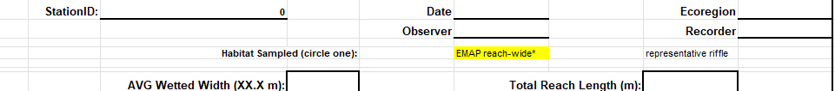

Substrate particle showing its 3 main axes of measurement. (Harrelson, et al. 1994).

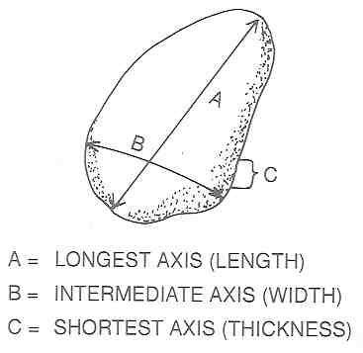

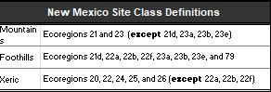

# Percent Canopy Conver Field Form

Data Entry/Upload (date and initials)_________________ Verified by (date and intials______________________

# **Bankfull Cross Section and Stream Flow Field Form**

Data Entry/Upload (date and initials)_________________ Verified by (date and intials______________________