

Air Quality Bureau
2017 Annual Network Review

Table of Contents

Introduction, Public Review and Comment 3

Section 1 Overview 3
Site Designation Coding 3
Air Monitoring Network 4
Air Quality Data 4
Overview of Monitored Parameters 4
Monitoring Methodology 5

Section 2.0 - Network Review by Pollutant and Respective Air Quality Control Regions 6
2.1 Nitrogen Dioxide (NO₂) 8
NO₂ - Air Quality Control Region 1 8
NO₂ - Air Quality Control Region 5 9
NO₂ - Air Quality Control Region 6 10
2.2 Ozone (O₃) 11
O₃ - Air Quality Control Region 1 12
O₃ - Air Quality Control Region 2 13
O₃ - Air Quality Control Region 3 15
O₃ - Air Quality Control Region 5 15
O₃ - Air Quality Control Region 6 16
2.3 Sulfur Dioxide (SO₂) 18
SO₂ - Air Quality Control Region 1 18
2.4 Particulate Matter PM_{2.5} Non-Continuous - Federal Reference Method (FRM) 19
PM_{2.5} - Air Quality Control Region 5 20
PM_{2.5} - Air Quality Control Region 6 20
2.5 Particulate Matter PM_{2.5} Continuous 20
2.5.1 Particulate Matter PM_{2.5} Continuous (TEOM) 20
PM_{2.5} - Air Quality Control Region 3 21
PM_{2.5} - Air Quality Control Region 6 22
2.5.2 Particulate Matter PM_{2.5} Continuous (BAM) 22
PM_{2.5} - Air Quality Control Region 3 23
PM_{2.5} - Air Quality Control Region 5 23
PM_{2.5} - Air Quality Control Region 6 23
2.6 Particulate Matter PM₁₀ Non-Continuous – Federal Reference Method (FRM) 24
PM₁₀ - Air Quality Control Region 6 24
2.7 Particulate Matter PM₁₀ Continuous 25
2.7.1 Particulate Matter PM₁₀ Continuous (TEOM) 25
PM₁₀ - Air Quality Control Region 6 25
2.7.2 Particulate Matter PM₁₀ Continuous (BAM) 25
PM₁₀ - Air Quality Control Region 1 26
PM₁₀ - Air Quality Control Region 6 27
PM₁₀ - Air Quality Control Region 7 28

Section 3.0 - Other Projects 28

Section 4.0 - Summary 28
4.1 Network Modifications During FY2017 28
4.2 Anticipated Network Modifications During FY2018 30

Section 5.0 - Addressing New Monitoring Requirements in Monitoring Network 31
5.1 Lead 31
5.2 Nitrogen Dioxide 31
5.3 Sulfur Dioxide 31
5.4 Ozone 32

Section 6.0 - Other Issues 32

List of Figures

Figure 1 – New Mexico Air Quality Control Regions 6
Figure 2 – Monitoring Network Locations 7
Figure 3 – Air Quality Control Region 1 NO₂ Monitoring Locations 9
Figure 4 – Air Quality Control Region 5 NO₂ Monitoring Locations 10
Figure 5 – Air Quality Control Region 6 NO₂ Monitoring Locations 11
Figure 6 – Northern New Mexico Ozone Monitoring Locations 12
Figure 7 – Southern New Mexico Ozone Monitoring Locations 12
Figure 8 – Air Quality Control Region 1 Ozone Monitoring Locations 13
Figure 9 – Air Quality Control Region 2 Ozone Monitoring Locations 14
Figure 10 – Air Quality Control Region 3 Ozone Monitoring Locations 15
Figure 11 – Air Quality Control Region 5 Ozone Monitoring Locations 16
Figure 12 – Air Quality Control Region 6 Ozone Monitoring Locations 17
Figure 13 – Air Quality Control Region 1 SO₂ Monitoring Locations 18
Figure 14 – Air Quality Control Region 6 PM_{2.5} FRM Monitoring Locations 19
Figure 15 – Air Quality Control Region 3 PM_{2.5} Continuous (TEOM) Monitoring Locations 21
Figure 16 – Air Quality Control Region 6 PM_{2.5} Continuous (TEOM) Monitoring Locations 21
Figure 17 – Air Quality Control Region 3 PM_{2.5} Continuous (BAM) Monitoring Location 22
Figure 18 – Air Quality Control Region 5 & 6 PM_{2.5} Continuous (BAM) Monitoring Locations 23
Figure 19 – Air Quality Control Region 6 PM₁₀ FRM Monitoring Location 24
Figure 20 – Air Quality Control Region 6 PM₁₀ Continuous (TEOM) Monitoring Locations 25
Figure 21 – Air Quality Control Region 1 PM₁₀ Continuous (BAM) Monitoring Location 26
Figure 22 – Air Quality Control Region 6 PM₁₀ Continuous (BAM) Monitoring Locations 27

2017 Network Review
Air Quality Bureau
New Mexico Environment Department
July 1, 2017

Prepared by
Roman Szkoda, Ambient Air Monitoring Program Manager

The purpose of this document is to provide information concerning the operation of the ambient air monitoring network by the New Mexico Environment Department (NMED) Air Quality Bureau (AQB) in Fiscal Year 2017 which covers the period from July 1, 2016 through June 30, 2017.

Introduction

In October 2006, US EPA issued final regulations concerning state and local agency ambient air monitoring networks. These regulations require states to submit an annual monitoring network review to US EPA. This network plan is required to provide the framework for establishment and maintenance of an air quality surveillance system and to list any changes that are proposed to take place to the current network during the 2017 Fiscal Year.

Under 40 CFR, Part 58, Subpart B, States are required to submit an annual monitoring network review to the Environmental Protection Agency (EPA) regional office in Dallas, Texas. This network review is required to provide the framework for establishment and maintenance of an air quality surveillance system. The annual monitoring network review must be made available for public inspection for at least 30 days prior to submission to EPA.

1.0 Overview

At the end of the state fiscal year June 30, 2017, the Bureau operated 20 criteria air pollutant monitoring sites located in 11 of the State’s 33 counties. Each air monitoring location is sited to meet the three basic monitoring objectives and at least one of the six federal criteria of: NO₂, O₃, CO, Lead, particulate matter (PM₁₀ and PM_{2.5}), and SO₂ for ambient air monitoring networks.

In 2017 the Ambient Air Monitoring Section currently has a full-time staff of seven, there was one vacancy from October 1, 2016 through February 27, 2017.

Table 1 (Network Element Worksheet) contains a listing of all New Mexico Environment Department, Air Quality Bureau ambient air monitoring sites operating at the end of the state fiscal year 2017.

Site Designation Coding
The NMED-Air Quality Bureau 20 air monitoring stations each have their own state region designation identified with a numeric-alpha code and site name (i.e.1ZB Bloomfield). The number and name represents the state’s Air Quality Control Region and the letter(s) identifies the site followed by the name of the site. In addition, each site has a numeric AQS (Air Quality System) identifier code which is based on EPA’s state, county and site ID (i.e. 35-045-1005) designation. The first two numbers identify the state (New Mexico is 35), the second set of three numbers refers to the county where the monitoring site is located. The third set of four numbers is the monitoring site ID number. Figure 1 on page 6 shows the state and EPA air regions. The table below is a complete listing of all 20 air monitoring sites designation code, both state and EPA throughout the network.

NMED Site Designation EPA - AQS Number Designation
1H - Sub Station 35-045-1005
1ZB - Bloomfield 35-045-0009
1NL - Navajo Lake 35-045-0018
2LL - Los Lunas 35-061-0008
2ZJ - Bernalillo 35-043-1001
3CRD - Coyote Ranger District 35-039-0026
3SFA - Santa Fe Airport 35-049-0021
3ZD - Taos 35-055-0005
5ZR - Carlsbad 35-015-1005
5ZS - Hobbs Jefferson 35-025-0008
6CM - Anthony 35-013-0016
6O - La Union 35-013-0008
6Q - Las Cruces Office 35-013-0025
6WM - West Mesa 35-013-0024
6ZL - Holman Road 35-013-0019
6ZK - Chaparral 35-013-0020
6ZM - Desert View 35-013-0021
6ZN - Santa Teresa 35-013-0022
6ZQ - Solano 35-013-0023
7E - Deming Airport 35-029-0003

Air Monitoring Network
NMED-AQB regulates air quality to protect public health and the environment in the State of New Mexico, excluding Bernalillo County. Air monitoring data are required by regulation and are used to determine compliance with U.S. EPA’s NAAQS. Other important uses of the air monitoring data include the production of a daily Air Quality Index (AQI), daily air quality forecast report, support of short and long-term health risk assessments, identification of a localized health concerns, and tracking long-term trends in air quality. New Mexico monitors four of the six NAAQS criteria pollutants: NO₂, O₃, particulate matter (PM₁₀ and PM_{2.5}), and SO₂. NMED-AQB does not monitor for CO or Lead as New Mexico currently does not meet the criteria for monitoring these pollutants.

Air Quality Data

Overview of Monitored Parameters – Criteria Pollutants

Nitrogen Dioxide (NO₂)
NO₂ is a highly toxic, reddish brown gas that is created primarily from fuel combustion in industrial sources and vehicles. It creates an odorous haze that causes eye and sinus irritation, blocks natural sunlight, and reduces visibility.

Ozone (O₃)
Ground- level O₃, also known as photochemical smog, is not emitted into the atmosphere as ozone, but rather is formed by the reactions of other pollutants. The primary pollutants entering into this reaction,VOC’s and oxides of nitrogen, create ozone in the presence of sunlight. Ozone is a strong irritant of the upper respiratory system and causes damage to crops.

Sulfur Dioxide (SO₂)
SO₂ is a gaseous pollutant that is emitted primarily by industrial furnaces or power plants burning coal or oil containing sulfur. At high concentrations, breathing can be impaired. Damage to vegetation can also result.

Fine Particulate Matter (PM_{2.5})
Fine particulate matter with a diameter of 2.5 microns or less is created primarily from industrial processes and fuel combustion. These particles are breathed deep into the lungs. Exposure to particle pollution is linked to a variety of significant health problems ranging from aggravated asthma to premature death in people with heart and lung disease.

Particulate Matter (PM₁₀)
Particulate matter with a mean diameter of 10 microns or less is emitted from transportation and industrial sources. Exposure to particle pollution is linked to a variety of significant health problems ranging from aggravated asthma to premature death in people with heart and lung disease.

Meteorological Monitoring
NMED-AQB includes meteorological monitoring of the local area because the outcome of air pollutants is influenced by the movement and characteristics of the air mass into which they are emitted. If the air is calm and pollutants cannot disperse, then the concentration of these pollutants will build up. Conversely, if a strong and turbulent wind is blowing, the pollutant will rapidly disperse into the atmosphere and will result in lower concentrations near the pollution source. The measurements of wind speed and direction, temperature, humidity, rainfall, barometric pressure, ultraviolet radiation and solar radiation are important parameters used in the study of air quality monitoring results and to further understand the chemical reactions that occur in the atmosphere.

Monitoring Methodology
NMED-AQB air monitoring network uses Thermo Environmental Instruments i-Series for all gaseous monitoring. The Model 42i Chemiluminescence monitor collects NO/NOx/NO₂ data, the Model 43i Pulsed Florescence monitor collects SO₂ data and the Model 49i UV Photometric monitor collects Ozone data. For particulate matter sampling, NMED-AQB is now using the Thermo Environmental Instruments 2025i Series Partisol FRM samplers. Three of the four 2025i samplers are PM_{2.5} designated and the other is designated as PM₁₀ to replace the one aging Wedding PM₁₀ sampler. NMED-AQB is replacing the aging TEOM PM₁₀ continuous samplers in the network with Met-One Instrument’s BAM-1020 PM₁₀ continuous samplers, per approval by EPA Region VI of NMED’s – AQB Five Year Network Assessment and 2016 Annual Network Plan dated October 28, 2016.

2.0 Network Review by Pollutant and Respective Air Quality Control Regions

NMED-AQB has reviewed its current ambient air quality network and proposed changes to the network implemented during Fiscal Year 2017. Current NAAQS, data trends, siting concerns, site access concerns, and other monitoring issues all contribute to any proposed network revisions.

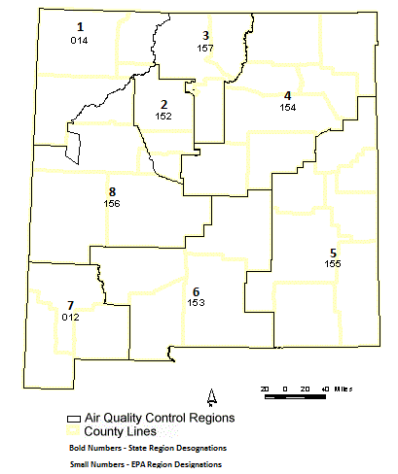

Figure 1

The Bureau’s air monitoring network for 2017 consists of the sites and monitors listed in Network Elements Spreadsheet. All site changes which have occurred or plan to take place in 2017 are included along with any network modifications for 2017. Figure-1 is an overview of the state’s and EPA’s designation of Air Quality Control Regions (AQCR’s). Figure-2 depicts AQB’s current monitoring network and shows the locations of monitoring sites as of 2017. The number of monitoring locations operated by the State remained unchanged at 20 sites.

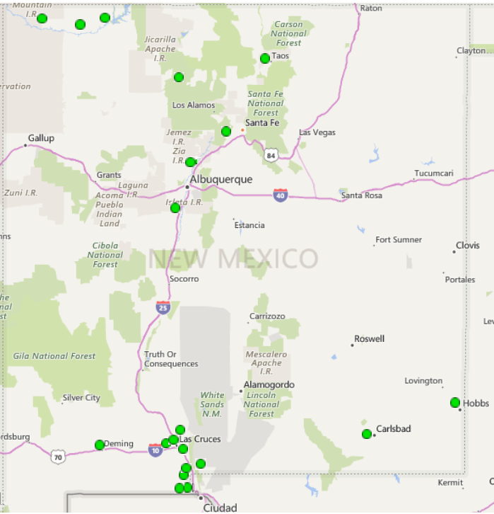
Monitoring Network Locations
Figure 2

Population of Metropolitan Statistical Areas (MSA’s)

Albuquerque MSA | Population
*Bernalillo County  Sandoval County  Torrance County  Valencia County  Total | 676.953  142,025  15,302  75,626  909,906
El Paso-Las Cruces MSA  Doña Ana County | Population  214,207
Farmington MSA | Population
San Juan County | 115,079
Santa Fe MSA  Santa Fe County | Population  148,651
Carlsbad-Artesia & Hobbs CBSA | Population
Eddy County  Lea County  Total | 57,621  69,749  127,370
Taos CBSA  Taos County  *NMED has no air monitoring stations in Bernalillo county due to the City of Albuquerque having its own monitoring group which covers the county.  Above population statistics based on US Census Bureau 2016 data. | Population  33,065

Based on the most current population NMED’s Air Quality Bureau meets the air monitoring network requirements set forth in 40 CFR Part 58 Appendices A through E.

2.1 Nitrogen Dioxide (NO₂)
The Bureau operates seven air monitoring sites in the network for Nitrogen Dioxide. Three in AQCR-1 which are located in San Juan County, two in AQCR-5, one being in Eddy County and the second in Lea County and two in AQCR-6 both of which operate in Doña Ana County.

Nitrogen Dioxide (NO₂)Air Quality Control Region 1 (EPA Region 014)
The Bureau operates three air monitoring sites in AQCR-1 for Nitrogen Dioxide which are located in San Juan County consisting of the Substation, Bloomfield, and Navajo Lake sites. Figure 3 below indicates the location of the monitoring sites.
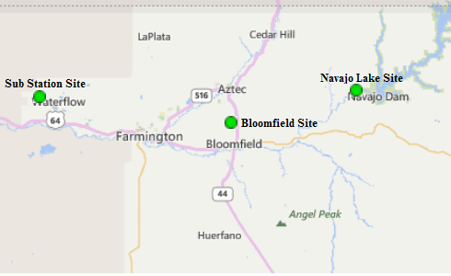

Figure 3

Substation Site AQS #: 35-045-1005:
Substation NO₂ Parameter 42602, Method 074, POC 2
The Bureau continues to operate the NO₂ monitor at the Substation air monitoring site. No changes occurred in 2017.

Bloomfield Site AQS #:35-045-0009:
Bloomfield NO₂ Parameter 42602, Method 074, POC 1
The Bureau continues to operate the NO₂ monitor at the Bloomfield air monitoring site. No changes occurred in 2017.

Navajo Lake Site AQS# 35-045-0018:
Navajo Lake NO₂ Parameter 42602, Method 074, POC 2
The Bureau continues to operate the NO₂ monitor at the Navajo Lake air monitoring site. No changes occurred in 2017.

Nitrogen Dioxide (NO₂) Air Quality Control Region 5 (EPA Region 155)
The Bureau operates two air monitoring sites in AQCR-5, located in Eddy County, and Lea County consisting of the Carlsbad and Hobbs sites. Figure 4 below indicates the location of the monitoring sites.
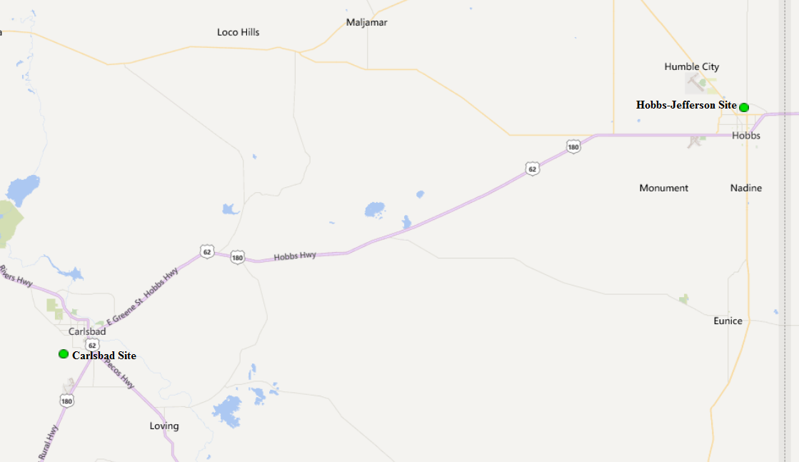

Figure 4

Carlsbad AQS #: 35-015-1005:
Carlsbad NO₂ Parameter 42602, Method 074, POC 1
The Bureau continues to operate the NO₂ monitor at the Carlsbad air monitoring site. No changes occurred in 2017.

Hobbs Jefferson AQS #: 35-025-0008:
Hobbs NO₂ Parameter 42602, Method 074, POC 2
The Bureau continues to operate the NO₂ monitor at the Hobbs air monitoring site. No changes occurred in 2017.

Air Quality Control Region 6 (EPA Region 153)
The Bureau operates nine air monitoring sites in AQCR-6, located in Doña Ana County. Two of the nine monitoring sites, Desert View and Santa Teresa monitor for NO₂. Figure 5 below indicates the location of the monitoring sites.

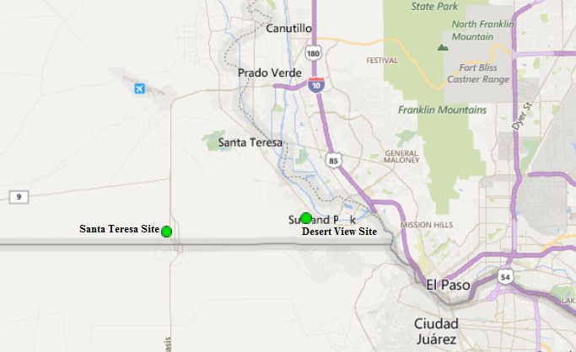

Figure 5

Desert View AQS #: 35-013-0021:
Desert View NO₂ Parameter 42602, Method 074, POC 2
The Bureau continues to operate the NO₂ monitor at the Desert View air monitoring site. No changes occurred in 2017.

Santa Teresa AQS #: 35-013-0022:
Santa Teresa NO₂ Parameter 42602, Method 074, POC 2
The Bureau continues to operate the NO₂ monitor at the Santa Teresa air monitoring site. No changes occurred in 2017.

2.2 Ozone (O₃)
The Bureau operates fourteen air monitoring sites in the network for Ozone with seven in northern New Mexico and seven in southern New Mexico. In the northern half of the state there are three sites in AQCR-1 which are located in San Juan County, two sites in AQCR-2, one being in Sandoval County and the second in Valencia County, and two sites in AQCR-3, one in Santa Fe County and the second in Rio Arriba County. In the southern half of the state, there are two sites in AQCR-5, one in Lea County and the second in Eddy County, and five sites in AQCR-6 which are located in Doña Ana County. Figure 6 below indicates the location of the northern monitoring sites and Figure 7 indicates the location of the southern monitoring sites.

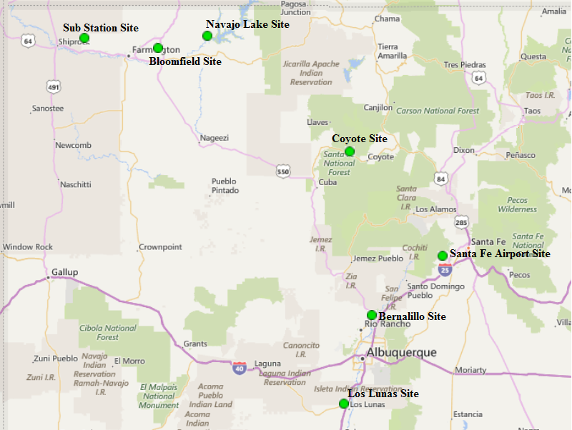

Figure 6

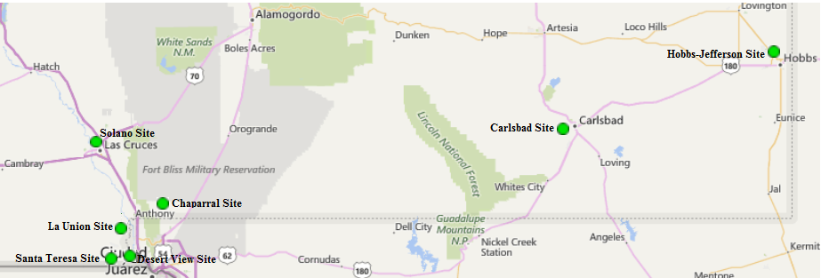

Figure 7

Ozone (O₃)Air Quality Control Region 1 (EPA Region 014)
The Bureau operates three air monitoring sites in AQCR-1 for Ozone which are located in San Juan County consisting of the Substation, Bloomfield, and Navajo Lake sites. Figure 8 indicates the location of the monitoring sites.

Figure 8

Substation Site AQS #: 35-045-1005:
Substation O₃ Parameter 44201, Method 047, POC 1
The Bureau continues to operate the O₃ monitor at the Substation air monitoring site. No changes occurred in 2017.

Bloomfield Site AQS #:35-045-0009:
Bloomfield O₃ Parameter 44201, Method 047, POC 1
The Bureau continues to operate the O₃ monitor at the Bloomfield air monitoring site. No changes occurred in 2017.

Navajo Lake Site AQS# 35-045-0018:
Navajo Lake O₃ Parameter 44201, Method 047, POC 1
The Bureau continues to operate the O₃ monitor at the Navajo Lake air monitoring site. No changes occurred 2017.

Ozone (O₃) Air Quality Control Region 2 (EPA Region 152)
The Bureau operates two ozone air monitoring sites in AQCR-2, one located in Sandoval County, and the second in Valencia County consisting of the Bernalillo and Los Lunas sites respectively. Figure 9 indicates the location of the Bernalillo and Los Lunas sites.

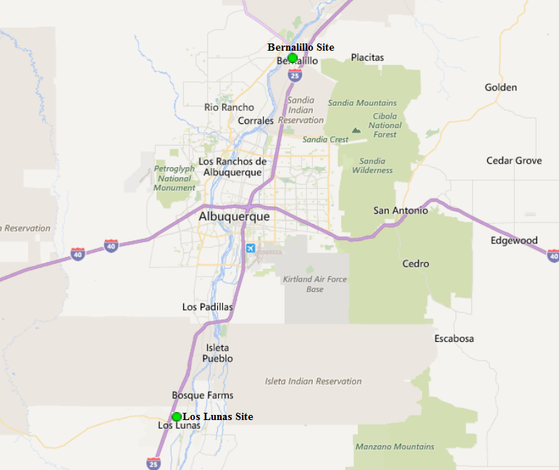

Figure 9

Bernalillo (DOT Yard) Site AQS#: 35-043-1001:
Bernalillo O₃ Parameter 44201, Method 047, POC 1
The Bureau continues to operate the Ozone monitor at the Bernalillo air monitoring site. EPA Region-VI has noted that this site is not required due to the City of Albuquerque (COA) currently operating more than the required Ozone sites for the Albuquerque MSA. However, NMED had requested to continue operating the O₃ monitor at Bernalillo and provided an explanation for continuing ozone monitoring in the Five Year Network Assessment. NMED will continue collaborating with EPA Region-VI on appropriateness of continuing operating the Bernalillo site. Also within the last year NMED-AQB had concerns with the monitoring shelter being too close to the road along the DOT Yard where it is located and determined that it did not meet siting criteria. NMED requested to relocate the equipment into the new monitoring shelter and received approval per EPA letter dated July 13, 2016. However, due to state budgetary constraints, electrical power installation and equipment relocation was not performed until December 6, 2016. The new shelter meets all siting criteria requirements per 40 CFR Part 58 App. E.

Los Lunas AQS #: 35-061-0008:
Los Lunas O₃ Parameter 44201, Method 047, POC 1
The Bureau continues to operate the Ozone monitor at the Los Lunas air monitoring site. No changes occurred in 2017.

Ozone (O₃) Air Quality Control Region 3 (EPA Region 157)
The Bureau operates two ozone air monitoring sites in AQCR-3 located in Santa Fe County and Rio Arriba County consisting of the Santa Fe Airport and Coyote Ranger District sites. Figure 10 indicates the location of the two sites.

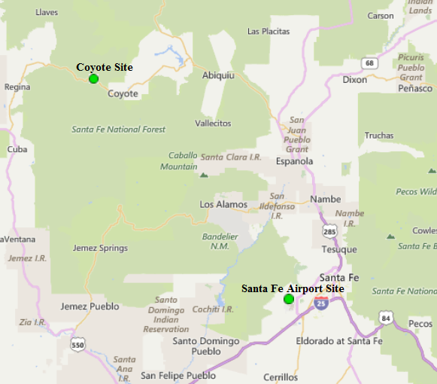

Figure 10

Santa Fe Airport AQS #: 35-049-0021:
Santa Fe Airport O₃ Parameter 44201, Method 047, POC 1
The Bureau continues to operate the Ozone monitor at the Santa Fe Airport air monitoring site. No changes occurred in 2017.

Coyote Ranger District AQS #: 35-039-0026:
Coyote Ranger District O₃ Parameter 44201, Method 047, POC 1
The Bureau continues to operate the Ozone monitor at the Coyote Ranger District air monitoring site. No changes occurred in 2017.

Ozone (O₃) Air Quality Control Region 5 (EPA Region 155)
The Bureau operates two ozone air monitoring sites in AQCR-5, located in Eddy County, and Lea County consisting of the Carlsbad and Hobbs sites. Figure 11 indicates the location of the two sites.

Figure 11

Carlsbad AQS #: 35-015-1005:
Carlsbad O₃ Parameter 44201, Method 047, POC 1
The Bureau continues to operate the Ozone monitor at the Carlsbad air monitoring site. No changes occurred in 2017.

Hobbs Jefferson AQS #: 35-025-0008:
Hobbs Jefferson O₃ Parameter 44201, Method 047, POC 1
NMED-AQB had concerns with the car port installed adjacent to the monitoring site. However, a recent EPA Technical Systems Audit was conducted in June 2016 and EPA commented that the site appeared to be meeting siting criteria per requirement of the 40 CFR Part 58 App. E. and that NMED-AQB submit a separate document indicating all distances and heights of any obstructions to show compliance. NMED conducted and submitted an Annual Siting Criteria Report dated July 14, 2016 indicating that the site meets all requirements of 40 CFR Part 58 App. E. EPA acknowledged and approved the report in the letter dated October 28, 2016 referring to NMED’s 2016 Annual Network Plan. The Bureau continues to operate the Ozone monitor at the Hobbs air monitoring site. No changes occurred in 2017 other than stated above.

Ozone (O₃) Air Quality Control Region 6 (EPA Region 153)
The Bureau operates a total of eight air monitoring sites in AQCR-6. Five of those sites monitor for ozone consisting of the Chaparral, Desert View, La Union, Santa Teresa, and Solano sites. Figure 12 indicates the location of the ozone monitoring sites.

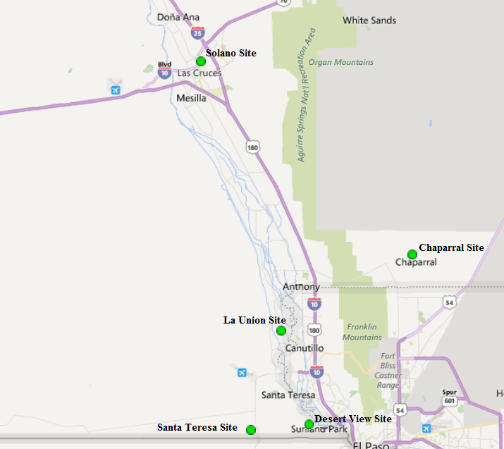

Figure 12

Chaparral AQS #: 35-013-0020:
Chaparral O₃ Parameter 44201, Method 047, POC 1
The Bureau continues to operate the Ozone monitor at the Chaparral air monitoring site. No changes occurred in 2017.

Desert View AQS #: 35-013-0021:
Desert View O₃ Parameter 44201, Method 047, POC 1
The Bureau continues to operate the Ozone monitor at the Desert View air monitoring site. No changes occurred in 2017.

La Union AQS #: 35-013-0008:
La Union O₃ Parameter 44201, Method 047, POC 2
The Bureau continues operating the Ozone monitor at La Union, no changes occurred in 2017.

Santa Teresa AQS #: 35-013-0022:
Santa Teresa O₃ Parameter 44201, Method 047, POC 1
The Santa Teresa site and surrounding area had been undergoing major commercial growth over the last several years due to the New Mexico Governor’s economic development initiative for Santa Teresa as a commercial zone between Mexico and the US. The surrounding area has become more industrial due to the Union Pacific Railroad’s Intermodal facility as well as freight storage and transport facilities. Recently growth in the area has leveled off, but expected to continue in the near future. NMED-AQB had requested to relocate the Santa Teresa site approximately a half mile east of its present location due to increased traffic to and from Mexico occurring at the Santa Teresa Border crossing. The relocation request is still under bureau revision to include EPA’s requested inclusions. The Bureau continues to operate the Ozone monitor at Santa Teresa, no changes occurred in 2017.

Solano Road AQS #: 35-013-0023:
Solano Road O₃ Parameter 44201, Method 047, POC 1
The Bureau continues operating the Ozone monitor at Solano Road. NMED is monitoring the surrounding area as there are concerns that nearby trees could possibly affect the siting criteria. The NMED QA section will be performing their annual siting criteria to verify compliance. Currently, no changes are anticipated for the remainder of FY2017.

2.3 Sulfur Dioxide (SO₂)
The Bureau operates two air monitoring sites in the network for Sulfur Dioxide. Both sites are located in the northern half of the state in AQCR-1 which is in San Juan County consisting of the Sub Station and Bloomfield air monitoring sites. Figure 13 below indicates the location of the SO₂ monitoring sites.
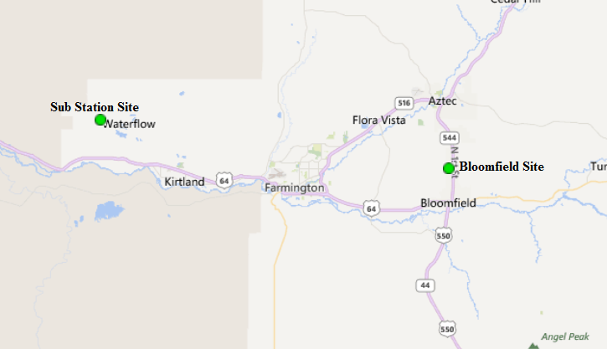

Figure 13

Sulfur Dioxide (SO₂)Air Quality Control Region 1 (EPA Region 014)

Substation SO₂ AQS #:35-045-1005
Substation SO₂ Parameter 42401, Method 060, POC 3
The Bureau continues to operate the SO₂ monitor at the Substation air monitoring site. No changes are anticipated for 2017.

Bloomfield SO₂ AQS #:35-045-0009
Bloomfield SO₂ Parameter 42401, Method 060, POC 3
The Bureau continues to operate the SO₂ monitor at the Bloomfield air monitoring site. EPA Region-VI stated in NMED’s 2016 ANR Technical Comments dated October 28, 2016 that “monitor at Bloomfield is not needed to meet requirements of Population Weighted Emission index or the Data Requirements Rule and seems this monitor could be decommissioned”. However, NMED will need to continue operating the SO₂ monitor at Bloomfield until such time when the two oldest boiler units at San Juan Generator Station have been shut down for at least two years. Therefore, no changes are anticipated for the remainder of 2017.

2.4 Particulate Matter PM_{2.5} Non-Continuous Federal Reference Method (FRM)
The Bureau currently operates three Method 145 PM_{2.5} FRM Partisol samplers within the air monitoring network, all three are in Doña Ana County which is AQCR-6. The Desert View monitoring site is the designated co-location site for the FRM 145 samplers operating in the network. This reflects recent changes as approved by EPA in the letter dated December 7, 2016 referring to NMED’s 2015 Five Year Network Assessment and 2016 Annual Network Plan. The Bureau discontinued use of the FRM Partisol model 2025A samplers operating as Method 118 which utilized the WINS impactors. However, due to replacing the FRM samplers with the new series Partisol model 2025i samplers which utilize the VSCC (Very sharp Cut Cyclone), EPA requested that NMED-AQB use Method code 145. All three samplers operate on a one in every three-day schedule. Though technically the co-located Desert View site sampler operates on a one in every twelve-day schedule. AQB operates it on a one in every three-day schedule due to power outages experienced in the past which caused the co-located sampler filter to be voided. Operating the co-located sampler on a one in every three-day schedule prevents sample loss. Additionally, AQS will be updated for the FRM monitor installed at the Anthony site in time for the 2Q 2017 data submittal. It will be reflected as 35-013-0016-88101-2, with a begin date of 6/1/17.

NMED discontinued the PM_{2.5} FRM samplers at both the Las Cruces Office (regional transport site location) and Hobbs (general background site location) monitoring sites and replaced them with Method 170 BAM-1020 PM_{2.5} samplers. The BAM-1020 samplers are continuous and will capture particulate data daily as compared to once every third day sampling as with the FRM samplers. Of the three FRM samplers, the Desert View monitoring site is the designated co-location site. Figure 14 indicates the location of the discontinued Las Cruces PM_{2.5} FRM site and operational FRM samplers at Anthony and Desert View.
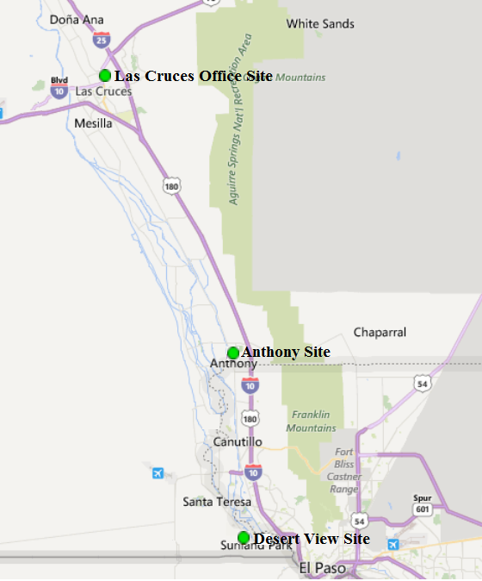

Figure 14
Particulate Matter PM_{2.5} (FRM) Air Quality Control Region 5 (EPA Region 155)

Hobbs Jefferson AQS #: 35-025-0008:
Hobbs Jefferson PM_{2.5} FRM Parameter 88101, Method 145, POC 1
The Bureau discontinued operating this FRM PM_{2.5} sampler at the Hobbs monitoring site on February 16, 2017. NMED-AQB replaced the Partisol 2025A series sampler with a Method 170 BAM-1020 PM_{2.5} continuous sampler per EPA approval letter dated December 7, 2016. The FRM sampler was operating in conjunction with the BAM-1020 sampler for approximately one month before discontinuation in order to verify comparability of particulate matter data. This site is the NMED-AQB designated General Background site. No additional changes are anticipated for 2017.

Particulate Matter PM_{2.5} (FRM) Air Quality Control Region 6 (EPA Region 153)

Desert View AQS #: 35-013-0021:
Desert View PM_{2.5} FRM (Primary) Parameter 88101, Method 145, POC 2
Desert View PM_{2.5} FRM (Co-Located) Parameter 88101, Method 145, POC 3
The Desert View site is designated as the bureau’s co-location site using the Thermo 2025i series Partisol PM_{2.5} samplers. Co-location data into AQS officially started on December 15, 2015. The Desert View site was chosen for co-location due to the area experiencing residential and commercial development nearby in Santa Teresa and on the Mexican side along the US/Mexican border which is just one mile south of the Desert View site. No changes occurred in 2017.

Anthony AQS#: 35-013-0016:
Anthony PM_{2.5} FRM Parameter 88101, Method 145, POC 2
The Bureau installed a co-located Partisol 2025i FRM PM_{2.5} sampler at the Anthony air monitoring site on May 23, 2017 with sampling starting on June, 3, 2017. NMED has a BAM-1020 FEM PM_{2.5} operating at the site and added the Partisol sampler to meet requirements of 40 CFR Part 58 App. B.

Las Cruces AQS #: 35-013-0025:
Las Cruces PM_{2.5} FRM Parameter 88101, Method 145, POC 1
The Bureau discontinued operating this PM_{2.5} FRM sampler at the Las Cruces Office monitoring site on March 30, 2017. NMED-AQB replaced the Partisol 2025A series sampler with a Method 170 BAM-1020 continuous sampler per EPA approval letter dated December 7, 2016. The FRM sampler was operating in conjunction with the BAM-1020 sampler for approximately one month before discontinuation in order to verify comparability of particulate matter data. This site is the NMED-AQB designated Regional Transport site. No additional changes are anticipated for 2017.

2.5 Particulate Matter PM_{2.5} Continuous

2.5.1 Particulate Matter PM_{2.5} Continuous (TEOM)
NMED-AQB is nearing completion of discontinuing and replacing the aging TEOM PM_{2.5} samplers within the network. Method 170 BAM-1020 PM_{2.5} FEM samplers will be installed per EPA approval letter dated December 7, 2016 referring to the bureau’s Five-Year Network Assessment and 2016 Annual Network Plan technical comments. Two of the three TEOM samplers have been replaced and the third is anticipated to be replaced August 2017. Two of the three TEOM samplers have been replaced with BAM-1020 samplers at the Desert View and Santa Fe sites. AQS has been updated to reflect the discontinuation of the TEOM and installation of the BAM at Santa Fe Airport. The BAM-1020 PM2.5 monitor at Desert View was discontinued on 1/11/17. AQB’s Quality Assurance staff have been experiencing difficulty in AQS entering the discontinuation date, they have contacted the AQS helpdesk for assistance. The third TEOM at the Taos site is anticipated to be replaced with a BAM-1020 August 2017. Figure 15 indicates the location of the continuous TEOM PM_{2.5} sites in northern New Mexico, and Figure 16 indicates the location of the southern New Mexico site.
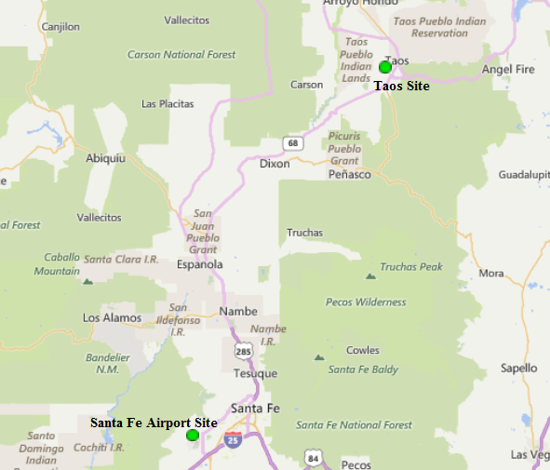

Figure 15

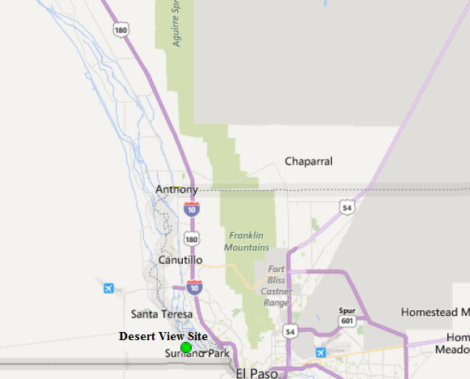

Figure 16

Particulate Matter PM_{2.5} Continuous Air Quality Control Region 3 (EPA Region 157)

Taos AQS #: 35-055-0005:
The Bureau had concerns with the tree growth adjacent to the monitoring site, and determined that it did not meet siting criteria. NMED requested in both the Five-Year Network Plan and 2016 Annual Network plan to relocate the site to meet siting criteria requirements. The Taos site was approved for relocation as per EPA approval letter dated July 15, 2016 to meet siting criteria requirements. On November 2, 2016 the site was successfully relocated 45 feet south-southwest. The physical location of the site is now at Latitude 36.3832˚ North and Longitude -105.5851˚ West.
Taos PM_{2.5} Continuous Parameter 88502, Method 701, POC 3
The Bureau continues to operate the TEOM PM_{2.5} sampler at the Taos air monitoring site. However, the bureau anticipates discontinuing this sampler in August 2017 and replacing it with a Method 170 BAM-1020 PM_{2.5} continuous sampler per EPA approval letter dated December 7, 2016 referring to NMED’s 2015 Five-Year Network Assessment and 2016 Annual Network Plan.

Santa Fe Airport AQS #: 35-049-0021:
Santa Fe Airport PM_{2.5} Continuous Parameter 88502, Method 701, POC 3
The Bureau discontinued operating the TEOM PM_{2.5} sampler at the Santa Fe Airport air monitoring site per EPA approval letter dated December 7, 2016 referring to NMED’s 2015 Five-Year Network Assessment and 2016 Annual Network Plan. The sampler was replaced with a BAM-1020 PM_{2.5} sampler Parameter 88101, Method 170, POC 1 on March 22, 2017. The last date of when data was submitted into AQS was March 15, 2017.

Particulate Matter PM_{2.5} Continuous Air Quality Control Region 6 (EPA Region 153)

Desert View AQS #: 35-013-0021:
Desert View PM_{2.5} Continuous Parameter 88502, Method 701, POC 3
The Bureau discontinued operating the TEOM PM_{2.5} sampler at the Desert View air monitoring site on January 11, 2017 per EPA approval letter dated December 7, 2016 referring to NMED’s 2015 Five-Year Network Assessment and 2016 Annual Network Plan. The last date of when data was submitted into AQS was January 11, 2017.

2.5.2 Particulate Matter PM_{2.5} Continuous (BAM-1020 Sampler)
The Bureau currently operates four Method 170 BAM-1020 PM_{2.5} samplers within the air monitoring network designated as SLAMS with a fifth expected to be on line in August. It was anticipated to have the fifth BAM on line by the end of Fiscal Year 2017. However, due to recent EPA PM_{2.5} Grant changes, the Bureau is unable to purchase the required BAM shelter until July to complete the installation. Two out of the current four samplers are located at southern New Mexico’s Doña Ana County at the Anthony, Las Cruces Office and one in Lea County at the Hobbs monitoring sites. The fourth is located in northern New Mexico at the Santa Fe Airport monitoring site. Figure 17 indicates the location of the Santa Fe Airport site and Figure 18 indicates the Anthony, Las Cruces Office and Hobbs monitoring sites.
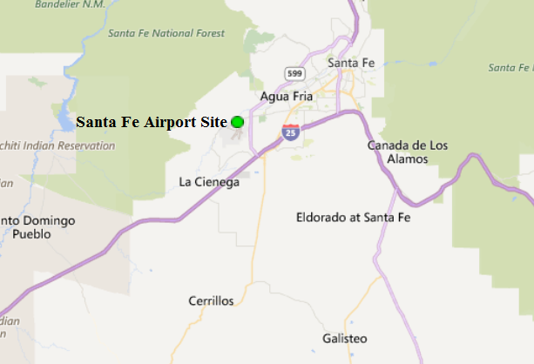
Figure 17
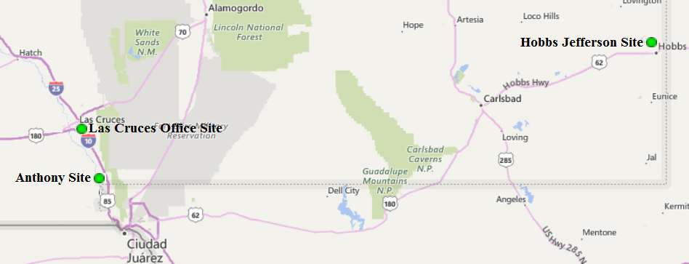

Figure 18

Air Quality Control Region 3 (EPA Region 157)

Santa Fe Airport AQS #: 35-049-0021:
Santa Fe Airport PM_{2.5} Continuous Parameter 88101, Method 170, POC 1
The Bureau installed a Met-One BAM-1020 PM_{2.5} sampler Parameter 88101, Method 170, POC 1 on March 22, 2017 operating as a SLAMS sampler per EPA approval letter dated December 7, 2016 referring to NMED’s 2015 Five Year Network Assessment and 2016 Annual Network Plan. This sampler replaced the aging TEOM PM_{2.5} sampler and data in AQS started on March 23, 2017 after the required 72-hour back ground test. No additional changes are anticipated for 2017.

Air Quality Control Region 5 (EPA Region 155)

Hobbs Jefferson AQS#: 35-025-0008:
Hobbs Jefferson PM_{2.5} Continuous Parameter 88101, Method 170, POC 1
The Bureau installed a Met-One BAM-1020 PM_{2.5} sampler Parameter 88101, Method 170, POC 1 on February 16, 2017 operating as a SLAMS sampler per EPA approval letter dated December 7, 2016. This sampler replaced the existing non-continuous FRM PM_{2.5} Partisol sampler which operated on a once every 3-day schedule. With the BAM being continuous the Bureau’s able to capture data everyday preventing any high wind data loss that can occur with the FRM sampler on non-sampling days.

Air Quality Control Region 6 (EPA Region 153)

Anthony AQS #: 35-013-0016:
Anthony PM_{2.5} Continuous Parameter 88101, Method 170, POC 2
The Bureau has installed the Met-One BAM-1020 PM_{2.5} sampler which had been operating as a Special Purpose Monitor (SPM) since April 2014, Parameter 88101, Method 170, POC 1. Per EPA approval letter dated December 7, 2016 this sampler has been re-designated as a SLAMS monitor with an effective date in AQS of April 1, 2017. A co-located Method 145 Partisol 2025i sampler was installed on May 23, 2017 per requirement of 40 CFR Part 58 App. D and sampling began on June 3, 2017 after EPA discussions in October and November 2016 and approval letter dated December 7, 2016. The Anthony site will be the designated co-location site for the FEM 170 samplers operating in the network. No additional changes are anticipated for 2017.
Las Cruces Office AQS #: 35-013-0025:
Las Cruces PM_{2.5} Continuous Parameter 88101, Method 170, POC 1
The Bureau installed a Met-One BAM-1020 PM_{2.5} sampler Parameter 88101, Method 170, POC 1 as a SLAMS sampler per EPA approval letter dated December 7, 2016 referring to NMED’s 2015 Five-Year Network Assessment and 2016 Annual Network Plan. This sampler replaced the aging Thermo Partisol 2025A FRM PM_{2.5} and is the Bureau’s Regional Transport particulate site. However, due to the monitoring shelter experiencing issues with the air conditioning system, the initial operation of the BAM sampler did not begin until February 15, 2017 after the required 72-hour back ground test. Sporadic air conditioner issues persisted throughout the remainder of February and March so the sampler was not fully operational until the end of March 2017. The FRM sampler was operating in conjunction with the BAM-1020 sampler during this period to prevent loss of any PM_{2.5} sampling. Data in AQS started on April 1, 2017. No additional changes are anticipated for 2017.

2.6 Particulate Matter PM₁₀ Non Continuous Federal Reference Method (FRM)

Air Quality Control Region 6 (EPA Region 153)
Anthony PM₁₀ FRM Parameter 81102/85101, Method 062, POC 1
The Bureau replaced the Wedding PM₁₀ non-continuous sampler with a Thermo Partisol 2025i FRM PM₁₀ sampler parameter 81102, Method 127 POC 1. The sampler was installed on March 15, 2017 per EPA approval letter dated November 17, 2016 pertaining to NMED-AQB’s request to discontinue the Wedding PM₁₀ sampler and replacing it with the Partisol 2025i sampler. Sampling did not begin until May 5, 2017 due to electrical power issues which were resolved. Figure 19 indicates the location of the PM₁₀ monitoring site. Additionally, EPA had previously approved NMED’s request per their approval letter dated April 14, 2015 to operate a Met One BAM-1020 PM₁₀ sampler at the Anthony site as a co-located sampler for the PM₁₀ FRM sampler.

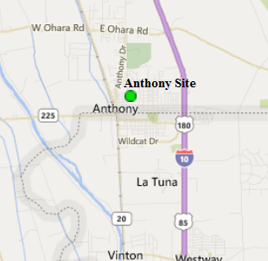

Figure 19
2.7 Particulate Matter PM₁₀ Continuous

2.7.1 Particulate Matter PM₁₀ Continuous (TEOM Sampler)
The Bureau recently completed discontinuing all PM₁₀ FEM TEOM continuous samplers in AQCR 6 and AQCR 7 replacing them with BAM-1020 samplers per EPA approval letter, dated April 14, 2015 referring to NMED’s 2014 Annual Ambient Air Monitoring Network Plan technical comments. Figure 20 indicates the locations of the sites.
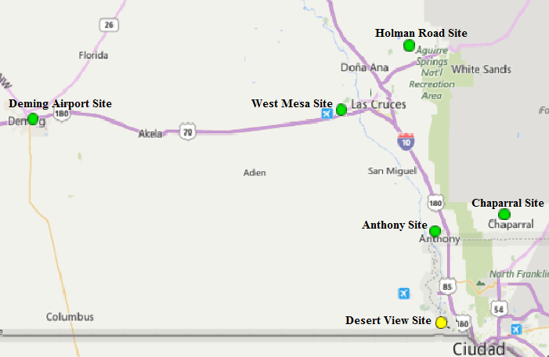

Figure 20

PM₁₀ Air Quality Control Region 6 (EPA Region 153)

Anthony AQS #: 35-013-0016:
Anthony PM₁₀ Continuous Parameter 81102, Method 079, POC 2
The Bureau’s TEOM sampler at this site was discontinued on May 18, 2017 and replaced with Method 122 BAM-1020 PM₁₀ sampler. AQS has been updated to show that 35-013-0016-85101-1 (Anthony PM10 LC) is discontinued effective 5/3/17.

2.7.2 Particulate Matter PM₁₀ Continuous (BAM Sampler)
The Bureau installed Method 122 BAM-1020 PM₁₀ samplers throughout the southern network per EPA approval letter, dated April 14, 2015 referring to NMED’s 2014 Annual Ambient Air Monitoring Network Plan technical comments. Six BAM-1020 samplers replaced aging TEOM PM₁₀ samplers as SLAMS in the southern air monitoring network. Installation of the samplers occurred at the following air monitoring sites from 2015 through 2016: 6WM West Mesa site, 6ZL Holman Road site, 6ZK Chaparral site, 6ZM Desert View, and 7E Deming Airport site. The Bureau recently installed the final Method 122 BAM-1020 PM₁₀ sampler at the 6CM Anthony site on April 5, 2017 which is the designated co-located sampler for the Partisol 2025i FRM PM₁₀ sampler. This BAM sampler replaces the TEOM PM₁₀ sampler which has recently been discontinued.

A BAM-1020 PM₁₀ sampler was added on May 5, 2016 as a Special Purpose Monitor (SPM) in the northern monitoring network located at the 1ZB Bloomfield site, but data into AQS did not start until July 30, 2016. This was due to training the site operator in calibration procedures and required routine maintenance of the sampler. Figure 21 indicates the location of the northern New Mexico monitoring site. Figure 22 indicates the locations of where the BAM-1020 PM₁₀ samplers in the southern network.

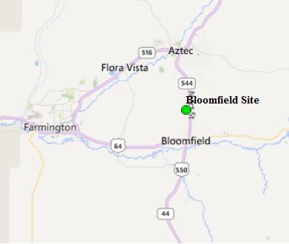

Figure 21

PM₁₀ Air Quality Control Region 1 (EPA Region 014)

Bloomfield Site AQS #:35-045-0009:
Bloomfield PM₁₀ Continuous Parameter 81102, Method 122, POC 1
The Bureau operates a Met-One BAM-1020 FEM PM₁₀ sampler as a Special Purpose Monitor (SPM) to obtain representative sampling of PM₁₀ for San Juan County per approval of EPA letter, dated April 14, 2015 referring to NMED’s 2014 Annual Ambient Air Monitoring Network Plan technical comments. The sampler was installed on May 5, 2016 and data input into AQS started July 30, 2016. EPA expressed concerns during the Technical Services Audit (TSA) conducted in September 2016 in regards to nearby sand and asphalt piles that could potentially induce bias PM₁₀ data. NMED has conducted a siting criteria audit and is collaborating with EPA Region-VI in determining if relocating the PM₁₀ sampler may be warranted.

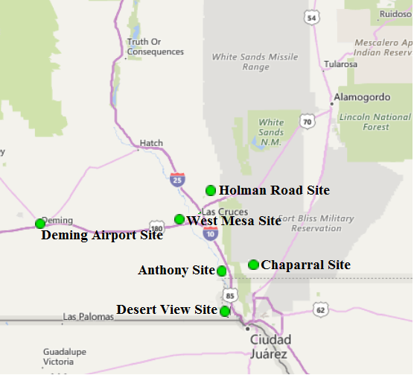

Figure 22

PM₁₀ Air Quality Control Region 6 (EPA Region 153)

Anthony AQS #: 35-013-0016:
Anthony PM₁₀ Continuous Parameter 81102, Method 122, POC 2
The Bureau installed a Met-One BAM-1020 FEM PM_{2.5} sampler Parameter 88101, Method 122, POC 2 on April 5, 2017 operating as a SLAMS sampler per EPA approval letter dated December 7, 2016 referring to NMED’s 2015 Five Year Network Assessment and 2016 Annual Network Plan. This sampler replaced the aging TEOM PM₁₀ sampler and data in AQS started on May 4, 2017 after the required 72-hour back ground test. The TEOM sampler was operating in conjunction with the BAM-1020 sampler for approximately one month before discontinuation in order to verify comparability of particulate matter data. No additional changes are anticipated for 2017.

Chaparral AQS #: 35-013-0020:
Chaparral PM₁₀ Continuous Parameter 81102, Method 122, POC 2
The Bureau continues to operate the Met-One BAM-1020 FEM PM₁₀ continuous sampler. No changes occurred in 2017.

Desert View AQS #: 35-013-0021:
Desert View PM₁₀ Continuous Parameter 81102, Method 122, POC 2
The Bureau continues to operate the Met-One BAM-1020 FEM PM₁₀ continuous sampler. No changes occurred in 2017.

Holman Road AQS #: 35-013-0019:
Desert View PM₁₀ Continuous Parameter 81102, Method 122, POC 2
The Bureau continues to operate the Met-One BAM-1020 FEM PM₁₀ continuous sampler. No changes occurred in 2017.

West Mesa AQS #: 35-013-0024:
West Mesa PM₁₀ Continuous Parameter 81102, Method 122, POC 2
The Bureau continues to operate the Met-One BAM-1020 FEM PM₁₀ continuous sampler. No changes occurred in 2017.

PM₁₀ Air Quality Control Region 7 (EPA Region 012)

Deming Airport AQS #: 35-029-0003:
Deming Airport PM₁₀ Continuous Parameter 81102, Method 122, POC 2
The Bureau continues to operate the Met-One BAM-1020 FEM PM₁₀ continuous sampler. No changes occurred in 2017.

3.0 Other Projects

There are two other projects continuing in New Mexico and are supported by NMED/AQB staff.

- Northern air monitoring staff is continuing the NADP-sponsored project to collect passive ammonia monitoring data in San Juan County, New Mexico. This project will continue at least through the next year. Ammonia is a precursor of fine particulate matter which adversely affects public health and visibility. This continued study will augment the baseline data collected in 2007 to assess any significant changes in ambient ammonia levels.

- NMED has submitted a development plan for Ozone nonattainment in the southern border region of New Mexico from the FY14 Border Grant.

- NMED was notified by Mark Sather of EPA Region-VI that the Passive Mercury study will restart on July 13, 2017 with sampling to be conducted at NMED’s monitoring sites in the four corners area consisting of the (1NL) Navajo Lake, Farmington Regional Airport and (1H) Sub Station air monitoring sites. This will be a two-year study ending August 2019.

4.0 Summary

The intention of the Bureau is to continue to focus on pollutants of concern while also striving to continue to serve the public health needs and to satisfy the expectations of the New Mexico communities. The Bureau will inform Region VI staff early in the process of any plans to make changes or modifications to the ambient air monitoring network, other than those described in this review, to ensure that state and federal priorities continue to be aligned.

4.1 Network Modifications During FY2017

During Fiscal Year 2017 which occurred from July 1, 2016 through June 30, 2017 the Bureau made changes throughout the monitoring network by either discontinuing or replacing aging/obsolete monitoring equipment. Modification occurred at nine monitoring sites which consisted of the following with the modification listed below.
AQCR-1
Bloomfield PM₁₀ AQS #:35-045-0009
NMED installed a BAM-1020 PM₁₀ Federal Equivalent Method (FEM) particulate sampler in May 2016. Due to training the site operator on the use, calibration, and maintenance of the sampler, it did not officially start in AQS until July 30, 2016.

AQCR-2
Bernalillo (DOT Yard) Site AQS#: 35-043-1001
NMED relocated the air monitoring equipment into a new monitoring shelter due to the existing shelter not meeting siting criteria requirements set forth in 40 CFR Part 58 App. E. Monitoring equipment was moved on December 6, 2016 immediately following electrical power installation to the new monitoring shelter.

AQCR-3
Santa Fe Airport AQS #: 35-049-0021
NMED installed a BAM-1020 PM_{2.5} Federal Equivalent Method (FEM) particulate sampler parameter 88101, Method 170, POC 1 in March 2017. This sampler replaced the aging Method 701, TEOM PM_{2.5} sampler.

Taos AQS #: 35-055-0005
The site was relocated 45 feet south-southwest on November 2, 2016 due to siting criteria non-compliance. Per EPA approval letter dated July 15, 2016 referring to NMED’s Five Year Network Assessment the Taos site now meets all siting criteria per 40 CFR Part 58 App. E.

AQCR-5
Hobbs AQS #: 35-025-0008
NMED discontinued operating the FRM PM_{2.5} sampler at the Hobbs monitoring site on February 16, 2017. The Partisol 2025A series sampler was replaced with a parameter 88101, Method 170 BAM-1020 PM_{2.5} continuous sampler per EPA approval letter dated December 7, 2016. As stated in section 2.4 above, the FRM sampler was operating in conjunction with the BAM-1020 sampler for approximately one month before discontinuation in order to verify comparability of particulate matter data. This site is the NMED-AQB designated General Background site.

AQCR-6
Anthony PM_{2.5} FEM AQS #: 35-013-0016
NMED designated the existing BAM-1020 PM_{2.5} (FEM) particulate sampler parameter 88101, Method 170, POC 1 from Special Purpose Monitor (SPM) to a SLAMS monitor POC 1. Additionally, a Partisol 2025i PM_{2.5} FRM particulate sampler parameter 88101 Method 145 was installed as a co-located sampler for the PM_{2.5} BAM as required per 40 CFR Part 58 App. D.

Anthony PM_{2.5} FRM AQS#: 35-013-0016
As stated on page 20 the Bureau installed a co-located Partisol 2025i FRM PM_{2.5} sampler at the Anthony air monitoring site on May 23, 2017 with sampling starting on June, 3, 2017. NMED has a BAM-1020 FEM PM_{2.5} operating at the site and added the Partisol sampler to meet requirements of 40 CFR Part 58 App. B.

Anthony PM₁₀ AQS #: 35-013-0016
NMED discontinued operation of the Wedding PM₁₀ sampler parameter 81102/85101 Method 162 POC 1 and replaced it with a Thermo Partisol 2025i PM₁₀ FRM particulate sampler parameter 88101 Method 127 POC 2. The co-located TEOM PM₁₀ sampler was also discontinued and replaced with a BAM-1020 PM₁₀ (FEM) particulate sampler parameter 88101, Method 170, POC 1.

Desert View AQS #: 35-013-0021
NMED discontinued operation of the TEOM PM_{2.5} sampler as well as the BAM-1020 PM_{2.5} as this site has co-located FRM PM_{2.5} samplers that have been in operation since January of 2014.

Las Cruces Office AQS #: 35-013-0025
NMED discontinued operating the FRM PM_{2.5} sampler at the Las Cruces Office monitoring site on March 30, 2017. The Partisol 2025A series sampler was replaced with a parameter 88101, Method 170 BAM-1020 PM_{2.5} continuous sampler per EPA approval letter dated December 7, 2016. As stated in section 2.5.2 above, the FRM sampler was operating in conjunction with the BAM-1020 sampler for approximately one month before discontinuation in order to verify comparability of particulate matter data. This site is the NMED-AQB designated Regional Transport particulate site.

4.2 Anticipated Network Modifications During FY2018

During Fiscal Year 2018 NMED anticipates retrofitting all 18 meteorological towers in the monitoring network with a manual winch controlled retractable boom. This will allow for one person operation when conducting required audits and or maintenance/repair work on the meteorological sensors, and provide for additional safety as it will not require physically lowering and raising the meteorological tower. Additionally, the current Air Pollution Instruments (API) model T-700 Multi-Gas Calibrators will be replaced with Thermo Environmental Instruments (TEI) model 146i Multi-Gas Calibrators at the 14 air monitoring sites that contain or require calibration units. Other anticipated network modifications to occur in FY2018 are listed below.

AQCR-1
Bloomfield PM₁₀ AQS #:35-045-0009
NMED is currently in discussion with EPA Region-VI on possible relocation of the BAM-1020 PM₁₀ sampler due to EPA’s concerns of nearby sand and asphalt piles that could possibly bias the sampler data.

AQCR-2
Bernalillo (DOT Yard) Site AQS#: 35-043-1001
NMED requests to install a Met One BAM-1020 PM_{2.5} sampler due to the Bureau receiving numerous complaints from citizens in the nearby Village of Placitas housing community (part of the Town of Bernalillo) which is adjacent to four aggregate facilities. In addition, that area of Sandoval County is experiencing continued residential and commercial growth, as well as increased vehicular traffic along the I-25 and NM 550 Highway corridor. The addition of the sampler would assist the Bureau in characterizing growth patterns in Sandoval County and any increases in mining activities. EPA Region-VI has acknowledged NMED’s request for installation of the sampler in the Five-Year Network Assessment response letter dated July 15, 2016, but did not approve the request. NMED will pursue further discussion with EPA on this matter to come up with a resolution.
5.0 Addressing New Monitoring Requirements in Monitoring Network

5.1 Lead (Pb)

Two federal criteria have been set up for Pb monitoring:

• Source-oriented – For sources over 0.5 Tons per year.
• “Non-source”-oriented in every urban area with NCore monitoring sites, that have a population of 500,000 or more.

Based on these criteria, no Pb monitors are required in regions under NMED/AQB jurisdiction.

5.2 Nitrogen Dioxide

Two federal criteria have been set up for NO₂ monitoring:
• Near-road NO₂ monitoring; 1 micro-scale site would be required in Core Based Statistical Areas (CBSA) ≥ 500,000 at a location of expected highest hourly NO₂ concentrations sited near a major road with high Annual Average Daily Traffic (AADT) counts.
• Community-wide; required in CBSAs ≥ 1 million at a location of expected highest NO₂ concentrations representing neighborhood or larger (urban) spatial scale.

Based on these criteria, no new NO₂ monitors are required in regions under NMED/AQB jurisdiction.

5.3 Sulfur Dioxide

Two federal criteria have been set up for SO₂ monitoring:

• Based on population per CBSA and amount of SO₂ emissions within that CBSA, that is, the Population Weighed Emissions Index (PWEI) and
• Based on individual state contribution to national SO₂ inventory in the 2005 National Emissions Inventory (NEI).

Based on the PWEI criteria, NMED/AQB would not need to deploy any new monitors. Based on the 2005 NEI criteria, NMED/AQB would need one monitor. This requirement is already being complied with by virtue of the Substation site.

SO₂ Data Requirements Rule
Per EPA Requirement that by July 1, 2016, each air agency was required to identify, for each source area on the list, the approach it will use to characterize air quality to help characterize sources listed as 2,000 tpy or larger, air agencies were to indicate by July 1, 2016 one of the three options to use which were:

Option 1: Ambient air monitoring for a source
Option 2: Air quality modeling for a source
Option 3: Federally enforceable emissions limits applicable to sources less than 2,000 tpy

NMED chose the second option, but requires operating both SO₂ monitors in the network (1H Sub Station site and the 1ZB Bloomfield site) in order to provided data for modeling.

5.4 Ozone

Previous to this writing three federal criteria had been set up for ozone monitoring. Although these criteria are no longer required, one is still listed because NMED/AQB set up a new ozone site based on that criterion.

• 1 monitor in an area of high ozone concentration outside of currently monitored MSAs and Micropolitan areas.

6.0 Other Issues

The Bureau filled one vacant (ESS-O) operational position in February 2017. At present all Monitoring Section positions are filled.

A draft of this document was made available to the public in June of 2017, at http://www.nmenv.state.nm.us/aqb/. Any comments pertaining to this document should be sent to the following contact:

Roman Szkoda
Monitoring Program Manager
New Mexico Environment Department
Air Quality Bureau
525 Camino de los Marquez, Suite 1
Santa Fe, New Mexico, 87505

Or email at:
roman.szkoda@state.nm.us

