Mail Application To:  New Mexico Environment Department  Air Quality Bureau  Permits Section  525 Camino de los Marquez, Suite 1  Santa Fe, New Mexico, 87505  Phone: (505) 476-4300  Fax: (505) 476-4375  www.env.nm.gov/aqb |  |  |  |  | For Department use only:  AIRS No.:
ACI Title V Permit Application
Use this application for an Air Curtain Incinerator (ACI) combusting less than 35 tons per day of wood waste and subject to 40 CFR 60 Subpart CCCC, DDDD, EEEE, or FFFF or 40 CFR 62 Subpart III.

Acknowledgements:

I acknowledge that a pre-application meeting is available to me upon request.

Please call 505-476-4338 or email Elizabeth.kuehn@state.nm.us to request a meeting or for assistance in filling out this application.

This ACI is not located in Bernalillo County or on tribal lands.

This application is (check one box below):

a new application for an air curtain incinerator.

a revision to an application for an air curtain incinerator.

an application for a revision to a permit for an air curtain incinerator.

Section 1 – General Information

Section 1-A: Company Information
1 | ACI Project Name:
a | Street Address (If no street address is available, provide directions from a prominent intersection):
2 | ACI Operator Name: |  |  | Phone/Fax:
a | ACI Operator Address: |  |  | E-mail:
3 | ACI Owner Name (if different than above): |  |  | Phone/Fax:
a | ACI Owner Mailing Address (of different than above): |  |  | E-mail:
4 | Responsible Official  (20.2.70.300.D.2 NMAC): |  |  | Phone:
a | R.O. Title: |  |  | R.O. e-mail:
b |  | R. O. Address:
5 |  | Alternate Responsible Official  (20.2.70.300.D.2 NMAC): |  | Phone:
a |  | A. R.O. Title: |  | A. R.O. e-mail:
b |  | A. R. O. Address:
6 |  | Affected Programs to include Other States, local air pollution control programs (i.e. Bernalillo) and Indian tribes:  Will the property on which the ACI is proposed to be operated be closer than 80 km (50 miles) from other states, local pollution control programs, or Indian tribes and pueblos (20.2.70.402.A.2 and 20.2.70.7.B)? If yes, state which ones and provide the distances in kilometers:

Section 1-B: ACI Capacity and Operating Schedule
1 | List the ACI’s maximum firing rate and specify units (typically given in tons of wood combusted per hour).
Hourly: |  | Daily: |  | Annually:
2 | ACI maximum operating (): |  | (): |  | (): |  |  | ():
3 | ACI maximum daily operating schedule (if less than 24 )? Start: |  |  |  |  | AM PM | End: |  | AM PM
4 | Month and year of anticipated start of construction (locating the ACI onsite):
5 | Month and year of anticipated startup of the ACI (first day of operation):

Section 1-C: ACI Location Information (First Location)
1 | UTM Zone: 12 or 13 | Datum: NAD 27 NAD 83 WGS 84
a | UTM E (in meters, to nearest 10 meters): | UTM N (in meters, to nearest 10 meters):
b | AND Latitude (deg., min., sec.): | Longitude (deg., min., sec.):
c | County: | Elevation (ft):
2 | Status of land at facility (check one): Private Indian/Pueblo Federal BLM Federal Forest Service Other (specify)

Section 1-D – Submittal Requirements
- One hard copy original signed and notarized application package printed double sided ‘head-to-toe’ 2-hole punched as we bind the document on top, not on the side.
- Include one working hard copy for Department use. This copy does not need to be 2-hole punched.
- One CD copy is required (in a sleeve, not a crystal case, please).

Table of Contents

Section 1: General Facility Information
Section 2: Regulate Equipment and Emission Summary
Section 3: Application Summary
Section 4: Process Flow Sheet
Section 5: Map
Section 6: Air Dispersion Modeling
Section 7: Requirements for the Title V (20.2.70 NMAC) Program
Section 8: Certification Page
Unit Number | Source Description | Manufacturer | Model # | Serial # | Maximum Capacity (tons of wood per hour or horsepower) | Date of Manufacture
 |  |  |  |  |  | Date of Installation
Burner |  |  |  |  | tons/hour
Engine |  |  |  |  | hp
Section 2: ACI Equipment Specifications and Emissions

Maximum Estimated Annual Emissions (tons/year)
Operating Scenario | NOx | CO | SO₂ | PM | PM₁₀ | PM_{2.5}
If your facility burns < 5 tons of wood per hour and the generator is < 85 hp, the potential emission rate of the facility is: | TBD | TBD | TBD | TBD | TBD | TBD

Section 3

Application Summary
_____________________________________________________________________________________________

3.1 Application Summary: Below is an example description of an ACI facility and its process. Leave this box checked if it accurately describes this facility. If the example does not accurately describe this facility, remove the check from the box and provide a brief site-specific description of the facility and its process below.

A pile of any combination of clean lumber, wood waste, and yard waste is loaded into the ACI and ignited. Within 30 minutes, the fire is strong and the air curtain is engaged. The air curtain runs continuously during steady state operation, and material is loaded at a rate consistent with the rate of burn. The daily throughput for this ACI will not exceed 35 tons/day. Air pollutants and ash waste are products of the process.
OR
Provide a brief site-specific description of the facility and its process here.
_____________________________________________________________________________________________

3.2 Material: This ACI will be used to burn only wood waste, clean lumber, or yard waste. See the definitions below, and put a check in the box(es) next to the type of material(s) to be burned in this ACI.

Clean lumber means wood or wood products that have been cut or shaped and include wet, air-dried, and kiln-dried wood products. Clean lumber does not include wood products that have been painted, pigment-stained, or pressure-treated by compounds such as chromate copper arsenate, pentachlorophenol, and creosote, or manufactured wood products that contain adhesives or resins (e.g., plywood, particle board, flake board, and oriented strand board).
Wood waste means untreated wood and untreated wood products, including tree stumps (whole or chipped), trees, tree limbs (whole or chipped), bark, sawdust, chips, scraps, slabs, millings, and shavings. Wood waste does not include:
(1) Grass, grass clippings, bushes, shrubs, and clippings from bushes and shrubs from residential, commercial/retail, institutional, or industrial sources as part of maintaining yards or other private or public lands.
(2) Construction, renovation, or demolition wastes.
(3) Clean lumber.
(4) Treated wood and treated wood products, including wood products that have been painted, pigment-stained, or pressure treated by compounds such as chromate copper arsenate, pentachlorophenol, and creosote, or manufactured wood products that contain adhesives or resins (e.g., plywood, particle board, flake board, and oriented strand board).
Yard waste means grass, grass clippings, bushes, shrubs, and clippings from bushes and shrubs. Yard waste comes from residential, commercial/retail, institutional, or industrial sources as part of maintaining yards or other private or public lands. Yard waste does not include two items:
(1) Construction, renovation, and demolition wastes.
(2) Clean lumber.
_____________________________________________________________________________________________

3.3 Determining Applicability: This application is limited to ACIs subject to 40 CFR 60 Subpart CCCC, DDDD, EEEE, or FFFF or 40 CFR 62 Subpart III. Most facilities applying for the ACI Title V Permit are subject to 40 CFR 60 Subpart EEEE. Check the appropriate box(es) below to indicate which requirements are applicable. Be aware notification is required prior to commencing construction. The notification form is available on the Air Quality Bureau’s website.

The facility’s primary SIC code is 4953, and its NAIC code is 562213.
The following state regulations apply:
- 20.2.7 NMAC
- 20.2.61 NMAC
- 20.2.70 NMAC
- 20.2.77 NMAC

This ACI was (select the date of manufacture):
Manufactured after December 9, 2004 or modified on or after June 16, 2006. It is subject to 40 CFR Part 60, Subpart EEEE. See §60.2970-2974 at http://www.ecfr.gov/cgi-bin/text-idx?SID=6777c2d6e1ca7205ce79bd5b19d44663&node=sp40.7.60.eeee&rgn=div6#sg40.7.60_12969.sg74
Manufactured on or before December 9, 2004. It is subject to 40 CFR Part 60, Subpart FFFF. See §60.3062-3069 at http://www.ecfr.gov/cgi-bin/text-idx?SID=6777c2d6e1ca7205ce79bd5b19d44663&node=sp40.7.60.ffff&rgn=div6#sg40.7.60_13061.sg91

This ACI was (select the date of manufacture):
Manufactured after November 30, 1999 but no later than June 4, 2010 or modified on or after June 1, 2001 but no later than August 7, 2013. It is subject to 40 CFR Part 60, Subpart CCCC. See §60.2245-2260 at http://www.ecfr.gov/cgi-bin/text-idx?SID=a3577ea51761f90815f504a30270b7ad&node=sp40.7.60.cccc&rgn=div6#sg40.7.60_12242.sg44
Manufactured on or before November 30, 1999 and not modified after June 1, 2001. It is subject to 40 CFR Part 60, Subpart DDDD. See §60.2810-2870 at http://www.ecfr.gov/cgi-bin/text-idx?SID=6777c2d6e1ca7205ce79bd5b19d44663&node=sp40.7.60.dddd&rgn=div6#sg40.7.60_12805.sg59
Manufactured on or before November 30, 1999. It is subject to 40 CFR Part 62, Subpart III. See §62.14765-14825 at http://www.ecfr.gov/cgi-bin/text-idx?SID=6777c2d6e1ca7205ce79bd5b19d44663&node=sp40.9.62.iii&rgn=div6#sg40.9.62_114760.sg431

Section 4

Process Flow Sheet
_____________________________________________________________________________________________

An example process flow sheet of the ACI is provided. If this flow sheet does not accurately reflect the process at this facility, provide a process flow sheet and/or block diagram indicating the ACI and how material is transferred to the ACI.
_____________________________________________________________________________________________

Property Boundary

Wood Pile ACI (Unit 1)

Section 5

Map(s)
_____________________________________________________________________________________________

Provide a map such as a 7.5 minute topographic quadrangle showing the exact location of the source. Include the latitude and longitude or UTM coordinates. Below is an example, using Google Earth, of the type of map that should be submitted in Section 5.
_____________________________________________________________________________________________

To save paper and to standardize the application format, delete this sentence and the map below, and begin your submittal for this attachment on this page.

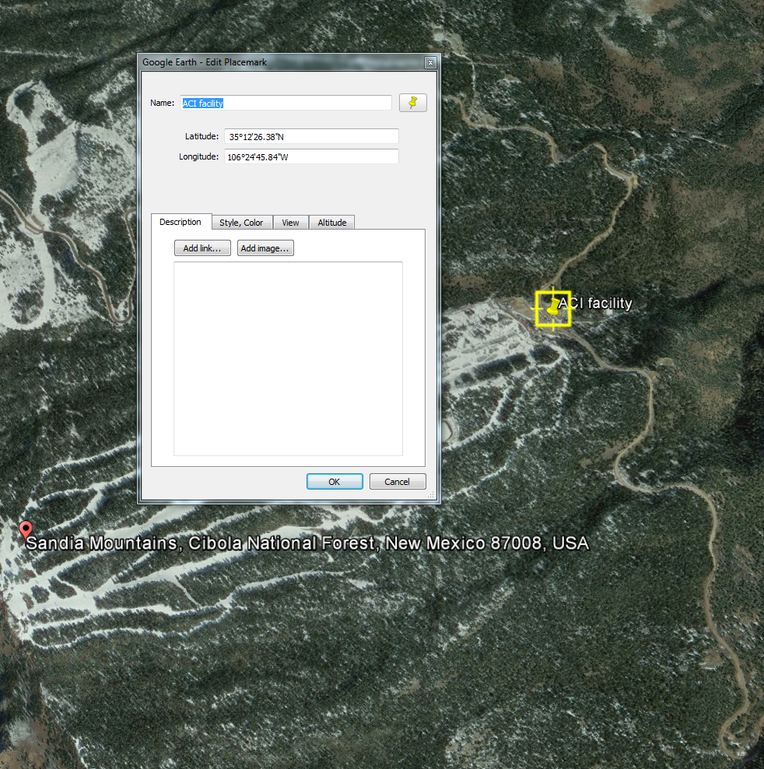

Section 6

Air Dispersion Modeling
_____________________________________________________________________________________________

Title V (20.2.70 NMAC) Modeling: Air dispersion modeling is not required for facilities that meet the parameters below. The Department has performed air dispersion modeling analyses for this operating scenario and demonstrated compliance with all applicable National and New Mexico ambient air quality standards.

This ACI facility meets the following parameters:

- The facility combusts less than 35 tons of wood waste per day and the generator is equal to or less than 85 hp; and

- The ACI will have a setback distance of 10 meters from the closest occupied structure and the perimeter of the setback will contain signage prohibiting trespassing within the restricted area.
_____________________________________________________________________________________________________

To save paper and to standardize the application format, delete this sentence, and begin your submittal for this attachment on this page.

Section 7

Requirements for Title V Program
_____________________________________________________________________________________________

7.1 - Continued Compliance (20.2.70.300.D.10.c NMAC)
Check this box to confirm this ACI will continue to be in compliance with applicable requirements and this ACI will comply with other applicable requirements as they come into effect during the permit term.
Check this box if this ACI is not in compliance with applicable requirements at this time. See Section 7.3 below to develop a compliance plan and schedule.
_____________________________________________________________________________________________

7.2 - Schedule for Submission of Compliance (20.2.70.300.D.10.d NMAC)
The proposed schedule for submission is (check one):
January 1 of each year.
June 1 of each year.
This is a non-binding proposed schedule. The issued Title V permit will provide a specific schedule and requirements for submittals.
_____________________________________________________________________________________________

7.3 - Compliance Plan and Schedule
If the second box is checked in Section 7.1 at the top of this page, provide the following:

    - Description of Compliance Status: (20.2.70.300.D.11.a NMAC)
A narrative description of your ACI's compliance status with respect to all applicable requirements (as defined in 20.2.70 NMAC) at the time this permit application is submitted to the department.

    - Compliance plan: (20.2.70.300.D.11.B NMAC)
A narrative description of the means by which your ACI will achieve compliance with applicable requirements with which it is not in compliance at the time you submit your permit application package.

    - Compliance schedule: (20.2.70.300D.11.c NMAC)
A schedule of remedial measures that you plan to take, including an enforceable sequence of actions with milestones, which will lead to compliance with all applicable requirements for your ACI. This schedule of compliance must be at least as stringent as that contained in any consent decree or administrative order to which your source is subject. The obligations of any consent decree or administrative order are not in any way diminished by the schedule of compliance.

    - Schedule of Certified Progress Reports: (20.2.70.300.D.11.d NMAC)
A proposed schedule for submission to the department of certified progress reports must also be included in the compliance schedule. The proposed schedule must call for these reports to be submitted at least every six (6) months.
_____________________________________________________________________________________________

7.4 - Distance to Other States, Bernalillo, Indian Tribes and Pueblos

Will the property on which the ACI will be located be closer than 80 km (50 miles) from other states, local pollution control programs, and Indian tribes and pueblos (20.2.70.402.A.2 and 20.2.70.7.B NMAC)?
If the answer is yes, indicate which apply and provide the distance(s) in kilometers.

Section 8: Certification

Company Name: _

I, ___________________________________, hereby certify that the information and data submitted in this application are true and as accurate as possible, to the best of my knowledge and professional expertise and experience.

Signed this day of , , upon my oath or affirmation, before a notary of the State of

__________________________________.

_______________________________________ _______________________
*Signature Date

_______________________________________ _______________________
Printed Name Title

Scribed and sworn before me on this day of , .

My authorization as a notary of the State of expires on the

day of , .

_______________________________________ _______________________
Notary's Signature Date

______________________________________
Notary's Printed Name

*The signature must be of the Responsible Official as defined in 20.2.70.7.AE NMAC.

