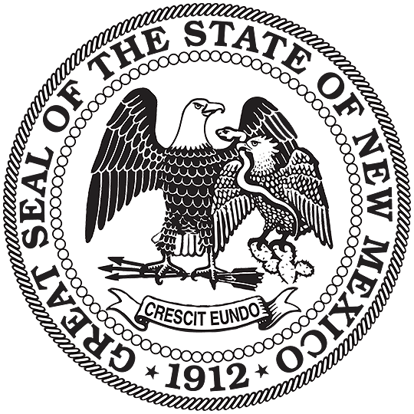


NEW MEXICO
ENVIRONMENT DEPARTMENT

Solid Waste Bureau

Harold Runnels Building – Room N-2150
1190 St Francis Dr.
PO Box 5469, Santa Fe, NM 87502-5469
Phone (505) 827-0197 Fax (505) 827-2902
www.env.nm.gov

SMALL ANIMAL CREMATORIUM REGISTRATION FORM

Notice to Registrant: The New Mexico Solid Waste Rules (SWR), 20.9.3.27 NMAC, requires the registration of a small animal crematorium with the New Mexico Environment Department. The owner or operator of a small animal crematorium must apply for a registration at least 30 days prior to any operations and every five years thereafter. Existing small animal crematorium shall apply for a registration at least 30 days prior to the expiration of their existing permit or registration. A small animal crematorium that fails to file a timely and complete application for registration may be deemed an unpermitted solid waste facility, subjecting the owner or operator to potential civil penalties, permit requirements and nuisance abatement orders.

This form is provided to assist you in completing the registration process. Return the completed form with all attachments to: c/o Manager, Permitting Section, Solid Waste Bureau, New Mexico Environment Department, 1190 St. Francis Drive, P.O. Box 5469, Santa Fe, New Mexico 87502-5469.

I. GENERAL INFORMATION (Please type or print)

Facility Name:

Facility Owner:

Mailing Address:

Telephone:
Contact Person:

Facility Operator:

Mailing Address:
Contact Person:
Telephone:

Physical Address of Facility:

Legal Description of Property (GPS coordinates and/or section, township & range, county and state):

Land Use and Zoning of Facility:

II. FACILITY LAYOUT

Attach a Map of the Facility Location, Indicating the Land Use and Zoning of the Surrounding Area, Parcel Size and Set Backs as required.

Attach a Site Map of the Facility Identifying:

- North arrow, name and location of facility including adjacent roads or highways
- Facility boundary dimensions, fencing, gates, entrances and exits
- Traffic flow pattern
- Dead animal unloading and storage areas
- Location of all buildings, structures and utilities – including overhead electrical lines
- Location of the crematorium incinerator
- Ash storage location

- OPERATIONS

Anticipated Start Up Date (For new facilities):

Estimated Days/Hours of Crematorium Operation:

Origin (Indicate from where solid waste will be accepted, by country, state, county and/or municipality):

Type/Composition (e.g., types of animals and /or parts):

Operational Rate (Maximum one day or 24 hour capacity in pounds or tons per hour and estimated operational hours per 7 day week):

Manufacturer, model type and trade name of crematorium incinerator:

Is crematorium incinerator multi-chambered? □ Yes □No Describe and attach manufacturer’s diagram of unit.

Crematorium vent stack height above ground level and diameter of stack:

Attach a copy of documentation from the New Mexico Environment Air Quality Permit Section (Phone: 505-476-4305) as to whether or not an air quality permit is required. If not required, attach a copy of the NPR (No Permit Required) letter.

OPERATIONS PLAN:

Attach an Operations Plan describing procedures for solid waste acceptance, storage, processing and removal. The plan shall address the following items:

- Means of controlling access to the facility (through use of fencing, gates, locks or other means)
- Type and size of dead animal storage unit and will it meet peak demand
- Conducting safe and sanitary operations and handling of dead animals
- Frequency of solid waste removal and description of ash containment including method to verify that ashes are properly cooled prior to disposal and disposal containment (e.g., double bagged, sealed 5-gallon buckets, etc.)
- Disposition of solid waste (removal from the facility), including names, telephone numbers, addresses, and NMED permit numbers of all utilized commercial haulers and solid waste facilities
- Procedures to be taken if unauthorized or infectious waste is received
- Procedures in response to emergency situations and equipment break down to ensure that stored animals will be removed in a timely manner to avoid nuisances or hazards
- Record keeping requirements
Submit an annual report to the Department (on the Department form that will be sent to you) within 45 days from the end of each calendar year to include:
(1) the type and weight or volume of waste received during the year;
(2) final disposition of material disposed off-site; and
- Required training requirements for personnel operating the crematoria (safety, operations, etc.)
- Any additional information required by the Secretary

NOTE: The owner or operator of a small animal crematorium shall not create a public nuisance. Failure to comply with the terms of the registration may be deemed a public nuisance. If the secretary determines, based on the information submitted with the registration or based upon any other information that the facility will be or has become a public nuisance, or that a facility covered by this section is in violation of the Solid Waste Act or 20.9.2 - 20.9.10 NMAC, the secretary may deny the registration, issue an order requiring the owner or operator to abate the public nuisance, or may issue any other order pursuant to the Solid Waste Act or 20.9.2 - 20.9.10 NMAC, or any combination thereof. The owner or operator or other affected person may appeal the secretary's order by filing a request for hearing within 30 days of the date of the secretary's order. The appeal shall be conducted in accordance with the procedures in 20.1.5 NMAC, Adjudicatory Procedures- Environment Department.

IV. ACKNOWLEDGEMENTS

A. I AM AWARE THAT THE OWNER OR OPERATOR IS REQUIRED TO COMPLY WITH ALL OF THE TERMS OF THE APPROVED REGISTRATION
INITIALS
B. I AM AWARE THAT THE OWNER OR OPERATOR MUST UPDATE THIS REGISTRATION TO REFLECT ANY MATERIAL CHANGES IN OPERATIONS (PRIOR TO IMPLEMENTING SUCH CHANGES)
INITIALS

The undersigned attests the information provided is true and accurate.

Signature and Title Date Telephone

