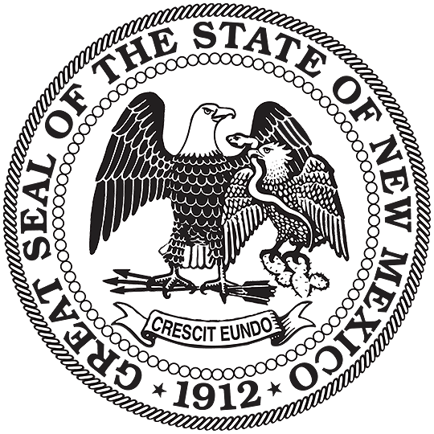


NEW MEXICO
ENVIRONMENT DEPARTMENT

Solid Waste Bureau

Harold Runnels Building – Room N2150
1190 St Francis Dr.
PO Box 5469, Santa Fe, NM 87502-5469
Phone (505) 827-0197 Fax (505) 827-2902
www.env.nm.gov

GROUND WATER (or VADOSE ZONE) MONITORING SYSTEM PLAN CERTIFICATION

Owner/Operator Name: __________________________________________________________

Mailing address:________________________________________________________________

Phone: ________________________

Facility Name: _________________________________________________________________

Consultant/Contractor Name:______________________________________________________

Mailing Address: _______________________________________________________________

Phone: ______________________

Qualified Ground Water Scientist Name (Print):_______________________________________

Date Plan was last amended (if applicable): __________________________________________

This is to certify that the attached Ground Water (or Vadose Zone) Monitoring System Plan or plan amendment change for the above listed facility has been submitted and is in compliance with 20.9.9 NMAC and upon approval by the Solid Waste Bureau will be placed in the operating record.

_______________________________________ Date: __________________________
Certification Signature (Ground Water Scientist)

