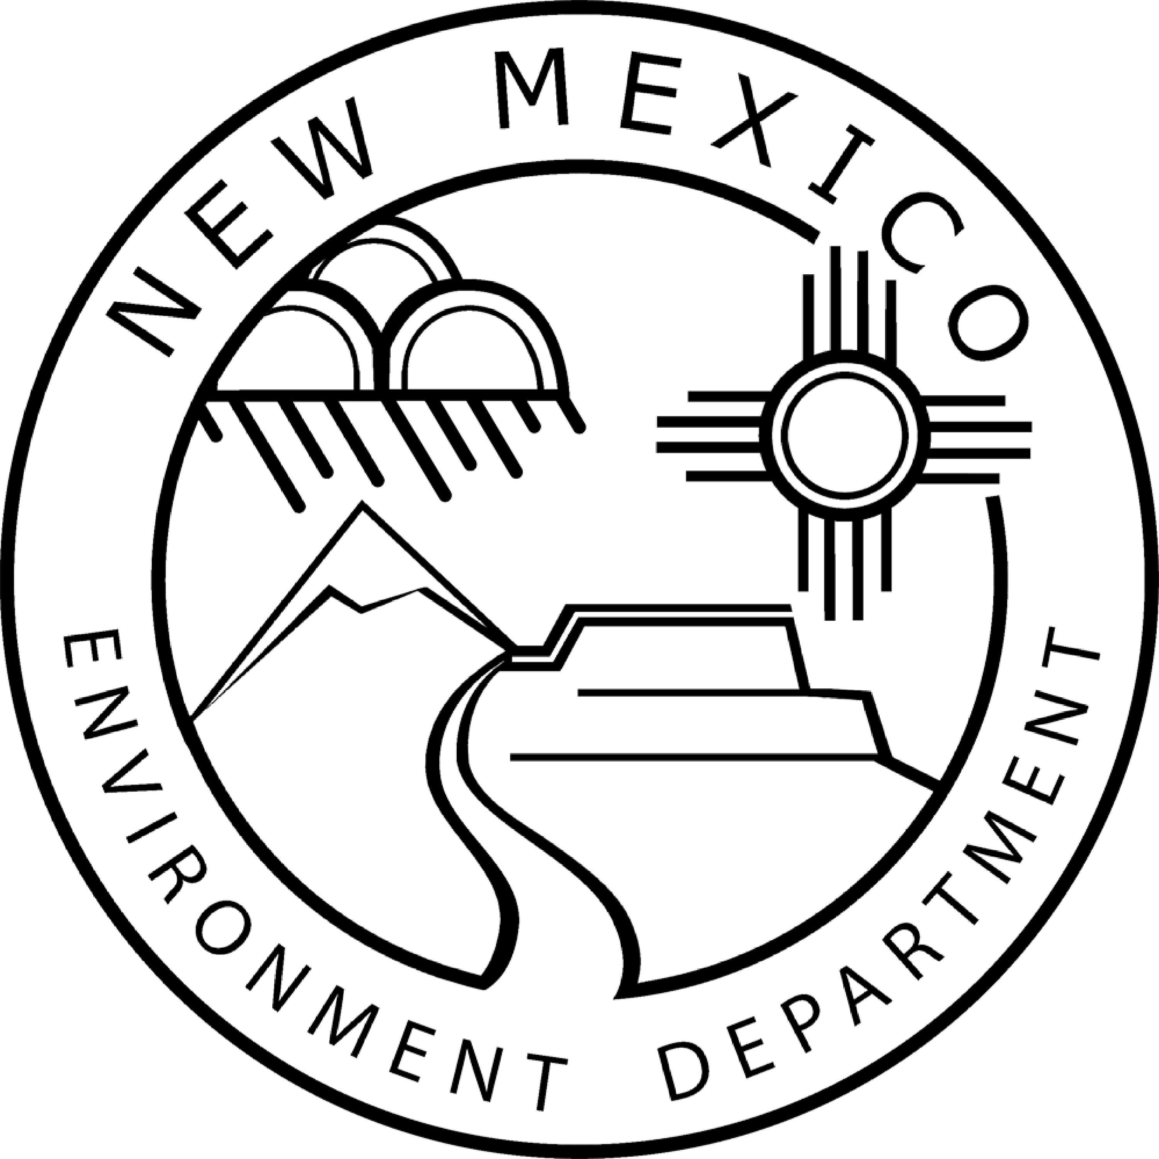

Notice that the New Mexico Environment Department, Surface Water Quality Bureau is Reviewing FOREST ROAD 1920 NORTH PONIL ROAD CROSSING HARDENING, SPA-2019-00139-ABQ for the Purpose of Preparing a State Certification or Denial Pursuant to Section 401 of the Federal Clean Water Act, and Opportunity for Public Comment

Pursuant to the Federal Clean Water Act, Section 404 (CWA), the U.S. Army Corps of Engineers (Corps) is in the process of issuing a Dredge and Fill General Permit to cover discharges at the FR 1920 crossing with North Ponil Creek in the Valle Vidal Management Unit of the Carson National Forest north of Cimarron off of Forest Road 1950 and U.S. Route 64. Activities include placing approximately 3-5 cubic yards of clean cobble within 3 feet of the stream bank edge with additional road base material (approximately 15 cubic yards) placed on top of the cobble that will extend away from the stream. The purpose of this project is to reduce the impacts of heavy equipment passage on the stream channel, such that may occur from Forest Fire Engines, and to reduce suspended sediment from entering the stream. The applicant is:

District Forest Ranger
Questa Ranger District, Carson National Forest, USDA Forest Service
PO Box 110
Questa, NM 87556

This Notice serves to notify the public that the New Mexico Environment Department (Department), Surface Water Quality Bureau (SWQB) will consider issuing certification under Section 401 of the CWA. The purpose of certification is to reasonably ensure that the permitted activities will comply with applicable New Mexico water quality standards, including the anti-degradation policy, and the statewide water quality management plan. This Notice is also posted on the SWQB website at
https://www.env.nm.gov/surface-water-quality/public-notices/.

The Department will accept written comments regarding the state certification of the draft permit until 5:00 p.m. MDT on July 10, 2019. The Department will consider all comments timely received in its preparation of the state certification. Comments may be submitted electronically or by hard copy to:

Abraham J. Franklin
Program Manager, Watershed Protection Section
Surface Water Quality Bureau
New Mexico Environment Department
PO Box 5469
Santa Fe, NM 87502-5469
Phone: 505-827-2793
fax: 505-827-0160
abraham.franklin@state.nm.us

NMED does not discriminate on the basis of race, color, national origin, disability, age or sex in the administration of its programs or activities, as required by applicable laws and regulations. NMED is responsible for coordination of compliance efforts and receipt of inquiries concerning non-discrimination requirements implemented by 40 C.F.R. Part 7, including Title VI of the Civil Rights Act of 1964, as amended; Section 504 of the Rehabilitation Act of 1973; the Age Discrimination Act of 1975, Title IX of the Education Amendments of 1972, and Section 13 of the Federal Water Pollution Control Act Amendments of 1972. If you have any questions about this notice or any of NMED’s non- discrimination programs, policies or procedures, you may contact:

Kristine Yurdin, Non-Discrimination Coordinator
New Mexico Environment Department
1190 St. Francis Dr., Suite N4050
P.O. Box 5469
Santa Fe, NM 87502
(505) 827-2855
nd.coordinator@state.nm.us

If you believe that you have been discriminated against with respect to a NMED program or activity, you may contact the Non-Discrimination Coordinator identified above or visit our website at https://www.env.nm.gov/non-employee-discrimination-complaint-page/ to learn how and where to file a complaint of discrimination.

