UNITED STATES ENVIRONMENTAL PROTECTION AGENCY
REGION 6
1201 ELM STREET, SUITE 500
DALLAS, TEXAS 75270

Mr. Abraham Franklin
Watershed Protection Section
Surface Water Quality Bureau
New Mexico Environmental Department
1190 St. Francis Drive
Santa Fe, New Mexico 87502

Dear Mr. Franklin:

We have completed our review of the Embudo Watershed-Based Plan (WBP). This WBP addresses the Environmental Protection Agency’s nine key elements for Section 319 funding. This WBP is designed to restore water quality impairments in the Embudo Watershed by reducing sediment loads throughout the watershed.

EPA greatly appreciates the combined efforts of the Arid Lands Institute, the Embudo Valley Regional Acequia Association, Ecotone Landscape Planning, and the New Mexico Environment Department to prepare this WBP. This plan will provide a living document and framework to effectively address existing as well as future nonpoint sources of pollution in the watershed. We are pleased to inform you that we consider this plan effectively addresses the nine elements in compliance with EPA national guidance. We expect that this living document will be refined as data collection continues and milestone reviews assess implementation effectiveness.

Based on our acceptance of the WBP, the State of New Mexico is now eligible for CWA Section 319 funding for watershed implementation projects consistent with this WBP and the Surface Water Quality Bureau’s Nonpoint Source Management Plan. If you or your staff have any questions regarding our review, please contact me at 214-665-7286.

Sincerely,
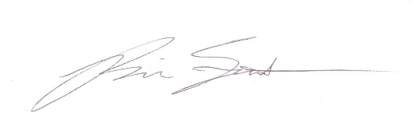

Brian E. Fontenot, Ph.D.
Nonpoint Source Regional Coordinator
Marine, Coastal, and Nonpoint Source Section
Water Division

