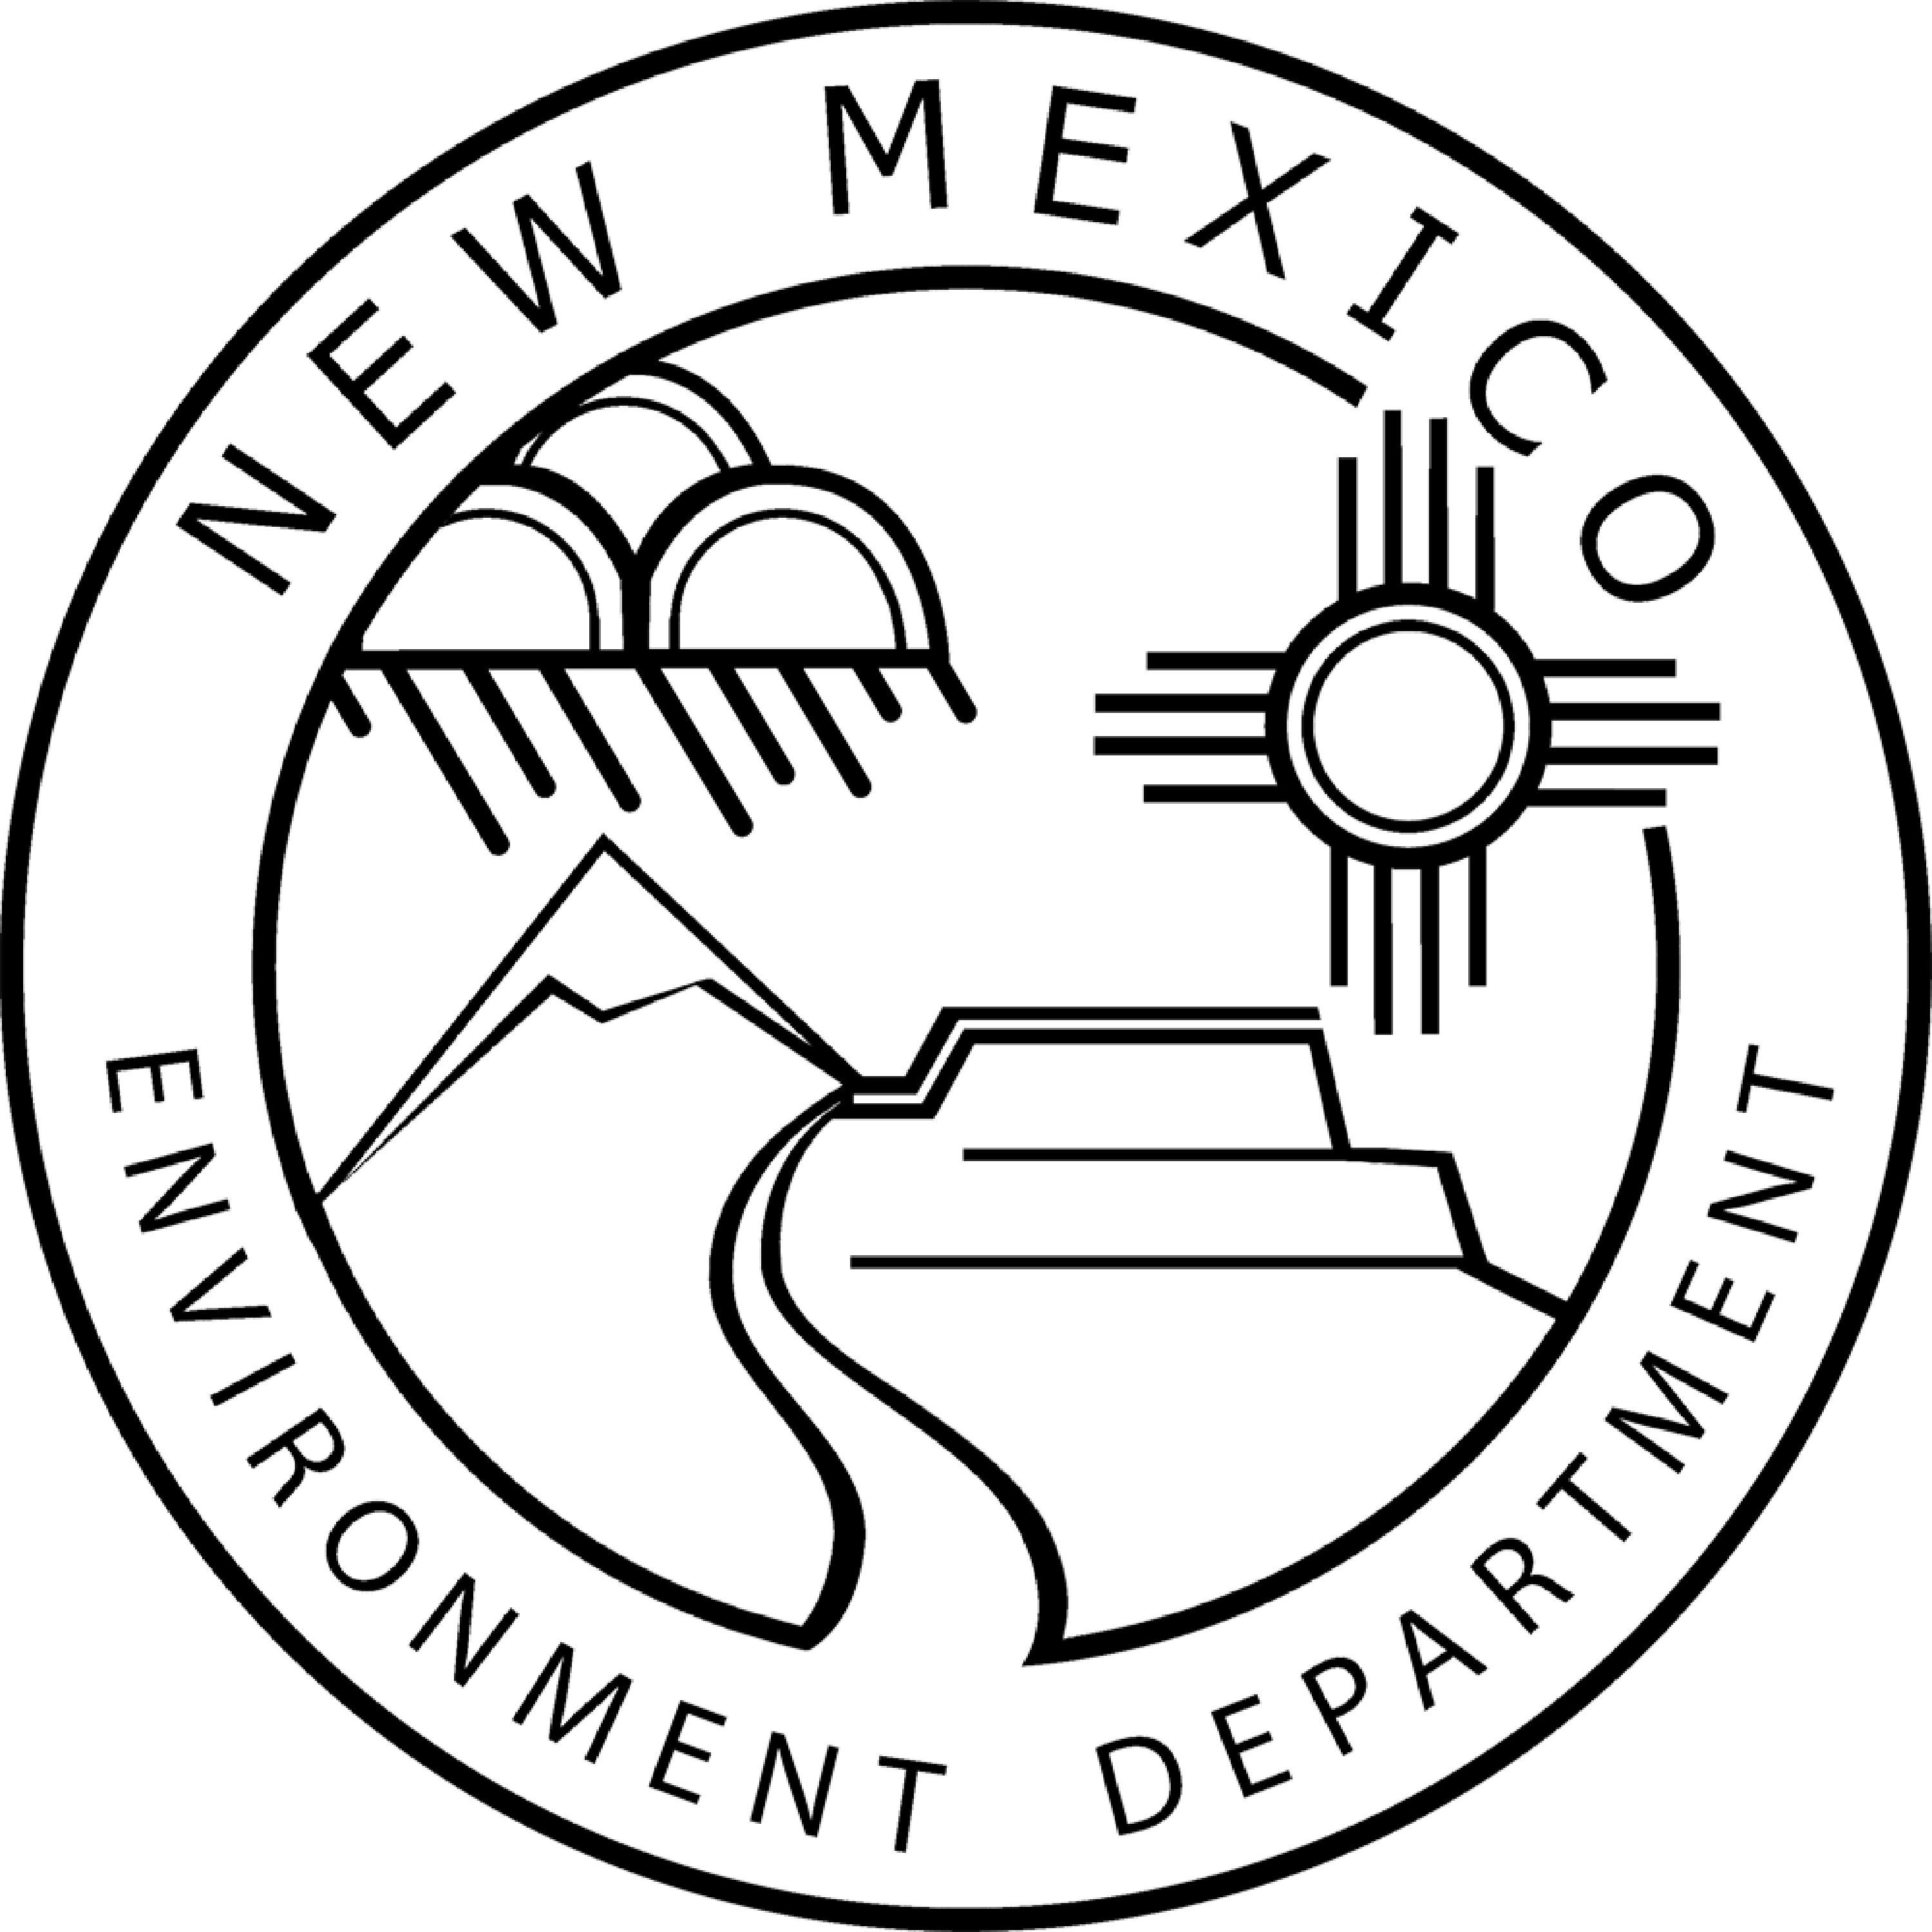
Notice that the New Mexico Environment Department, Surface Water Quality Bureau is Reviewing STREAM STABILIZATION AND WATER QUALITY IMPROVEMENT PROJECTS WITHIN URBAN EPHEMERAL CHANNELS, REGIONAL GENERAL PERMIT NO. NM-14-01, SPA-2013-00565-ABQ for the Purpose of Preparing a State Certification or Denial Pursuant to Section 401 of the Federal Clean Water Act, and Opportunity for Public Comment
Pursuant to the Federal Clean Water Act, Section 404, the U.S. Army Corps of Engineers (Corps) is in the process of reissuing Regional General Permit (RGP)-NM-14-01 which will authorize discharges of dredged or fill material into Waters of the United States for stream stabilization and water quality improvement projects in ephemeral drainages located in urban environments located in Farmington, Santa Fe, the greater Albuquerque area (including Rio Rancho, Bernalillo, and Corrales), Los Lunas, and Las Cruces. This RGP is not applicable to situations where the segment of ephemeral channel that is proposed for work is located within an undeveloped environment. Examples of work that may be covered by this permit, upon authorization by the District Engineer, include but are not limited to:

- Bank stabilization projects that exceed the thresholds for Nationwide Permit 13 and are determined by the Corps to result in minimal impacts to the aquatic environment.
- Construction of grade control structures, energy dissipaters, and flow deflection structures.
- Installation of water quality improvement features (e.g. debris containment or removal structures, sediment settling basins).
- Any combination of these types of activities if the proposed undertaking will result in minimal impacts to the aquatic environment.

More information on RGP-NM-14-01, SPA-2013-00565-ABQ is available at:
https://www.spa.usace.army.mil/Missions/Regulatory-Program-and-Permits/Public-Notices/.

This Notice serves to notify the public that the New Mexico Environment Department (Department), Surface Water Quality Bureau (SWQB) will consider issuing certification under Section 401 of the CWA. The purpose of certification is to reasonably ensure that the permitted activities will comply with applicable New Mexico water quality standards, including the anti-degradation policy, and the statewide water quality management plan. This Notice is also posted on the SWQB website at
https://www.env.nm.gov/surface-water-quality/public-notices/.

The Department will accept written comments regarding the state certification of the draft permit until 5:00 p.m. MDT on April 27, 2019. The Department will consider all comments timely received in its preparation of the state certification. Comments may be submitted electronically or by hard copy to:

Abraham J. Franklin
Program Manager, Watershed Protection Section
Surface Water Quality Bureau
New Mexico Environment Department
PO Box 5469
Santa Fe, NM 87502-5469
Phone: 505-827-2793
fax: 505-827-0160
abraham.franklin@state.nm.us
_____________________________________________________________________________________
NMED does not discriminate on the basis of race, color, national origin, disability, age or sex in the administration of its programs or activities, as required by applicable laws and regulations. NMED is responsible for coordination of compliance efforts and receipt of inquiries concerning non-discrimination requirements implemented by 40 C.F.R. Part 7, including Title VI of the Civil Rights Act of 1964, as amended; Section 504 of the Rehabilitation Act of 1973; the Age Discrimination Act of 1975, Title IX of the Education Amendments of 1972, and Section 13 of the Federal Water Pollution Control Act Amendments of 1972. If you have any questions about this notice or any of NMED’s non- discrimination programs, policies or procedures, you may contact:

Kristine Yurdin, Non-Discrimination Coordinator
New Mexico Environment Department
1190 St. Francis Dr., Suite N4050
P.O. Box 5469
Santa Fe, NM 87502
(505) 827-2855
nd.coordinator@state.nm.us

If you believe that you have been discriminated against with respect to a NMED program or activity, you may contact the Non-Discrimination Coordinator identified above or visit our website at https://www.env.nm.gov/non-employee-discrimination-complaint-page/ to learn how and where to file a complaint of discrimination.
_____________________________________________________________________________________

