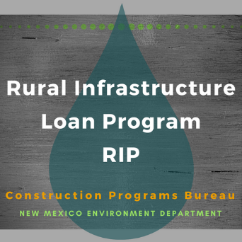

RURAL INFRASTRUCTURE LOAN (RIP) PROGRAM

Please submit the following documents apply for RIP funding for a project.

- Contact Information (form attached).

- Summary Information (form attached).

- Project Information (form attached).

- Financial Information (form attached).

- Proposed Project Budget (form attached).

If you have any questions or need assistance, you may contact NMED at (505) 827-2806 or by email at nmenv-cpbinfo@state.nm.us.

SECTION A.
CONTACT INFORMATION

Primary Contact Person:

Title:

Address:

Phone #: Fax #:

E-mail address:

Additional Contact Person:

Title:

Address:

Phone #: Fax #:

E-mail address:

SECTION B.
PROJECT SUMMARY INFORMATION

- NAME OF ENTITY

- TYPE OF ENTITY (i.e. MDWCA, Town, Village, City, County)

- TYPE OF PROJECT (i.e. water, wastewater, solid waste)

- POPULATION SERVED BY PROJECT:

- NUMBER OF HOUSEHOLDS SERVED BY PROJECT:

SECTION C.
PROJECT INFORMATION

1. Describe the problem and the proposed solution. Also describe the existing facilities including size, condition, age, and capacity if known. The applicant should also include as much information available on the number of water or wastewater connections, and the estimated costs of the proposed improvements.

2. Will additional property need to be acquired for the proposed project? If so, will RIP funds be used to purchase the land or easements?

3. Please indicate any and all of the following documents that have been completed for the proposed project?

Preliminary Engineering Report (PER)

Environmental Information Document (EID)

Plans & Specifications

4. Is the applicant currently out of compliance with current discharge permits or other environmental permits? Please list any known permit numbers.

5. Will the funds result in a complete/operational project? If not further clarification of how the project will be completed must be provided.

SECTION D. FINANCIAL INFORMATION

1. ESTIMATED TOTAL FUNDING NEEDED (INCLUDED ALL COSTS INCLUDING ENGINEERING, CONSTRUCTION, ETC.)

2. PROPOSED FUNDING SOURCES:
(List loans and grants from same funding source separately.)

Source | Type of Funds | Amount | Status of Commitment | Loan Rates and Terms

3. CURRENT DEBT

Year Issued | Purpose | Type of Bond/ Security | Amount | Maturity Date (Month/Yr) | Debt Holder | Coverage Requirement | Avg. Annual Payment Amount | Outstanding Balance

4. MONTHLY USER RATES
Monthly residential water charge for 6,000 gallons and number of residential users
$

Monthly commercial water charge for 6,000 gallons and number of commercial users
$

Monthly residential wastewater charge for 6,000 gallons and number of residential users
$

Monthly commercial wastewater charge for 6,000 gallons and number of commercial users
$

