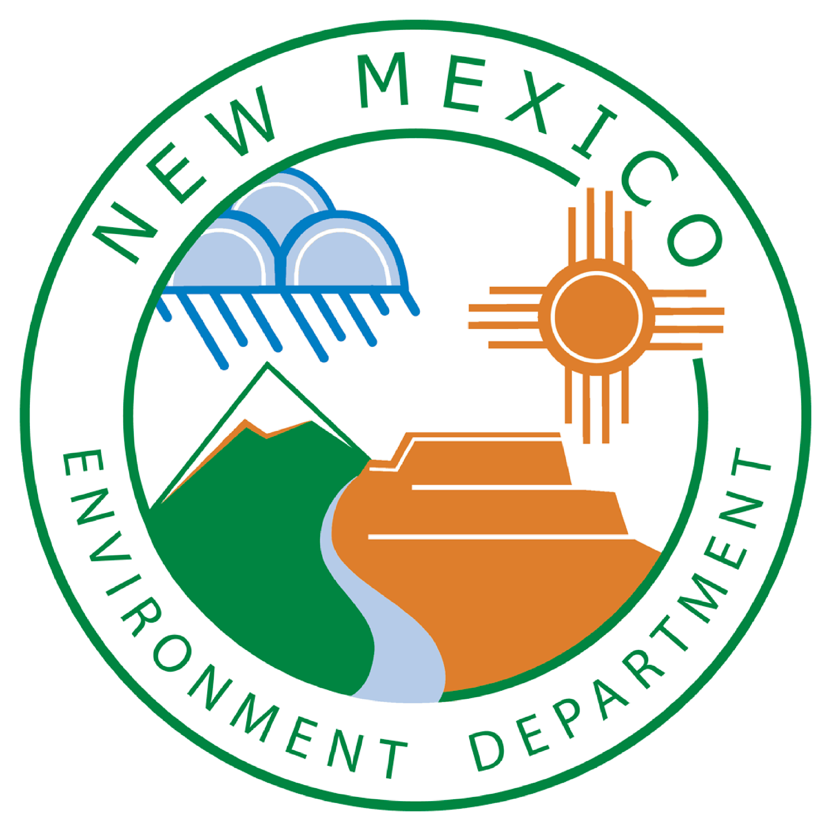

Source Water Protection
NMED ~ Drinking Water Bureau
Sustainable Water Infrastructure Group

Assistance Application

Source Water Protection Plans include an expanded source water assessment (with contaminant inventory and vulnerability assessment), system information, source water conditions, and protection goals and recommendations.
NMED Drinking Water Bureau will work with systems to develop a planning document and a program for implementing and maintaining the plan.

Source Water Project Contact Information:
Water System Name:
Water System ID#:

Primary contact person for the project:
Title/Role:
Phone: Email:

Secondary contact person for the project (if applicable):
Title/Role:

Phone: Email:

Participating in the Source Water Protection Program will require the full support of a Public Water System’s governing board or other decision-making authority.
Has the water system board (or other authority) been informed of this project and support the PWS’s participation?
Yes ☐ No ☐
Is there an existing Source Water Protection Plan in place? Yes ☐ No ☐ Not sure ☐
If so, what is the date of plan development or last update

The NMED Drinking Water Bureau is pleased to be able to offer this free assistance to systems to support source water planning efforts. Development of Source Water Protection Plans is done in partnership with the system staff, board, and other stakeholders identified by the system. NMED may also bring in a third-party contractor to assist with development of the technical and assessment portion of the plan.
NMED encourages community and stakeholder involvement in the source water planning process. We are also able to provide assistance with public meetings and facilitate stakeholder involvement. Typically, there will be one introductory meeting to explain the process and gather feedback and local knowledge from participants. A second meeting can be held to present the final plan to stakeholders. These meetings are coordinated by the system and held at the system’s request.
As needed by the system, NMED-DWB Source Water Protection Program can also work with systems to implement action items identified in the plan and to conduct further outreach. Our goal is for your source water protection planning efforts to be a success and a benefit to the system and customers.
Source Water Protection Planning program includes:
- Source Water Protection Plan
- Updated Source Water Assessment – as a section of the Plan
- Public meeting and presentation assistance (needs to be determined by the system)
- Assistance in implementing actions items and plan updates (as needed)

Signature of primary contact: ______________________________________ Date:

Send completed form to: Jill Turner, Source Water Protection Program Manager, NMED Drinking Water Bureau
Email: jill.turner@state.nm.us OR Paper Mail: 1190 St. Francis Dr. Suite S-2050, Santa Fe, NM 87505

